## Preparation

* Have the [Comparison](https://www.oerproject.com/OER-Materials/OER-Media/PDFs/Teacher-Resources/WHP-Comparison-Tool), [CCOT](https://www.oerproject.com/OER-Materials/OER-Media/PDFs/Teacher-Resources/WHP-CCOT-Tool), and [Causation](https://www.oerproject.com/OER-Materials/OER-Media/PDFs/Teacher-Resources/WHP-Causation-Tool) tools available
* Download the [WHP Writing Rubric](https://www.oerproject.com/OER-Materials/OER-Media/PDFs/Teacher-Resources/WHP-Writing-Rubric)

## Purpose

This assessment will help prepare you for the document-based questions (DBQs) you will probably encounter on exams. It will also give you a better understanding of your skills development and overall progress related to constructing an argument, interpreting historical documents, and employing the historical thinking practices you are using in this course.

## Practices

### Contextualization, sourcing, reading, writing

All DBQs require you to contextualize, source documents, and of course as part of this, read and write.

## Process

### Day 1

1. In this activity, you are going to prepare to respond to a DBQ, or document-based question. In this course, document-based questions give you a prompt or question along with seven source documents, and you’ll use the information in those documents (and any additional knowledge you have) to respond to the prompt. Your responses will be written in essay format, and will usually be five or six paragraphs long.
2. This DBQ asks you to respond to the following prompt: *Develop an argument that analyzes what led to the expansion and contraction of networks of exchange after c. 1200 CE.* To make sure you’re clear on what you’re being asked, take out the Question Parsing Tool, included at the end of the Unit 2 DBQ materials. Work with your classmates to deconstruct the prompt.
3. Take out the DBQ and relevant thinking tool to help you analyze the documents.
4. Take a look at the document library. As you do with the Three Close Reads process, quickly skim each of the documents for gist. Then, do a closer read of each one. For each document, write down the information you think you might use in your essay. If possible, also provide a source analysis for each document. Write your ideas on the relevant tool as you work through the documents. Discuss your ideas with the class.
5. Come up with a major claim or thesis statement that responds to the prompt. Use the information from your thinking tool to help you come up with an idea. What you have written should help you support your claim. One common mistake students make when responding to a DBQ is not directly answering the prompt—so, in creating your thesis, make sure that it directly answers and is relevant to the prompt.
6. Finally, it’s time to contextualize. Remember, that ALL historical essays require you to contextualize. If you need to refresh your memory, contextualization is the process of placing a document, an event, a person, or process within its larger historical setting, and includes situating it in time, space, and sociocultural setting. In this case, you are contextualizing the documents. Contextualization will often come at the beginning of your essay, or at least in the first paragraph, either before or after your thesis statement. As needed, you can use the Contextualization Tool for this part of the process.

### Day 2

1. This second day is your writing day. Feel free to use your tools and notes from any prewriting work you completed as you craft your essay response.
2. Make sure you have a copy of the WHP Writing Rubric available to remind you of what’s important to include in your essay.
3. Don’t forget to contextualize! In doing that, think of the entire time period, not just the time immediately preceding the historical event or process you are writing about.
4. Your teacher will give you a time limit for completing your five- to six-paragraph essay responding to the DBQ.

|  |  |  |  |
| --- | --- | --- | --- |
| Name: |  | Date: |  |

## Unit 2 DBQ

**Directions:** Write a five- to six-paragraph essay in response to the prompt below. Make sure to use the documents provided to help support your argument. In addition to trying to meet the criteria on the WHP Writing Rubric, make sure to address the most relevant of these historical thinking skills in your response: comparison, causation, or CCOT. Finally, make sure you contextualize (describe the broader historical context relevant to the prompt).

*We suggest you spend 10-15 minutes reading these documents and 35-45 minutes writing. Sources are edited for brevity and clarity.*

|  |
| --- |
| Develop an argument that analyzes what led to the expansion and contraction of networks of exchange after c. 1200 CE. |
|  |

## Document 1

**Source:** Marco Polo, *The Book of Ser Marco Polo: The Venetian Concerning Kingdoms and Marvels of the East,* Volume 1, trans. and ed. Colonel Sir Henry Yule (New York: Charles Scribner’s Sons, 1903), 412–15.

Marco Polo (1254–1324) traveled extensively throughout Mongol-controlled Asia. After returning to Venice, he recounted his travels, which were published and widely circulated throughout Europe.

You must know that the city of Cambaluc has such a multitude of houses, and such a vast population … that it seems quite past all possibility. … In those suburbs lodge the foreign merchants and travelers, of whom there are always great numbers who have come to bring presents to the Emperor, to sell articles at Court, or because the city affords so good a mart [market] to attract traders. …

Guards patrol the city every night in parties of 30 or 40, looking out for any persons who may be abroad at unseasonable hours …

To this city also are brought articles of greater cost and rarity, and in greater abundance of all kinds, than to any other city in the world. For people of every description, and from every region, bring things (including all the costly wares of India, as well as the fine and precious goods of Cathay itself with its provinces), … and thus between court and city the quantity brought in is endless.

As a sample, I tell you, no day in the year passes that there do not enter the city 1000 cart-loads of silk alone, from which are made quantities of cloth of silk and gold, and of other goods. …

Round about this great city of Cambaluc there are some 200 other cities at various distances, from which traders come to sell their goods and buy others for their lords; and all find means to make their sales and purchases …

## Document 2

**Source:** *J.F.P Hopkins and Nehemia Levtzion, eds., Corpus of Early Arabic Sources for West African History (Princeton: Markus Wiener Publishers, 2000).*

Abu Yahya Zakariya’ ibn Muhammad al-Qazwini (1203–1283) was an Arab-Persian physician, astronomer, and geographer who wrote a geographical dictionary, *Monument of Places and History of God’s Servants*.

The land of Gold. It is the land of the Sudan [the name given to sub-Saharan Africa] …

It is a three months’ journey from Sijilmasa [city in modern-day Morocco] to this country and merchants from Sijilmasa go there with great exertion. Their stock-in-trade is salt, pine and cedar wood, glass beads, bracelets of red copper and signet rings of the same, and bangles of brass. They have to cross over thirsty deserts with scorching winds and water so rotten it resembles ordinary water only in that it is liquid. … Thus they travel with much suffering until they reach the place which separates them from the owners of the gold. …

The people of this town are among the richest men and the most wealthy, for it is on the road to Ghana, which is the mine of gold. …

Ghana. A great town to the south of the Maghreb adjacent to the land of Gold. Merchants meet in Ghana, and from there they enter the land of Gold. Were it not for Ghana that would be impossible. Ghana is the richest in gold of all God’s countries.

## Document 3

**Source:** Henry Yule, *Cathay and the Way Thither: Being a Collection of Medieval Notices of China*, Volume 2 (London: The Hakluyt Society, 1866), 287–94. Edited for brevity and clarity.

Francis Balducci Pegolotti was a merchant who traveled extensively in the early to mid-fourteenth century. We do not know much about this author apart from what is learned from the account of his travels—*Notices of the Land Route to Cathay and of Asiatic Trade in the First Half of the Fourteenth Century*.

In the first place, from Tana [Azoz, on the Don River] to Gintarchan [Astrakhan, on the Volga River] may be twenty-five days with an ox-wagon, and from ten to twelve days with a horse-wagon. On the road you will find plenty of Mongols, that is to say, soldiers. And from Gittarchan to Sara [Sarai, on the Volga] may be a day by river, and from Sara to Saracanco [Sarachik, on the Ural River], also by river, eight days. You can do this either by land or by water; but by water you will be charged less for your merchandise. …

The road you travel from Tana to Cathay is perfectly safe, whether by day or by night, according to what the merchants say who have used it. …

Cathay is a province which contained a multitude of cities and towns. Among others there is one in particular … which is a great resort of merchants, and in which there is a vast amount of trade. …

Whatever silver the merchants may carry with them as far as Cathay, the lord of Cathay will take from them and put into his treasury. And to merchants who bring silver, they give them that paper money of theirs in exchange. This is of yellow paper, stamped with the seal of the lord … And this money is called *balishi*; and with this money you can readily buy silk and all other merchandise that you have a desire to buy.

## Document 4

**Source:** Still from Rebuilding the Silk Road (01:25), OER Project, [https://www.oerproject.com/OER-Materials/OER-Media/Videos/Origins/Era4/Rebuilding-](https://www.oerproject.com/OER-Materials/OER-Media/Videos/Origins/Era4/Rebuilding-the-Silk-Road) [the-Silk-Road](https://www.oerproject.com/OER-Materials/OER-Media/Videos/Origins/Era4/Rebuilding-the-Silk-Road)

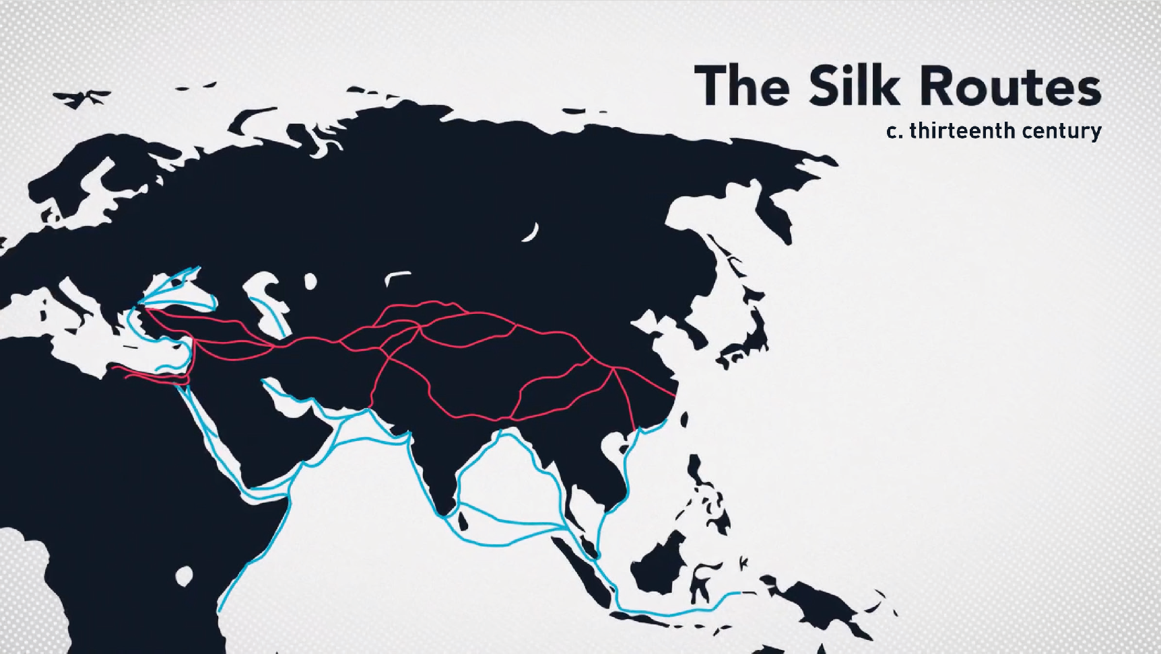

## Document 5

**Source:** Marchione di Coppo di Stefano Buonaiuti, *Cronaca fiorentina. Rerum Italicarum Scriptores*. Volume 30, ed. Niccolo Rodolico (Citta di Castello: 1903–13). <http://www2.iath.virginia.edu/osheim/marchione.html>

Marchionne di Coppo Stefani, birth name Baldassarre Buonaiuti, (1336–1385) was a wealthy businessman, historian, and politician from Florence, Italy. He spent most of his time as a diplomat for the Florentine government and traveled to various cities in Europe.

In the year of the Lord 1348 there was a very great pestilence in the city and district of Florence. …

Many died from [carrying away the dead], some rich, some after earning just a little, but high prices continued. Servants, or those who took care of the ill, charged from one to three florins per day and the cost of things grew. The things that the sick ate, sweetmeats and sugar, seemed priceless. … eggs cost between twelve and twenty-four pence each; and he was blessed who could find three per day even if he searched the entire city. Finding wax was miraculous. … Dressing in expensive woolen cloth as is customary in [mourning] the dead, that is in a long cloak, with mantle and veil that used to cost women three florins climbed in price to thirty florins and would have climbed to 100 florins had the custom of dressing in expensive cloth not been changed. … Benches on which the dead were placed cost like the heavens and still the benches were only a hundredth of those needed … None of the guilds in Florence was working. All the shops were shut, taverns closed; only the apothecaries and the churches remained open. If you went outside, you found almost no one.

## Document 6

**Source:** John Aberth, *The Black Death: The Great Mortality of 1348 – 1350: A Brief History with Documents* (New York: Bedford/St. Martin’s, 2005), 87.

Ahmad Ibn Alī al-Maqrīzī (1364–1442) was an Egyptian historian who wrote about the impact of the Black Death on Egypt and Syria under the Mamluk dynasty.

Most of the trades disappeared, for a number of artisans devoted themselves to handling the dead, while the others, no less numerous, occupied themselves in selling off to bidders [the dead’s] movable goods and clothing, so well that the price of linen and similar objects fell by a fifth of their real value, and still further until one found customers …

Thus the trade disappeared: One could no long find either a water carrier, or a laundress, or a domestic. The monthly salary of a groom rose from thirty *dirhams* to eighty. A proclamation made in Cairo invited the artisans to take up their old trades, and some of the recalcitrant [unruly] reformed themselves. Because of the shortage of men and camels, a goatskin of water reached the price of eight *dirhams*, and in order to grind an *ardeb* of wheat, one paid fifteen *dirhams*.

## Document 7

**Source:** *Omar H. Ali, Islam in the Indian Ocean World: A Brief History with Documents (Boston: Bedford/St. Martin’s, 2016), 50–53.*

*Abd-al-Razzāq Samarqandī (1413–1492) was a Persian historian and Islamic scholar, who wrote about fifteenth-century merchants and trade in the Indian Ocean.*

Continuing my journey, I arrived … at the shore of the Sea of Oman, and at Bender-Ormuz. The prince of Ormuz … having placed a vessel at my disposal, I went on board of it, and made my entry, with everything that I could require, and I was admitted to audience of the prince. Ormuz … is a port situated in the middle of the sea, and which has not its equal on the surface of the globe. The merchants of seven climates from Egypt, Syria, [Anatolia], [Azerbaijan], [Iraq and Persia] … the whole of the kingdoms of [China] … and the city of Khanbalik [former name of Beijing], all make their way to this port; the inhabitants of the sea coasts arrive here … they bring those rare and precious articles which the sun, the moon, and the rains have combined to bring to perfection, and which are capable of being transported by sea. Travelers from all countries resort here, and, in exchange for commodities which they bring, they can without trouble or difficulty, obtain all that they desire. Bargains are made either by money or exchange. For all objects, with the exception of gold and silver, a tenth of their value is paid by way of duty. …

Calicut [Kozhikode] is a perfectly secure harbor, which, like that of Ormuz, brings together merchants from every city and from every country; in it are to be found abundance of precious articles brought there from maritime countries, and especially from Abyssinia, [southeastern India and Zanzibar] … from time to time ships arrive there from shores of the House of Allah [Mecca] and other parts of the [Hijaz], and abide at will, for a greater or longer space, in this harbor… Security and justice are so firmly established in this city, that the wealthiest merchants bring to this place from maritime countries considerable cargoes, which they unload, and unhesitatingly send into the markets and the bazaars.

## Question Parsing Tool

**Directions:** Follow the steps to parse the prompt you are presented with. Use the key at the bottom to help you with the historical reasoning practice and composition questions.

1. **Prompt**:

|  |
| --- |
|  |

1. Rewrite the prompt in your own words:

|  |
| --- |
|  |

1. **Periodization**: What is the time period you are being asked to consider? Write out the years if you are given something in terms of century (for example, twentieth century = 1900s).

|  |
| --- |
|  |

1. **Location**: What areas of the world are included in this prompt?

|  |
| --- |
|  |

1. **Topic**: What is the main topic being asked about in this prompt?

|  |
| --- |
|  |

1. **Historical reasoning practice**: What historical reasoning practice is this prompt asking you to engage in? Provide justification for why you chose the one you did.

|  |
| --- |
|  |

1. **Composition**: What is the prompt stem asking you to do as part of your response? Remember the prompt stem is usually a verb.

|  |
| --- |
|  |

## Key

|  |  |
| --- | --- |
| Historical Reasoning Practice | Words/Phrases to Look For |
| Causation | Cause, effect, led to, lead to, emergence, resulted, bring about, give rise to, be the cause of, result in, produce, generate, spawn, precipitate, prompt, induce, promote, foster, provoke, trigger |
| Comparison | Similarities, differences, compare, contrast, set side-by-side, juxtapose, differentiate, liken, equate |
| CCOT | Continuities, changes, continuation, persistence, consistent, over time, two points in time |
| Prompt Stem Examples | **What It’s Asking in Simpler Language** |
| To what extent | Weigh, evaluate, assess |
| Evaluate, assess | How much—needs a quantitative answer/thesis/claim (Note: A quantitative answer is one that includes an amount or a number. For example: a lot, a little) |
| Analyze, develop | Describe and explain |
| Argue, argument | Make a claim |