## Purpose

Contextualization is a historical thinking skill that involves connecting historical events and processes to specific circumstances of time and place. Without understanding the circumstances that surround and build up to historical events, it’s difficult to make sense of them. In this first in the progression of activities on understanding context, you will begin to work with the idea of contextualization so you see how important it is for understanding the past.

## Practices

### Reading, claim testing, causation

To adequately make sense of the historical accounts you read, you need to understand the context in which events occurred and how the assertions about the events are supported through claim testing. In addition, when you categorize broad and narrow context, you will consider how these pieces of context led to the historical event being studied.

## Process

1. 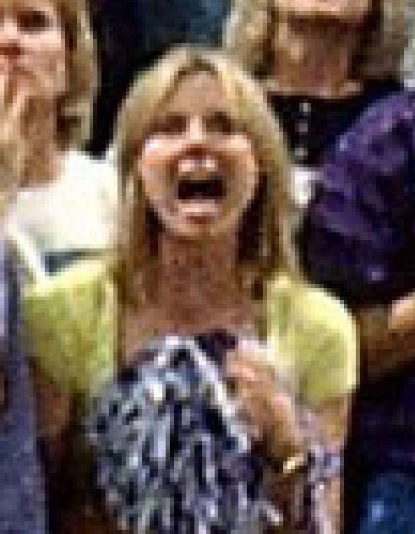Do you know what the word *context* means? Work with your class to come up with a definition. Can you think of a time when you needed to have context to understand something that happened?
2. Take a look at the photo on this page. Why is this person yelling? Share your ideas with your class.
3. Now, look at this photo with more context. Any additional ideas about why this person is yelling? Does having a fuller view of the picture give you more information? It may have helped you a little, but clearly, you need even more information.
4. This is actually a popular photograph from the 1900s. What else do you think you need to know to figure out what’s going on here? In other words, what categories of information might help you figure out what’s happening?
5. Discuss your ideas with your class and ask your teacher as many questions as you want. Once you’ve gotten more information, your teacher will tell you the title of this picture and give you any additional information you might need to figure out why this person is yelling.
6. Do you think you would have been able to figure out why this person is yelling without all this extra information?
7. Your teacher will break the class into small groups and hand out event cards. Work with your group members to divide the cards into two piles—one for broad context and the other for narrow context. *Broad context* represents broader themes, trends, events, eras, or regions that are related to the historical event you’re studying. Often, broad context helps us understand long-term causes of an event. *Narrow context* refers to the themes, trends, events, eras, and regions that are more closely tied in time or place to the historical event. Narrow context helps us see the short-term causes of an event.
8. Your teacher will ask a few groups to place their event cards on the board. Be prepared to explain why you chose to place your cards in a particular area of the funnel.
9. The process you just went through is called *contextualization*, and it’s something historians do all the time. It’s also something we do in our everyday lives to help us properly interpret things that have happened instead of just jumping to conclusions.
10. To help with historical contextualization in this course, we have a tool for you to use. Your teacher will either hand out or have you download the Contextualization—Introduction worksheet and ask you to review the Contextualization Tool with your class. You’ll be using this tool throughout the course to help you practice contextualizing, which will enable you to correctly interpret the historical events you’ll be studying.

|  |  |  |  |
| --- | --- | --- | --- |
| Name: |  | Date: |  |

## Contextualization Tool

**Directions:** Respond to each of the prompts below.

* **Broad**: Does the context represent broader themes, trends, events, eras, or regions related to the historical development at hand? Does it represent a long-term (underlying) cause or contributing factor?
* **Narrow**: Does the context represent themes, trends, events, eras, or regions that are more closely tied in time/place to the historical development at hand? Does it help us see the short-term (immediate) causes or contributing factors?

1. Write the date(s) and location(s) of the historical event being studied.

|  |
| --- |
|  |

1. Take the event cards and divide them up into broad and narrow context.
2. Place them on the funnel in their appropriate location. Be prepared to explain your placement.
3. Write one to two sentences that describe the broad context.

|  |
| --- |
|  |

1. Write one to two sentences that describe the narrow context.

|  |
| --- |
|  |

1. Write one to two sentences analyzing how the broad and narrow context help you better understand the historical event.

|  |
| --- |
|  |



**Broad Context**

**Narrow Context**

|  |  |
| --- | --- |
| Historical Event/Development: |  |