## Purpose

As you’ve learned, one of the main historical thinking tools that historians use to analyze and produce accounts of the past is comparison. In this activity, you’ll learn how to evaluate for continuity and change over time (which we’ll refer to as *CCOT* throughout the course) so that you have a method for comparing (and making claims about) how the same location, idea, or historical process either stayed the same or changed during a set time in history.

## Practices

### Comparison, causation

Continuity and change analysis involves comparison, but it’s different from the kind of historical comparison that you’ve been introduced to earlier in this course. Typically, historical comparison involves examining the similarities and differences between two things, while CCOT looks at how things stayed the same or changed over time. Comparison is often a component of a CCOT analysis. Additionally, part of understanding how and when a change occurred is related to understanding the causes and consequences of those changes.

## Process

1. What are continuities? What are changes? How do these relate to history? We refer to continuities as the things that have stayed the same over time in history. And changes—which are often easier to identify—are the things that did *not* stay the same. Historians often do something called *a continuity and change over time* *analysis* (CCOT analysis for short). They do this by looking at how certain things changed or stayed the same *over time*. One of the reasons historians find CCOT analysis useful is that recognizing what has stayed the same helps them decide which changes throughout history were the most significant. This, in turn, allows historians to see how those changes may have led to major transformations in how people lived and continue to live today.
2. Instead of looking at an event or something that happened at a defined moment or time period, we are now trying to understand how farms, one of the mainstays of societies since the development of agriculture, have evolved. We are going to look at farms in the state of Iowa from the 1700s, 1800s, 1900s, and today, to determine how farms have changed and how they’ve stayed the same over time.
3. Your teacher will either hand out or have you download the CCOT—Introduction worksheet. Glance at the pictures of the four farms on the first few pages. Based on just the images, discuss as a class what is the same and what is different about the four farms. Remember that the things that are the same are *continuities*. And the things that are different are, you guessed it, *changes*!
4. Review the CCOT Tool portion of the worksheet with your class. As with sourcing, claim testing, and reading, there is a tool that you can use to help you analyze continuities and changes.
5. Working in small groups, write down on the tool portion of the worksheet the timeframe with which you’re working. Then, read through the text accompanying the images of farms and write the continuities and changes you find on your sticky notes (one continuity or one change per sticky note).
6. Place your sticky notes on the graph (either using the graph in your worksheet or by drawing the graph on the board) and decide whether your continuities and changes were positive or negative. Be prepared to explain your reasons for categorizing your continuities and changes as either positive or negative.
7. Once your group has placed all your sticky notes on the graph, answer the remaining questions on the tool. In the last set of questions, you’ll be evaluating the most significant change and continuity. You can use the acronym ADE (amount, depth, and endurance) to help you determine historical significance. You’ll decide if the changes and continuities affected all people (amount); if the changes and continuities deeply affected people (depth); or if the changes and continuities were long lasting (endurance). Be prepared to share your most significant continuities and changes with the class.
8. Your teacher will collect your worksheets and use them to assess your understanding of this historical thinking practice. And remember, this is just a simple exercise to get you used to the idea of CCOT. It’s going to get a *lot* more complicated as you move through the course and increase your historical knowledge!

## Farms

**Directions**: Examine the photos and read about each of the farms below. Then, fill out the CCOT Tool.

### Farm of 1700: Ioway Native American Farm

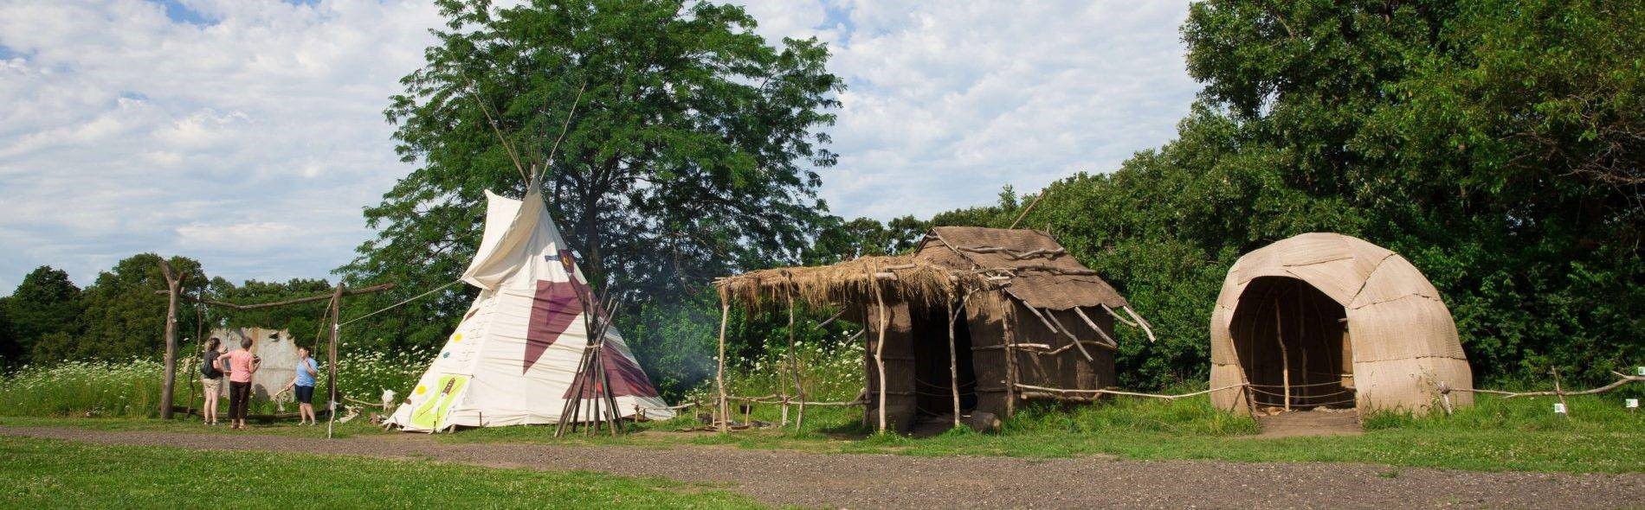

*Photo and text courtesy of and ©* [*by Living History Farms*](https://creativecommons.org/licenses/by/4.0/)

“The farming techniques practiced by the Ioway Indians in 1700 pre-dated written history and varied somewhat from European methods. Ioway farmers raised corn, beans, and squash. Women did the farming in the Ioway culture while men were responsible for hunting and making tools. Ioway families were subsistence farmers, raising just enough for their family to survive throughout the year and having a little put away in case of a bad year.

“Ioway Indians had separate summer, winter, and traveling lodges. Bark houses called náhachi kept the Ioway cool during hot summer months, while winter mat-houses called chákirutha, made from layers of sewn cattail leaves, protected the Ioway from harsh winters and stayed around 50 degrees inside.

“While traveling on hunting expeditions, the Ioway lived in a chibóthraje, or tipi made from buffalo hides. Their villages also contained sweat lodges, food-drying racks, cooking areas, work areas, hide-scraping racks, pottery pits, and gardens.”

### Farm of 1850: Iowan Pioneer Farm

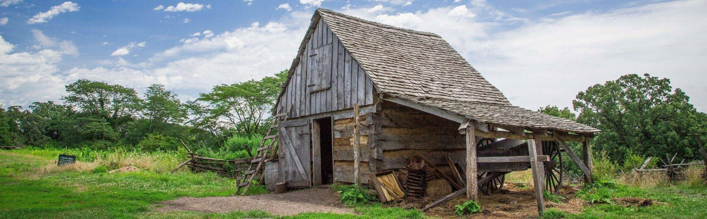

*Photo and text courtesy of and ©* [*by Living History Farms*](https://creativecommons.org/licenses/by/4.0/)

“The split rail fence, wheat field, rooting pigs, and log house represent a four-year-old farm, established when Iowa became a state in 1846. The farm site is in transition between subsistence agriculture (producing enough for the family to survive) and becoming a profit-making farm. Most farms in 1850 averaged 160 acres in size, with farmers cultivating anywhere from 25 to 40 acres. Corn, wheat, and potatoes were the three major crops in 1850. Most farmers used their corn crop to feed the pigs that were then sold for profit. Wheat and hogs were cash crops for farmers, and potatoes were a staple with nearly every meal and lasted throughout the winter.

“Until pioneer families earned enough money to purchase modern 1850 technology, they relied on older farming methods. For example, women prepared food over an open fire even though wood-burning cookstoves were available. The majority of people who settled in Iowa in the 1840s and 1850s came from the Eastern United States, and were eager to build a multi-room dwelling like they had lived in before coming west. Log houses were temporary structures that the pioneers improved or replaced once the farm was established.

“Pioneer families relied on poultry for three major purposes: meat, eggs, and money. Most pioneers who raised pigs built a smokehouse to help preserve the pork. In 1850, barns were of less significance to the farm than in later years. Pioneers used barns to store tools and some crops, rather than to house animals. The big barns that are associated with modern farms were not built in Iowa until the 1870s.”

### Farm of 1900: Iowan Horse-Powered Farm

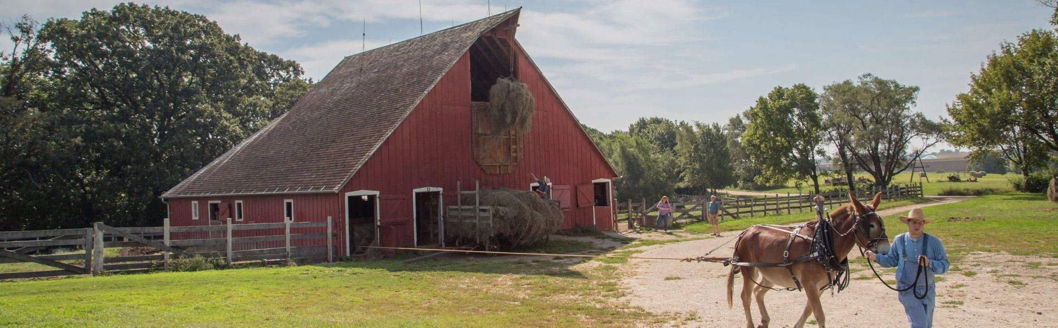

*Photo and text courtesy and ©* [*by Living History Farms*](https://creativecommons.org/licenses/by/4.0/)

“Dramatic changes in farming occurred between 1850 and 1900. The end of the Civil War led into the [Second] Industrial Revolution, and changes resulted throughout the barnyard. Instead of performing field work by hand, farmers used modern machinery to cut hay, plant corn, and bind oats. Inside the farm kitchen, the wood-burning cook stove and the Mason jar made food preparation and preservation much easier.

“The large barns were the center of daily activity on turn-of-the-century farms. Most farmers used the barn for multiple purposes, like storing hay and oats, stabling animals, milking cattle, and storing tools and equipment. Farmers harvested hay in June, July, and August, and then stored it in the barn to feed the animals during the winter months. The haymow, in the center of the barn, held more than 30 tons of loose hay.

“By 1900, most farmers used draft horses for hard labor. The 1,800-pound animals plowed the fields for corn and oats, planted the crops, cultivated the fields, brought in the hay crop, pulled wagons of field corn, hauled manure. Farms would not have been as successful without the aid of the horses.

“Technology had reached Iowa farms in 1900, by way of the hand-crank telephone, Acorn cook stove, and updated farm equipment, such the horse-drawn plow, planter, hay press, and more. Corn, oats, and hay were the most common crops on turn-of-the century Iowa farms. Commonly raised farm animals included sheep, chickens, hogs, milk-cows, beef cattle, ducks, geese, and turkeys.”

### 2014: Modern Farm in the American Midwest

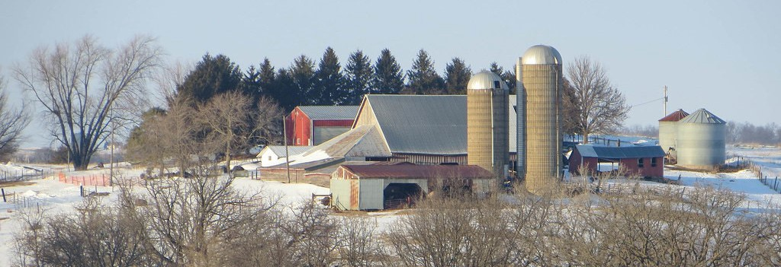

[*Near Wyoming, Iowa*](https://www.oerproject.com/?WT.mc_id=00_00_2021_x_OER-PDF_&WT.tsrc=OERPDF)*, by davidwilson1949, CC BY 2.0.*

“Today, most of Iowa’s land, about 85 percent, is farmland. The state includes 35.7 million acres of land and over 30 million acres are farmed in Iowa. Most of this, about 26 million acres, is cropland and the other 1.2 million acres is used as pastureland. There are about 88,000 farms in Iowa and the average farm size is 345 acres.

“Production on farms has increased dramatically due to technological advancements. Most farms in the American Midwest use tractors and synthetic pesticides and fertilizers to increase production. About 99 percent of farms in America are family owned but only about two percent of the labor force works in farming. While mostly men are farm operators, women’s participation as farm operators and owners has increased substantially in the last 25 years, from 5 to 12 percent of the total.

“Corn is the crop grown the most throughout the American Midwest, and Iowa ranks first in the United States for producing corn along with soybeans, pork, and eggs. Corn is mainly used in the production of animal feed and in ethanol, which is used to manufacture gasoline. Soybeans and pork are two of America’s largest exports, with the bulk of these products purchased by China. There are also a large number of dairy and cattle farms in the Midwest.

“The number of farms has decreased from 1900 to today but farms have also become more productive as technology has advanced. There are both positive and negative impacts of farm production including environmental concerns such as the release of greenhouse gasses and runoff of chemicals into waterways.”

*Source: Living History Farms, Economic Research Service of the United States Department of Agriculture, and the American Farm Bureau Federation.*

|  |  |  |  |
| --- | --- | --- | --- |
| Name: |  | Date: |  |

**Directions 1:** Fill in the following information for the assigned topic.

1. Write the dates for time period being studied.
2. Write down on sticky notes as many continuities and changes for the time period that you can find. Write one per sticky note and place each on the graph to show whether it was a continuity or a change, and whether it was positive or negative. Be prepared to explain your thinking.

|  |  |  |  |
| --- | --- | --- | --- |
| **Continuity** | **Positive** | | **Change** |
|  |  |
|  |  |
| **Negative** | |

1. Were there more changes or continuities? Explain why there were more of one than the other for this time period.

Historical significance can be determined in several ways. Use the acronym ADE to help you:

* **A**mount: How many people’s lives were affected by the continuity/change?
* **D**epth: Were people living in the time period being studied deeply affected by the continuity/change?
* **E**ndurance: Were the changes people experienced as a result of this continuity/ change long-lasting and/or recurring?

|  |
| --- |
|  |

1. Look over the **changes** on your graph.
   * Were they more positive or negative, overall? Explain why these were more positive or negative during this time period.
   * What was the most significant change during this time period? Why?

|  |
| --- |
|  |

1. Look over the **continuities** on your graph.
   * Were they more positive or negative, overall? Explain why these were more positive or negative during this time period.
   * What was the most significant continuity during this time period? Why?

|  |
| --- |
|  |