|  |  |  |  |
| --- | --- | --- | --- |
| Name: |  | Date: |  |

## Purpose

In the eighteenth and nineteenth centuries, all kinds of women became active in the fight for change. While these fights for rights may not seem particularly revolutionary today, and while not all of these women are famous or well known, these women were agents of change in history, helping to push the boundaries of what was “normal” at the time. In this activity, you will engage in an in-depth study of one revolutionary woman to illuminate just how “revolutionary” this person was, and how her impact is still felt and seen in women’s lives around the world today. You will create an influence campaign to show others how this woman’s history is still usable and important in today’s world.

## Practices

### CCOT

You will have to determine how the changes spurred by revolutionary women still impact lives today. In doing this, you will have to look at how those changes have persisted.

## Process

In this activity, you will research one revolutionary woman from history, with the goal of creating a mini-influencer campaign in order to show that your woman was the most revolutionary. Your teacher will start by reading the following passage to you – feel free to read along!

The eighteenth century marked a significant turning point for much of the world. It was an era of tremendous change, as people developed new ways to examine human nature using science, and at times called for radical political revolutions. It was the period of time in which intellectuals discussed creating a social contract between the people and the government. These new republican governments required the consent of the people because in the words of Thomas Jefferson, “all men are created equal.” You might ask, “What about women?” Abigail Adams brought up the question in a letter to her husband, an author of the US Constitution, requesting, “in the new Code of Laws which I suppose it will be necessary for you to make I desire you would Remember the Ladies, and be more generous and favourable to them than your ancestors.” The mere fact that women were active in fighting for change is one of the most revolutionary elements of that century and after. Some of these fighters were intellectual women of the European Enlightenment. But the revolutionary spirit had a much wider reach, including women from varying socio-economic and geographical backgrounds.

What do you think it means to “Remember the Ladies, and be more generous and favourable to them than [their] ancestors”? After you’ve discussed your ideas with the class, it’s time to start learning more about revolutionary women. You are going to both remember and celebrate revolutionary women by creating an influence campaign for one woman. So, what does it take to be “most revolutionary”? Well, that will be determined by the class, but generally, it will be the woman whom you show to have fostered the most change, with the effects of those changes still being felt around the globe today.

Once you’ve been assigned a revolutionary woman to study, take out the Revolutionary Women worksheet. First, read the excerpt that aligns to the geographic area your woman is from. You might also want to check out the other excerpts so you have a sense of the competition. Then, you should conduct Internet research to find out more about the woman you are studying. Consider the following questions as you dive into your research.

* Do they go by other names?
* What was their childhood and background like?
* What made them ordinary?
* What made them extraordinary?

Be sure to use the research cards on the Revolutionary Women worksheet to help you evaluate and record your sources.

Once you have a good sense of why the woman you are studying is revolutionary, it’s time to move on to the influence campaign. Your teacher will tell you who the specific audience is for this campaign so that you can target your materials accordingly. The audience will ultimately vote on the campaigns to identify the top three most revolutionary women in history.

For this campaign, the woman is the “influencer” and you’re the marketers collaborating with her. Your campaign must include at least five slides that incorporate the following information in one way or another. Feel free to get creative, but also make sure you address each of the criteria, in no particular order:

1. “Product” being endorsed
   * This is the agent of change/change itself (in this case, the woman).
2. Review(s) of the “product”
   * How did the change go? Was it positive, negative, or somewhere in between?
   * Find and cite 2-3 credible sources who may have offered an opinion on this change, whether positive, negative, or somewhere in between.
3. Contextualization
   * Why did this happen at this time? What were the contexts and conditions that helped spur this change?
4. Reach
   * How many people did this impact? (That is, study the reach of the impact and display it somehow.)
5. Relevance to today
   * Why is this person still important today? Where do we see their revolution at work?

The campaigns could be created using PowerPoint, Google Slides, or your teacher may suggest other options. They should include, where possible, images, data, and perhaps even videos that help strengthen the campaign. Each final product should be something that the audience can click through without requiring any outside information to understand what the campaign is about. In this way, the judges/audience could do a gallery walk through the campaigns without needing anyone there to explain them.

Once the campaigns have been shared and voted on, and the top three women selected, wrap up with a discussion of why the women chosen were the most revolutionary. Was it more about what they did or more about how the campaigner was able to argue their position? And were these the more well- known women or were the women chosen more representative of everyday women who happened to do something revolutionary? Finally, talk about how you were able to trace this historical impact over time, and think about other ways you can continue to connect the past to today, making sure that the history you learn is usable and applicable to you.

## Women in Europe and North America

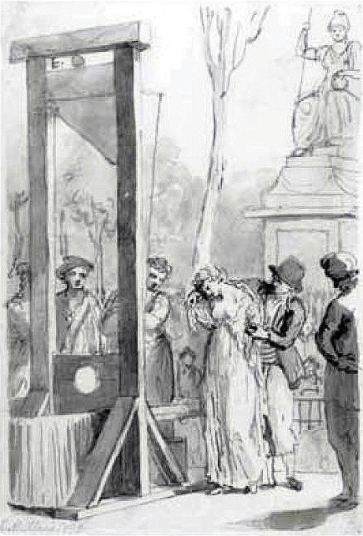Most studies of this era focus on how women participated in the Enlightenment movement, which was mainly centered in Europe and the Americas.[1] These historical works have pushed the stories of “remarkable” women or those women who broke free from social constraints to contribute in various fields. While “extraordinary” women are well worth our notice, these stories focus mostly on the elite. There are numerous studies on how women contributed as *salonnières*[2] and as authors of literary and artistic works. Women such as Mary Wollstonecraft, Abigail Adams, and Olympe de Gouges, who called upon the men in government to include more equal rights for women, have also been the focus of historians of this era. But the more complete history of women from different classes, races, and less urban areas in Europe and the Americas gets lost when we only discuss high-profile, individual women.

Many women participated in their countries’ revolutions as workers, nurses, and even on the battlefield. In fact, women often used their roles as mothers and as members of the more “moral sex” to fight for change.[3] In October 1789, Parisian women took to the streets to demand their king address the high cost of bread. Unable to feed their children and on the verge of starvation, they insisted the king and the royal family journey from Versailles to Paris to witness the crisis up close. Women’s roles as mothers thus inspired them to call for change in their governments.

Unfortunately, the new American Constitution was silent on the rights of all women, and minority women and men were considered property, or 3/5 of a person. Therefore, it would seem that John Adams indeed forgot the “ladies” despite his wife’s letter. In fact, under a policy known as coverture, most of the state laws restricted women’s ability to sign contracts, testify in court, serve on juries, and initiate divorces. As a legal practice, coverture basically said that once a woman got married, she became the property of her husband. Only he could sign legal documents and manage the family’s finances and property.

Execution of Olympe de Gouges, 1793, by Mettais, British Museum, public domain.

Across the Atlantic Ocean, there was a glimmer of hope for equal rights when one version of the new French Constitution was proposed in 1791. French women had participated in the revolution through protests, meetings at political clubs, and in their writings. Unfortunately, the men deciding the new rights of the republic did not agree with full, or even partial, equality for women. In 1789, *the Declaration of the Rights of Man and of the Citizen* was published, claiming that all free-born men had equal rights. French playwright Olympe de Gouges took one look at this and responded with her *Declaration of the Rights of Woman and of the Female Citizen*. The 1791 document called for equality of the sexes. In the decades that followed, women would begin working toward the first wave of feminism, with the goal of women’s suffrage, which was achieved on a global scale in the nineteenth and twentieth centuries (a topic that will be covered a bit later in this course).

## Women in Asia

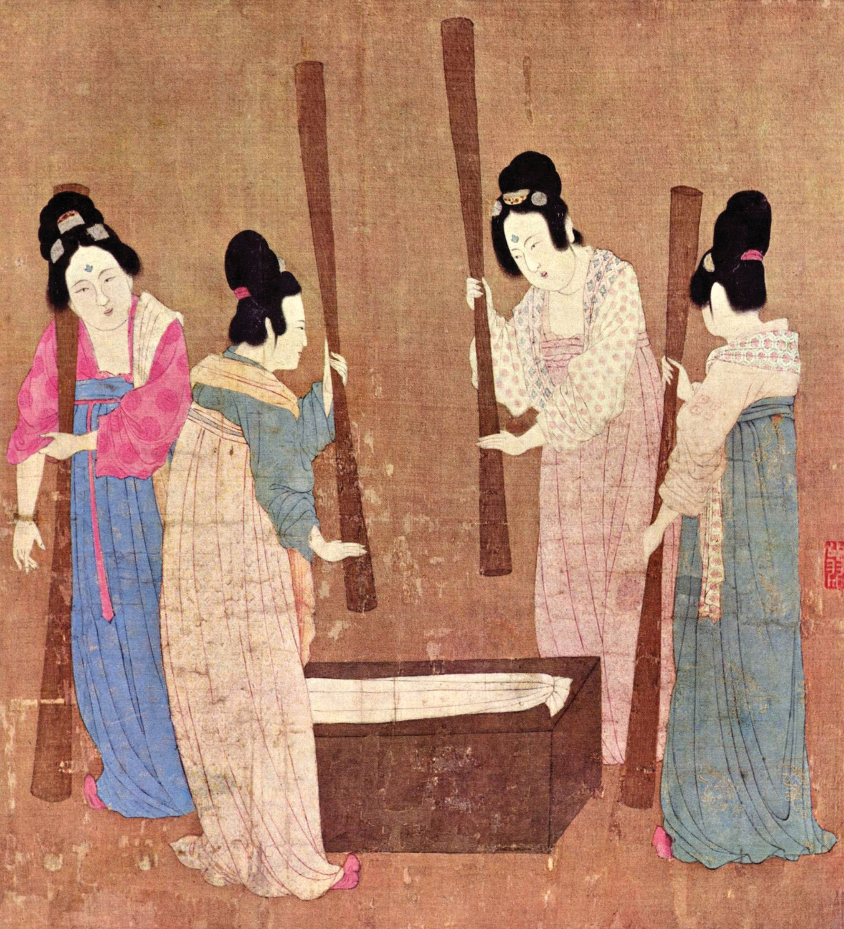Women’s experiences vary greatly according to geographical location and socioeconomic status. In many parts of Asia, women were expected to be virtuous and motherly, and little else. Many writings—by male authors—recounted the downfall of the immoral woman. These tales were used as a way to control the behavior of women by suggesting that moral women must remain exclusively in the private sphere (the home). Only men could be public officials, members of the military, or merchants. Still, many women exercised power either behind the scenes as dowagers, concubines, and even empresses. But even these women were supposed to behave like models of motherhood or as virtuous or redeemed women.

Despite the limits a conservative culture put on their gender, many women contributed in the areas of the arts, especially poetry, and also in the workforce. Women worked in the textile industry, producing silk and garments that were in high demand and traded along the Silk Road. Rural women also contributed to the family economy as farmers. Chinese emperors and government officials encouraged women to join the workforce, especially since there was so much tax revenue to be made from textile exports.

Court Ladies Preparing Newly Woven Silk, by Emperor Huizong, c. twelfth century CE, Museum of Fine Arts, Boston. Public domain.

## Women in Sub-Saharan Africa

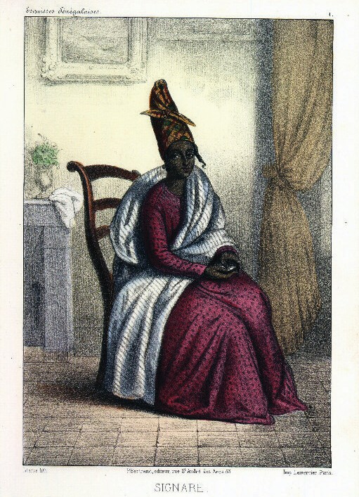Women’s “acceptable” roles in Africa were very similar to those in other areas of the world. Many found their power through the more traditional aspects of motherhood and as religious leaders. A number of areas in Africa traced the family line through their mothers (matrilineal descent), giving women a certain kind of power.[4] Women in these communities often became powerful “Queen-Mothers” who influenced the choice of male leaders and also advised their male heirs. Men in this region of the world, who were generally the main holders of political power, often ruled from the home. The resulting overlap of private and public spheres gave women more influence in politics.

In many areas of Africa, in particular in the western and southwestern regions, women held power and influence as traders. With the arrival of European ships and expanding exchange networks that developed, history has left us records that show women’s influence in this thriving industry. As the Portuguese began establishing trading posts along the coasts, they also built churches and local government offices. Most of the written records relating to African women from this era come from court proceedings recorded by the Portuguese and Spanish.

From these files we know that Portuguese men petitioned to have their marriages to African women, often called *signares*, recognized by the courts. The Catholic Church also kept records of all baptisms of children from these unions. We also know that some women were granted licenses to conduct trade with European merchants in these areas. Many of these women became incredibly wealthy from the trade of goods and slaves. Therefore, in these coastal towns, where European men came and went, the African wives and lovers they left behind could rise considerably in political, social, and economic status. Many African women were also enslaved during this era and forced to make the journey to the Americas, but the majority of women who were captured were sold within Africa to work on farms. Slavery forever changed this continent. Millions of young men and women were forced to leave their communities for a foreign land where they were treated as property, not as human beings.

Signare, 1853, by Abbé David Bollat, New York Public Library, public domain.

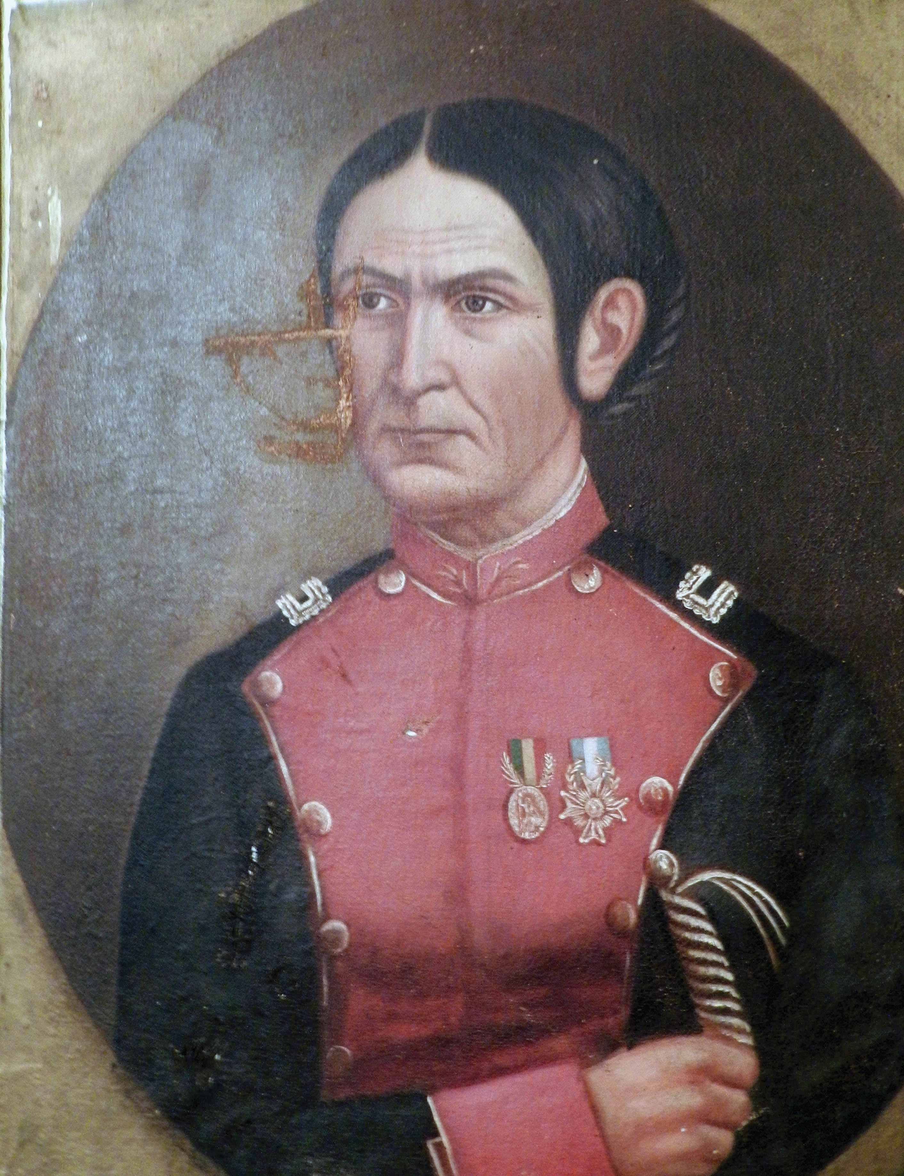As in the other areas of the world, a few women also gained fame as the leaders of empires. Artifacts, art, and linguistic studies tell the stories of women who ruled. However, these women were exceptions to the rule, putting them firmly in that respectable but limiting category of “exceptional” or “extraordinary” women. By the next century, the monarchs of Europe would carve up the African continent for themselves, deplete the natural resources, and declare themselves rulers of this land and anyone already living there. However, when the African people fought back in the mid-twentieth century, many African women were at the head of this cause.

## Women in Latin America

Women in Latin America, as in other parts of the world, were also mainly defined by their roles as mothers or religious leaders. However, prior to the arrival of Europeans in the early centuries of this era, indigenous women were viewed as complementary to men. That means they worked together with men in their communities on a more or less equal level. While their roles were usually separate from men’s, the combination of male and female roles created an important balance. This view of women’s and men’s spheres was rooted in the beliefs of indigenous cultures. For example, people of the Andes believed that women and men were descendants of separate, gendered lines. Women inherited customs, property, and ritual teachings from those women who came before them. This also held true for men, who saw the inheritance of such items passed down from the male line. Women were in charge of certain domestic areas relating to childbirth and family as well as weaving and religious rituals including healing, midwifery, and confessions. They also helped with harvests and engaged in trade.

It should be noted that despite this complementary belief in the importance of both male and female roles, men still assumed the highest levels of authority in most cases. There were some female rulers, who exercised a great deal of power, in what is now northern Peru and in Ecuador. A few of these women retained their right to rule after the conquest of the area by the Incans. But once the Spanish conquered the area, female rulers soon found themselves stripped of power.

After the arrival of Europeans in the late fifteenth century, the lives of all indigenous Americans were upended, with millions dying as a result of disease, war, and forced labor. Additionally, the Spanish imposed their patriarchal system upon the indigenous people. In a patriarchy, men hold the positions of power in public life, such as government and military. Men also took charge of religion since the teachings of the Catholic Church said only male priests could be experts in the faith. Once these customs and laws were forced on the indigenous people of the Americas, their traditional system of complementary gender relationships disappeared. Women lost their roles in medicine and religion. Eventually, even those women who were considered independent rulers—*capullanas*—in northern Peru and Ecuador lost their power and territories. The Spanish recognized only these women’s husbands or male heirs as the rightful administrators of their territories. After centuries of Spanish rule in the Americas, most of the traditional gender roles of indigenous Americans faded. These were replaced by a European, Catholic political and social system.

Portrait of Juana Azurduy, c. 1857, Salón de Espejos de la Alcaldía de Padilla, public domain.

However, as ideas about freedom, equality, and self-rule spread across the Atlantic, women in eighteenth- and nineteenth-century Latin America began to fight for independence. Women like Cecilia Tupac Amaru and Juana Azurduy fought alongside their male family members for independence from the Spanish colonial governments. Others like Loreto Sanchez de Peon acted as spies to undermine the Spanish colonial administrators and troops. These revolutionary women who fought for independence inspired others in Mexico and South America to fight for freedom for their nations. Their work laid the foundations for women’s suffrage in the twentieth century.

## Sources

Hicks, Philip. “Portia and Marcia: Female Political Identity and the Historical Imagination, 1770-1800.” *The William and Mary Quarterly, 62*(2), 2005.

Jaquette, Jane S. “Women in Revolutionary Movements in Latin America.” *Journal of Marriage and Family, 35*(2), 1973.

O’Connor, Bridgette Byrd. *Marie Le Masson Le Golft, 1749-1826: Eighteenth-Century Educator, Historian, and Natural Philosopher* (Unpublished doctoral dissertation). Wadham College, University of Oxford, Oxford, UK, 2005.

Pelz, William A. *A People’s History of Modern Europe*. London: Pluto Press, 2016.

Powers, Karen Vieira. “Andeans and Spaniards in the Contact Zone: A Gendered Collision.” *American Indian Quarterly, 24*(4), 2000.

Rose, R. B. “Feminism, Women and the French Revolution.” *Historical Reflections/Réflexions Historiques, 21*(1), 1995.

Sheldon, Kathleen E. *African Women: Early History to the 21st Century*. Bloomington: Indiana University Press, 2017.

Wang, Shuo. “The ‘New Social History’ in China: The Development of Women’s History.” *The History Teacher, 39*(3), 2006.

|  |  |
| --- | --- |
| RESEARCH CARDS | |
| Title: |  |
| Author: |  |
| Name of website  (if applicable): |  |
| What makes the author an authority on this topic? |  |
| What makes the website credible? |  |
| What information will you be using from this source? |  |
| Citation: |  |

|  |  |
| --- | --- |
| RESEARCH CARDS | |
| Title: |  |
| Author: |  |
| Name of website  (if applicable): |  |
| What makes the author an authority on this topic? |  |
| What makes the website credible? |  |
| What information will you be using from this source? |  |
| Citation: |  |

|  |  |
| --- | --- |
| RESEARCH CARDS | |
| Title: |  |
| Author: |  |
| Name of website  (if applicable): |  |
| What makes the author an authority on this topic? |  |
| What makes the website credible? |  |
| What information will you be using from this source? |  |
| Citation: |  |

| Criteria | Description | Notes |
| --- | --- | --- |
| Product being endorsed | This is the agent of change/change itself (i.e., the woman). |  |
| Reviews of the product | * How did the change go? Was it positive, negative, or somewhere in between? * Find and cite 2-3 credible sources who may have offered an opinion on this change, whether positive, negative, or somewhere in between. |  |
| Contextualization | * Why did this happen at this time? * What were the contexts and conditions that helped spur this change? |  |
| Reach | How many people might this have impacted? Study the reach both spatially and temporally and think of creative ways to both support and display your claims. |  |
| Relevance to today | * Why is this person still important today? * Where do we see and how do we benefit from their influence? |  |

1. Before the 1970s and the second wave of feminism, historians of all eras usually wrote about the history of great men and great wars. There were a few female authors and historians who included women in their works, but these were usually short biographies of “extraordinary” women such as queens, artists, or writers. The lives of “ordinary” women were mostly overlooked as if they were unimportant or were completely peripheral to the story.
2. Salonnières were women in eighteenth-century France who mediated conversations between intellectual men in their homes (in salons). This was an unusual role for women; however, women were often seen as the moral sex and thus were thought to bring decorum to the conversation. They acted as a “civilizing force” for the men involved in these meetings.
3. Prior to our modern age, women were often viewed as being more moral or virtuous than men. This probably stems from their involvement in religious practices.
4. Matrilineal descent, however, should not be confused with matriarchy, where women really are in charge. Most societies in Africa either practiced or developed a more patriarchal (rule by men) structure by the eighteenth century.