Name: |  | Date:

Purpose
  - Download the CP Writing Rubric

Purpose
This writing assessment is an opportunity for you to showcase your critical thinking, analysis, and argumentation skills. This will help you become better at making and supporting claims and may also help you on standardized assessments that ask you to analyze documents in response to a specific prompt.

Process
Day 1
- Before you begin, unpack the prompt so you have an understanding of what is being asked of you. A good strategy is to rewrite the prompt in your own words. This document-based question (DBQ) asks you to respond to this prompt: Develop an argument that analyzes how we know climate change is caused by human activities. Rewrite the prompt in your own words here:
- One way to craft a solid response to a DBQ is to make sure each element of the ACE acronym is reflected in your response. Review the ACE acronym:
• Answer the prompt/make a claim
• Cite evidence
• Explain how the evidence supports the claim (often referred to as reasoning)
- Next, independently read the texts in the Document Library, which is included in the Introduction to Climate Change DBQ worksheet. As you read, write down or underline the information you think you might use in your essay along with any additional evidence from this unit. Write your ideas in the Document Analysis Tool, included with the worksheet, as you work through the documents.
- Then, create a major claim or thesis statement that responds to the prompt. The notes you have taken should help you create a thesis that you can support with evidence.
Day 2
This second day is the writing day. Remember to use information from the Document Library—along with other information you’ve learned in this unit—as evidence to support your arguments and counterclaims (opposing points of view). It’s also important to cite the sources you use as evidence in your essays. As you craft your essay, feel free to use notes from any prewriting work you completed.

Directions: Write a five- to six-paragraph essay in response to the prompt below. Make sure to use the documents provided to help support your argument.
We suggest you spend 10–15 minutes reading these documents and 35–45 minutes writing. Sources are edited for brevity and clarity.

Develop an argument that analyzes how we know climate change is caused by human activities.

Document 1
Source: United Nations Climate Action. “What Is Climate Change?”
Climate change refers to long-term shifts in temperatures and weather patterns. Such shifts can be natural, due to changes in the sun’s activity or large volcanic eruptions. But since the 1800s, human activities have been the main driver of climate change, primarily due to the burning of fossil fuels like coal, oil and gas.
Burning fossil fuels generates greenhouse gas emissions that act like a blanket wrapped around the Earth, trapping the Sun’s heat and raising temperatures.
…
The average temperature of the Earth’s surface is now about 1.1°C warmer than it was in the late 1800s (before the industrial revolution) and warmer than at any time in the last 100,000 years. The last decade (2011–2020) was the warmest on record, and each of the last four decades has been warmer than any previous decade since 1850.

Document 2
Source: The Learning Network. “What’s Going on in This Graph?” The New York Times, August 2023. Graph source: NASA Goddard Institute for Space Studies, August 2023.
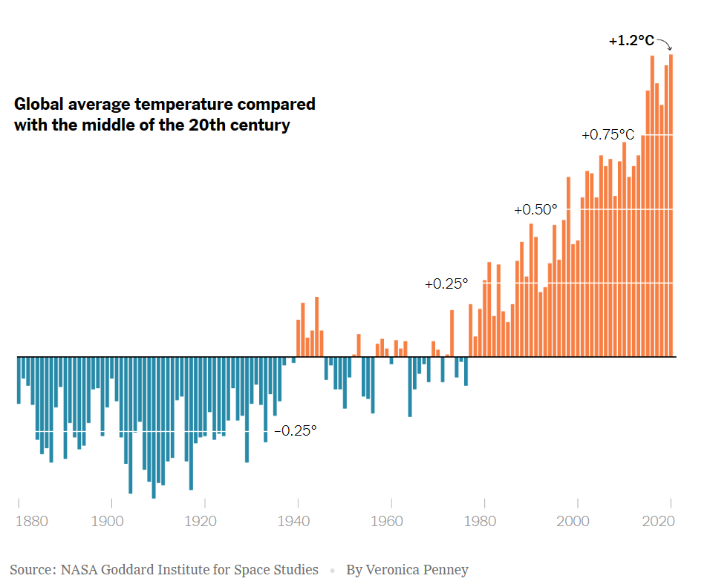

Document 3
This excerpt is from a report by the Intergovernmental Panel on Climate Change (IPCC), a global scientific body that provides policymakers with regular scientific assessments on climate change, its implications, and potential risks.
Source: Intergovernmental Panel on Climate Change. “Climate Change 2022: Impacts, Adaptation, and Vulnerability.” Contribution of Working Group II to the Sixth Assessment Report, 2022.
Climate-change impacts have become more frequent, intense and have affected many millions of people from every region and sector… Accelerating climate-change hazards pose significant risks to the well-being of populations and the natural, managed and human systems on which they depend. Addressing these risks has been made more urgent by delays due to misinformation about climate science that has sowed uncertainty and impeded recognition of risk.
Rhetoric and misinformation on climate change and the deliberate undermining of science have contributed to misperceptions of the scientific consensus, uncertainty, disregarded risk and urgency, and dissent.
Complex factors, including individual beliefs, ideology, world view, partisan identity as well as societal context, influence how the public, as well as professional groups, communities, and policymakers, perceive and understand climate change. While there is expert scientific consensus on anthropogenic climate change, rhetoric, misinformation, and politicization of science have contributed to misperceptions, polarization on the severity of impacts and risks to society, indecision and delayed action. This impedes adaptation efforts and inflates climate risks.

Document 4
Julia Rosen is a journalist with a PhD in geology. Her research involved studying ice cores from Greenland and Antarctica to understand past climate changes.
Source: Rosen, Julia. “The Science of Climate Change Explained: Facts, Evidence and Proof.” The New York Times. April 19, 2021.
During the Industrial Revolution, people started burning coal and other fossil fuels to power factories, smelters, and steam engines. This added more greenhouse gases to the atmosphere. Ever since, human activities have been heating the planet.
We know this is true thanks to an overwhelming body of evidence. This evidence begins with temperature measurements taken at weather stations and on ships starting in the mid-1800s. Later, scientists began tracking surface temperatures with satellites and looking for clues about climate change in geologic records. Together, these data all tell the same story: Earth is getting hotter.
Average global temperatures have increased by 2.2 degrees Fahrenheit, or 1.2 degrees Celsius, since 1880, with the greatest changes happening in the late 20th century.
…
This warming is unprecedented in recent geologic history. A famous illustration of this was first published in 1998 and is often called the hockey-stick graph. The graph shows how temperatures remained fairly flat for centuries (the shaft of the stick) before turning sharply upward (the blade). It’s based on data from tree rings, ice cores and other natural indicators. The basic picture has withstood decades of scrutiny from climate scientists and contrarians alike. It shows that Earth is hotter today than it’s been in at least 1,000 years, and probably much longer.
…
When it comes to climate change, there is virtually no debate: Numerous studies have found that more than 90 percent of scientists who study Earth’s climate agree that the planet is warming and that humans are the primary cause.
…
Currently, more than 97 percent of publishing climate scientists agree on the existence and cause of climate change (as does nearly 60 percent of the general population of the United States).

Document 5
This excerpt is from Article 4 of the Paris Agreement, an international treaty addressing climate change signed by 195 countries.
Source: United Nations Framework Convention on Climate Change, “Paris Agreement. UNFCCC.int. December 12, 2015.
In order to achieve the long-term temperature goal set out in Article 2 [1.5°C above pre-industrial levels], Parties aim to reach global peaking of greenhouse gas emissions as soon as possible, recognizing that peaking will take longer for developing country Parties, and to undertake rapid reductions thereafter in accordance with best available science, so as to achieve a balance between anthropogenic emissions by sources and removals by sinks of greenhouse gases in the second half of this century, on the basis of equity, and in the context of sustainable development and efforts to eradicate poverty.

Document Analysis Tool
Directions: Use the chart to take notes and keep track of the sources as you read.
Source title | Main point of the text | How does this document support, extend, or challenge the argument you hope to make?

