Preparation
- Print and cut out the Supporting Statement Cards
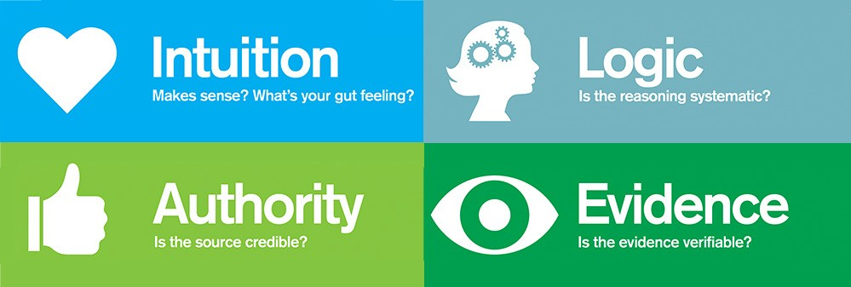
Purpose
Claim testing is an important analytical process for assessing the quality and veracity of claims. It helps you “see” and evaluate people’s assertions and gives shape an important and useful critical thinking practice. It’s important to learn the skill of testing claims early and use it frequently as part of evaluating claims that people make about climate change and the evidence they use to support these claims. Through use of this process, you will become familiar with the language of claim testing, which you should begin to use as part of accountable talk in the classroom.

Process
- First, review the definitions of the claim testers:
  - Intuition—We look for intuition to test some claims. Intuition is often a gut feeling, something we experience when the support for the claim just “seems” right.
  - Authority—This is when we accept information or data from a credible or believable source.
  - Logic—Sometimes we test claims by carefully thinking about something to see if it makes sense.
  - Evidence—The available information we gather up. Remember, evidence is an interesting word because it comes from evident: to be able to see something.

- In a little while, you’ll read some supporting statements for a claim and you’ll categorize the statements by claim tester. But first, your teacher will walk through an example to make sure you’ve got a good grasp of the claim testers. Here’s the practice statement:
Earth’s climate has changed throughout history. Just in the last 800,000 years, there have been eight cycles of ice ages and warmer periods. (Source: NASA)
Which claim tester is being used in the above statement? Discuss with your class.
- Now, keeping the claim testers in mind, evaluate this claim: The Earth’s temperature always goes up and down in a natural pattern.
Unless otherwise noted, this work is licensed under CC BY 4.0. Credit: “Claim Testing—Introduction”, OER Project, https://www.oerproject.com/
- Your teacher will divide you into groups. Together, decide which supporting statement matches up with which claim tester, and place each supporting statement in the appropriate quadrant of the grid your teacher has posted. If you can’t decide which statement fits which claim tester exactly, you can overlap.
- Discuss your group’s categorizations with the class.
- Come up with statements or counterclaims that might help refute the claim that the Earth’s temperature always goes up and down in a natural pattern.
- Write a statement about what you believe about the claim.


Claim Cards
Geological records such as ice core samples and ocean sediment show that temperatures have warmed and cooled in the past. | Last winter we got a huge blizzard, so things can’t be warming up too much. | I don’t see how humans could change the conditions enough to have a significant impact on temperature.
“Over at least the past million years, [warming and cooling] cycles have been triggered by variations in how much sunlight reaches the Northern Hemisphere in the summer, which are driven by small variations in the geometry of Earth’s axis and its orbit around the Sun.”  —David Herring, NOAA  Climate Program Office | It feels risky to interfere with the natural cycles of the Earth. | In the year 539 or 540 CE, the Ilopango volcano in El Salvador erupted violently. Volcanic sulfur from the eruption triggered a roughly 2-degree Celsius temperature drop that lasted 20 years.
This feels right because we have four distinct seasons where I live. | My grandma always says, “You can’t control the weather.” | “Serbian scientist Milutin Milankovitch hypothesized the long-term, collective effects of changes in Earth’s position relative to the Sun are a strong driver of Earth’s long-term climate, and are responsible for triggering the beginning and end of glaciation periods (Ice Ages).”  —Alan Buis, NASA’s Jet  Propulsion Laboratory

