Purpose
Climate change is a heavy topic. This lesson gives us a chance to reflect on our perspectives on climate change. In this short activity, you’ll see how a shift in perspective can completely change the meaning of something.

Process
- Read the poem “Worst Day Ever?”
- Now, read it from the bottom to the top—that is, start with the last line and read up to the first line.
- Once you’re done reading the poem in both directions, think about how this poem can help us understand how people often interpret the same event in different ways. Can you think of a recent time when people had very different views of the same event or circumstances?
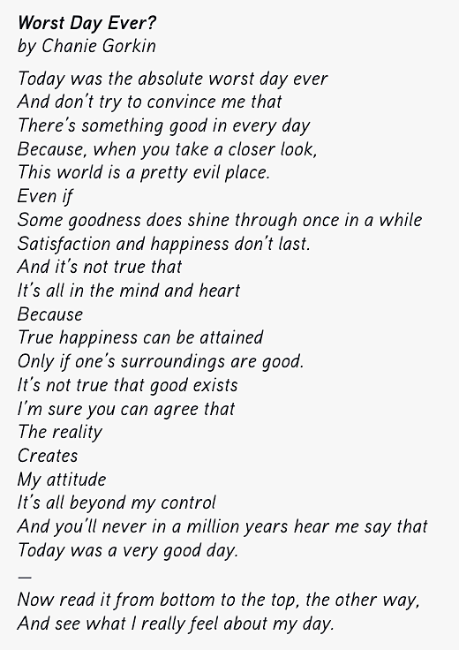
- Chat with a partner for a couple of minutes about your response.

