Name: |  | Date:

Purpose
  - Download the CP Writing Rubric

Purpose
This writing assessment is an opportunity for you to showcase your critical thinking, analysis, and argumentation skills. This will help you become better at making and supporting claims and may also help you on standardized assessments that ask you to analyze documents in response to a specific prompt.

Process
Day 1
- Before you begin, unpack the prompt so you have an understanding of what is being asked of you. A good strategy is to rewrite the prompt in your own words. This document-based question (DBQ) asks you to respond to this prompt: Develop an argument evaluating the extent to which climate change is impacting human and natural systems around the world. Rewrite the prompt in your own words here:
- One way to craft a solid response to a DBQ is to make sure each element of the ACE acronym is reflected in your response. Review the ACE acronym:
• Answer the prompt/make a claim
• Cite evidence
• Explain how the evidence supports the claim (often referred to as reasoning)
- Next, independently read the texts in the Document Library, which is included in the Impacts of Climate Change DBQ worksheet. As you read, write down or underline the information you think you might use in your essay along with any additional evidence from this unit. Write your ideas in the Document Analysis Tool, included with the worksheet, as you work through the documents.
- Then, create a major claim or thesis statement that responds to the prompt. The notes you have taken should help you create a thesis that you can support with evidence.
Day 2
This second day is the writing day. Remember to use information from the Document Library—along with other information you’ve learned in this unit—as evidence to support your arguments and counterclaims (opposing points of view). It’s also important to cite the sources you use as evidence in your essays. As you craft your essay, feel free to use notes from any prewriting work you completed.

Directions: Write a five- to six-paragraph essay in response to the prompt below. Make sure to use the documents provided to help support your argument.
We suggest you spend 10–15 minutes reading these documents and 35–45 minutes writing. Sources are edited for brevity and clarity.

Develop an argument evaluating the extent to which climate change is impacting human and natural systems around the world.

Document 1
This excerpt is from a report by the Intergovernmental Panel on Climate Change (IPCC), a global scientific body that provides policymakers with regular scientific assessments on climate change, its implications, and potential risks.
Source: Intergovernmental Panel on Climate Change. “Summary for Policymakers.” Climate Change 2022: Impacts, Adaptation and Vulnerability. Contribution of Working Group II to the Sixth Assessment Report. Cambridge University Press, Cambridge, UK, and New York, NY, USA, 2022.
Human-induced climate change, including more frequent and intense extreme events, has caused widespread adverse impacts and related losses and damages to nature and people, beyond natural climate variability. Across sectors and regions the most vulnerable people and systems are observed to be disproportionately affected. The rise in weather and climate extremes has led to some irreversible impacts as natural and human systems are pushed beyond their ability to adapt.
Widespread, pervasive impacts to ecosystems, people, settlements, and infrastructure have resulted from observed increases in the frequency and intensity of climate and weather extremes, including hot extremes on land and in the ocean, heavy precipitation events, drought and fire weather. These include increased heat-related human mortality, warm-water coral bleaching and mortality, and increased drought-related tree mortality. Observed increases in areas burned by wildfires have been attributed to human-induced climate change in some regions. Adverse impacts from tropical cyclones, with related losses and damages, have increased due to sea level rise and the increase in heavy precipitation. Impacts in natural and human systems from slow-onset processes such as ocean acidification, sea level rise or regional decreases in precipitation have also been attributed to human induced climate change.

Document 2
These images show a panoramic view of the terminus of Reid Glacier in Glacier Bay National Park and Preserve. The images were taken from the same vantage point approximately 100 years apart.
Source: Pope, Kristen. “Repeat Photography Shows Climate Change Impacts on Real Places.” Yale Climate Connections. February 1, 2022. Image Source: Upper photo: June 12, 1899, G.K. Gilbert, U.S. Geological Survey. Lower photo: June 27, 2004, Ron Karpilo.
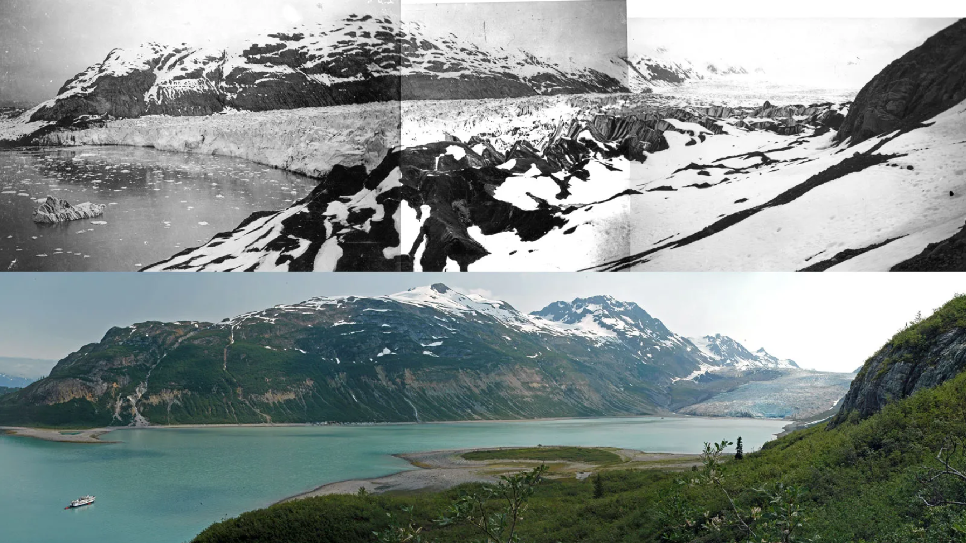

Document 3
Source: Wallace-Wells, David. “The Uninhabitable Earth.” New York Magazine. July 10, 2017.
What follows is not a series of predictions of what will happen—that will be determined in large part by the much-less-certain science of human response. Instead, it is a portrait of our best understanding of where the planet is heading absent aggressive action.
By the end of the century, the World Bank has estimated, the coolest months in tropical South America, Africa, and the Pacific are likely to be warmer than the warmest months at the end of the 20th century. Air-conditioning can help but will ultimately only add to the carbon problem; plus, the climate-controlled malls of the Arab emirates aside, it is not remotely plausible to wholesale air-condition all the hottest parts of the world, many of them also the poorest. And indeed, the crisis will be most dramatic across the Middle East and Persian Gulf, where in 2015 the heat index registered temperatures as high as 163 degrees Fahrenheit.
Climates differ and plants vary, but the basic rule for staple cereal crops grown at optimal temperature is that for every degree of warming, yields decline by 10 percent. Some estimates run as high as 15 or even 17 percent. Which means that if the planet is five degrees warmer at the end of the century, we may have as many as 50 percent more people to feed and 50 percent less grain to give them.
Drought might be an even bigger problem than heat, with some of the world’s most arable land turning quickly to desert. By 2080, without dramatic reductions in emissions, southern Europe will be in permanent extreme drought, much worse than the American dust bowl ever was. The same will be true in Iraq and Syria and much of the rest of the Middle East; some of the most densely populated parts of Australia, Africa, and South America; and the breadbasket regions of China. None of these places, which today supply much of the world’s food, will be reliable sources of any.
Climatologists are very careful when talking about Syria. They want you to know that while climate change did produce a drought that contributed to civil war, it is not exactly fair to say that the conflict is the result of warming; next door, for instance, Lebanon suffered the same crop failures. But researchers have managed to quantify some of the non-obvious relationships between temperature and violence: For every half-degree of warming, they say, societies will see between a 10 and 20 percent increase in the likelihood of armed conflict. In climate science, nothing is simple, but the arithmetic is harrowing: A planet five degrees warmer would have at least half again as many wars as we do today. Overall, social conflict could more than double this century.

Document 4
Source: “Are Natural Disasters Actually Natural?” Crash Course Climate & Energy #9. March 22, 2023.
From 2010 to 2015, the Rakhine State in Myanmar was pummeled by severe weather events. A cyclone swept through in 2010. Floods destroyed about 1.7 million tons of rice in 2011, making scarce a primary staple of the country’s diet. And in 2015, there was even more serious flooding. Events like these are becoming more frequent and more severe because of climate change.
But they don't affect everyone equally. In Rakhine, a group called the Rohingya were some of the hardest hit —and not just by the floods. The Rohingya are Muslims in a Buddhist-majority state, and they had been discriminated against by the government for decades.
When these storms made resources scarce, instead of being seen as neighbors, the Rohingya were seen as competitors. This fueled violence and deepened inequalities against the Rohingya. Since 2017, nearly a million have fled their homes and become refugees.
To be clear: climate change did not on its own cause this violence. People did. If we could remove people from climate change — and just think about how greenhouse gases are trapping more heat—well, that would be a lot simpler. What is complex about climate change is, well, us. Because when the effects of climate change impact communities all around the world, those impacts layer right on top of preexisting cultural, political, and economic contexts.

Document 5
This graph shows annual deaths from malaria, which rose about 8% between 2019 and 2021—the first increase in decades. Malaria deaths are rising for two main reasons. First, mosquitoes have evolved to resist the strategies to combat them that once worked. Second, warming temperatures have expanded the areas where disease-carrying mosquitoes can thrive.
Source: “The Mosquitoes Are Winning.” The New York Times, September 29, 2023. Graph data source: Our World in Data.
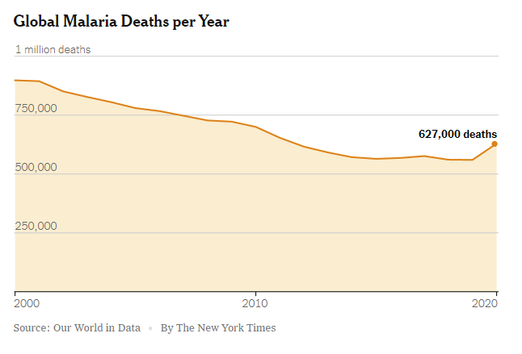

Document 6
Source: “Climate Change Impacts.” National Oceanic and Atmospheric Association. NOAA.gov. August 13, 2021.
Climate change will continue to have a significant impact on ecosystems and organisms, though they are not impacted equally. The Arctic is one of the ecosystems most vulnerable to the effects of climate change, as it is warming at least twice the rate of the global average and melting land ice sheets and glaciers contribute dramatically to sea level rise around the globe.
Some living things are able to respond to climate change; some plants are blooming earlier and some species may expand their geographic range. But these changes are happening too fast for many other plants and animals as increasing temperatures and changing precipitation patterns stress ecosystems. Some invasive or nuisance species, like lionfish and ticks, may thrive in even more places because of climate change.
Changes are also occurring in the ocean. The ocean absorbs about 30% of the carbon dioxide that is released into the atmosphere from the burning of fossil fuels. As a result, the water is becoming more acidic, affecting marine life. Sea levels are rising due to thermal expansion, in addition to melting ice sheets and glaciers, putting coastal areas at greater risk of erosion and storm surge.
The compounding effects of climate change are leading to many changes in ecosystems. Coral reefs are vulnerable to many effects of climate change: warming waters can lead to coral bleaching, stronger hurricanes can destroy reefs, and sea level rise can cause corals to be smothered by sediment. Coral reef ecosystems are home to thousands of species, which rely on healthy coral reefs to survive.

Document Analysis Tool
Directions: Use the chart to take notes and keep track of the sources as you read.
Source title | Main point of the text | How does this document support, extend, or challenge the argument you hope to make?

