Name: |  | Date:

Purpose
  - Download the CP Writing Rubric

Purpose
This writing assessment is an opportunity for you to showcase your critical thinking, analysis, and argumentation skills. This will help you become better at making and supporting claims and may also help you on standardized assessments that ask you to analyze documents in response to a specific prompt.

Process
Day 1
- Before you begin, unpack the prompt so you have an understanding of what is being asked of you. A good strategy is to rewrite the prompt in your own words. This document-based question (DBQ) asks you to respond to this prompt: Develop an argument that evaluates the extent to which climate innovation is necessary for effectively and equitably responding to climate change. Rewrite the prompt in your own words here:
- One way to craft a solid response to a DBQ is to make sure each element of the ACE acronym is reflected in your response. Review the ACE acronym:
• Answer the prompt/make a claim
• Cite evidence
• Explain how the evidence supports the claim (often referred to as reasoning)
- Next, independently read the texts in the Document Library, which is included in the Adaptation and Innovation DBQ worksheet. As you read, write down or underline the information you think you might use in your essay along with any additional evidence from this unit. Write your ideas in the Document Analysis Tool, included with the worksheet, as you work through the documents.
- Then, create a major claim or thesis statement that responds to the prompt. The notes you have taken should help you create a thesis that you can support with evidence.
Day 2
This second day is the writing day. Remember to use information from the Document Library—along with other information you’ve learned in this unit—as evidence to support your arguments and counterclaims (opposing points of view). It’s also important to cite the sources you use as evidence in your essays. As you craft your essay, feel free to use notes from any prewriting work you completed.

Directions: Write a five- to six-paragraph essay in response to the prompt below. Make sure to use the documents provided to help support your argument.
We suggest you spend 10–15 minutes reading these documents and 35–45 minutes writing. Sources are edited for brevity and clarity.

Develop an argument that evaluates the extent to which climate innovation is necessary for effectively and equitably responding to climate change.

Document 1
Source: “Adapting to a Warmer World, Solving for Zero: The Search for Climate Innovation.” Wondrium. 2022.
The ability to grow food as weather conditions change is something we all depend on, but for smallholder farms the stakes are especially high: if a crop fails, the result can be much more than just losing food and income, it could mean losing a way of life.
An organization whose mission is to help ensure that farmers can better adapt to the effects of climate change is a Consultative Group for International Agriculture Research (or One CGIAR, as it’s now known).
They work together with a variety of stakeholders to transform food, land, and water systems under a climate crisis. They work to make sure their research benefits millions of people in food systems around the world.
Of all the projects One CGIAR has initiated for adapting to climate change, their work on developing drought tolerant and stress tolerant maize, or corn, are among the most significant. Maize is one of the most important cereals around the world.
Just to give you an idea of the magnitude of this, 1.2 billion people in sub-Saharan Africa and Latin America consume maize and it’s one of the most important sources of food on their plates. It provides 30% of the calorie uptake of these households. It’s also used to feed animals.
Drought was one of the most significant things that was decreasing the productivity of maize in many countries.
So this was a long-term project in terms of funding, in terms of capacity building, which is very important, and in terms of providing the right incentive so that the farmers would use the varieties that were developed by the CGIAR.
At the end of the day, they developed more than 200 new maize varieties that were resilient to drought and that benefited around 48 million African people.

Document 2
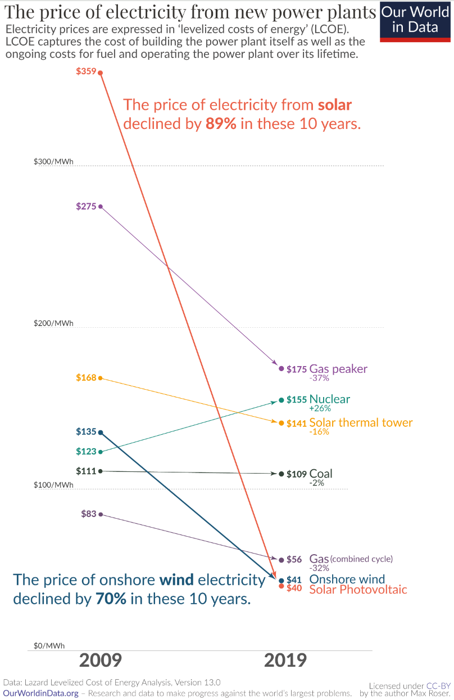
Source: Roser, Max. “Why Did Renewables Becomes So Cheap So Fast?” Our World in Data. December 1, 2020.

Document 3
Source: Breakthrough Energy. “The Green Premium.” 2022.
The Green Premium is the additional cost of choosing a clean technology over one that emits more greenhouse gases. Right now, clean solutions are usually more expensive than high-emissions ones, in part because we don’t factor the true economic and environmental costs of existing options like fossil fuels into the price we pay for them.
Moving our immense energy economy to net-zero solutions will cost something—but with the right policies and focus, we can lower the Green Premium. Ultimately, we need that premium to be so low that everyone everywhere can choose the clean alternative.
For some technologies, the Green Premium may be too high to pay. In those cases, we need to focus the greatest amount of research and development investment on reducing that premium and making those clean options more affordable as quickly as possible.
Cement, for example, is especially difficult, as it produces CO₂ not just from burning fossil fuels for heat, but also as a byproduct resulting from the chemical reactions required to make it. In this case, the Green Premium shows us we need more innovation in carbon capture and in cement production.
There are three ways to lower Green Premiums and make the transition to zero.
- Governments can implement public policies that make carbon-based technologies more expensive, or make the clean counterparts cheaper—or, ideally, do both. These policies can include rules about how much carbon a technology can emit, regulations that shape financial markets, and public investments in research and development.
- Companies and investors, meanwhile, can commit to buying cleaner alternatives to help drive their costs down, investing in research and development, supporting clean energy startups, and advocating for government policies that bring down the cost of getting to zero.
- Individuals can play a role, too. We can hold our elected officials accountable, and we can vote with our wallets. For example, when we buy an electric vehicle even though it may cost more, we show there is demand for these cleaner technologies, and if companies make more, we’ll buy them.

Document 4
Source: Vidangos, Natasha. “More than a Buzzword: Here’s Why Climate Innovation Matters.” Environmental Defense Fund. February 2023.
We’ve seen remarkable progress in clean energy in recent years. New data finds that 2022 was the first year when global investment in the world’s transition to clean energy matched investment in fossil fuels. It’s proof that powerful climate tools at hand today — like solar and wind power, battery storage, and zero-emission transportation — are gaining momentum and can ramp up even faster.
But in our journey to stabilize our climate, we’re also facing challenges for which we don’t have all the answers today. To achieve our global climate goals and secure the strongest possible future, studies by climate scientists find that we’ll need new solutions that aren’t ready for the market — yet.
This is where climate innovation comes in. Simply put, climate innovation is the process of creating, testing and scaling up new climate solutions. Climate innovation can take many forms, ranging from technologies to policy approaches. And many areas of our economy need climate innovation. We’ve leveraged this innovation process before with the power of governments, the private sector and communities — and we’ll need to do more.
We’ll need supportive government policies at every step of the innovation process to bring new solutions to the forefront safely and equitably. In the U.S., recent investments from historic climate laws offer an unprecedented opportunity to test emerging technologies that could address pollution from industry.
The private sector also has a lot of potential to ramp up new solutions across industries and supply chains. A recent report found that more than a quarter of all venture capital funding is invested in climate technology.
And critically, communities that have a stake in these solutions need to be involved in the innovation process, so that new technologies benefit everyone.

Document 5
Source: International Energy Agency. “Net Zero Roadmap: A Global Pathway to Keep the 1.5° C Goal in Reach.” 2023.
In order to achieve the long-term temperature goal set out in Article 2 [1.5°C above pre-industrial levels], Parties aim to reach global peaking of greenhouse gas emissions as soon as possible, recognizing that peaking will take longer for developing country Parties, and to undertake rapid reductions thereafter in accordance with best available science, so as to achieve a balance between anthropogenic emissions by sources and removals by sinks of greenhouse gases in the second half of this century, on the basis of equity, and in the context of sustainable development and efforts to eradicate poverty.

Document Analysis Tool
Directions: Use the chart to take notes and keep track of the sources as you read.
Source title | Main point of the text | How does this document support, extend, or challenge the argument you hope to make?

