Name: |  | Date:

Purpose
  - Download the CP Writing Rubric

Purpose
This writing assessment is an opportunity for you to showcase your critical thinking, analysis, and argumentation skills. This will help you become better at making and supporting claims and may also help you on standardized assessments that ask you to analyze documents in response to a specific prompt.

Process
Day 1
- Before you begin, unpack the prompt so you have an understanding of what is being asked of you. A good strategy is to rewrite the prompt in your own words. This document-based question (DBQ) asks you to respond to this prompt: Develop an argument that evaluates the extent to which tree planting is a solution to climate change. Rewrite the prompt in your own words here:
- One way to craft a solid response to a DBQ is to make sure each element of the ACE acronym is reflected in your response. Review the ACE acronym:
• Answer the prompt/make a claim
• Cite evidence
• Explain how the evidence supports the claim (often referred to as reasoning)
- Next, independently read the texts in the Document Library, which is included in the Climate Solutions DBQ worksheet. As you read, write down or underline the information you think you might use in your essay along with any additional evidence from this unit. Write your ideas in the Document Analysis Tool, included with the worksheet, as you work through the documents.
- Then, create a major claim or thesis statement that responds to the prompt. The notes you have taken should help you create a thesis that you can support with evidence.
Day 2
This second day is the writing day. Remember to use information from the Document Library—along with other information you’ve learned in this unit—as evidence to support your arguments and counterclaims (opposing points of view). It’s also important to cite the sources you use as evidence in your essays. As you craft your essay, feel free to use notes from any prewriting work you completed.

Directions: Write a five- to six-paragraph essay in response to the prompt below. Make sure to use the documents provided to help support your argument.
We suggest you spend 10–15 minutes reading these documents and 35–45 minutes writing. Sources are edited for brevity and clarity.

Develop an argument that evaluates the extent to which tree planting is a solution to climate change.

Document 1
Jerry Melillo is a scientist at the Marine Biological Laboratory and a professor of biology at Brown University.
Source: Melillo, Jerry. “Forests and Climate Change.” MIT Climate Portal, October 2021.
Forests cover about 30% of the Earth’s land surface. As forests grow, their trees take in carbon from the air and store it in wood, plant matter, and under the soil. If not for forests, much of this carbon would remain in the atmosphere in the form of carbon dioxide (CO2), the most important greenhouse gas driving climate change.
Each year since 2000, forests are estimated to have removed an average of 2 billion metric tons of carbon from the atmosphere. This “carbon sink function” of forests is slowing climate change by reducing the rate at which CO2, mainly from fossil fuel burning, builds up in the atmosphere. Careful forest management can therefore be an important strategy to help address climate change in the future. Healthy forests also provide a host of other benefits, from clean water to habitat for plants and animals that can live nowhere else.

Document 2
Source: Climate Interactive. “Trillion Trees: Calculating the Mitigation Potential in the En-Roads Simulator.” August 2023.

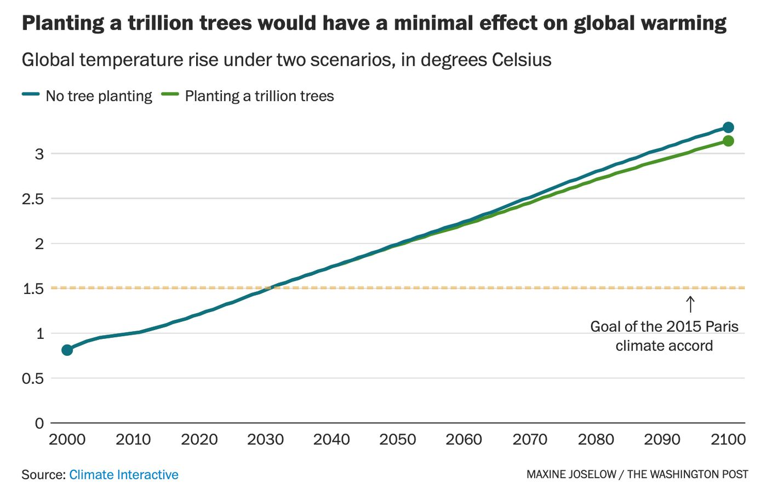

Document 3
This excerpt is from a report by the European Academies Science Advisory Council, a group of scientists from across Europe that advise European policymakers on scientific issues.
Source: European Academies Science Advisory Council. “Negative Emission Technologies: What Role in Meeting Paris Agreement Targets?” EASAC Policy Report 35. Leopoldina: German National Academy of Sciences, 2018.
Afforestation [the process of establishing a forest in an area where there was one before] and reforestation [the process of reestablishing a forest in an area where one had previously existed] absorb CO2 through plant growth. A positive point is that these are existing ‘technologies’ which can be applied at low cost. A negative point is that to absorb gigatonne quantities of CO2, large (and ever-increasing) areas would be required to absorb CO2 through forest growth (or regrowth).
Potential problems exist in the release of stored carbon during the disruption of planting or land-use change, nitrous oxide emissions where increased amounts of fertilizer are used, and effects on biodiversity. Forests and associated changes in land use may also affect climate through increased evapotranspiration, changes in cloud cover, and reflectance of solar radiation. There are also concerns over the availability of land against competition for food with a growing global population and vulnerability of the captured carbon to harvesting (legal and illegal logging), fires, pests and diseases. Carbon stored in living biomass may not be secure, and necessary measures and resources would need to be applied to protect and maintain expanding forest. Water requirements could be an important limit, particularly in dry region.

Document 4
Catrin Einhorn reports on climate, wildlife, and extinction for The New York Times. She was part of a team of reporters that won a Pulitzer Prize for Public Service in 2018.
Source: Einhorn, Catrin. “Tree Planting Is Booming. Here’s How That Could Help, or Harm, the Planet.” The New York Times. March 14, 2022.
As the climate crisis deepens, businesses and consumers are joining nonprofit groups and governments in a global tree planting boom. Last year saw billions of trees planted in scores of countries around the world. These efforts can be a triple win, providing livelihoods, absorbing and locking away planet-warming carbon dioxide, and improving the health of ecosystems.
But when done poorly, the projects can worsen the very problems they were meant to solve. Planting the wrong trees in the wrong place can actually reduce biodiversity, speeding extinctions and making ecosystems far less resilient.
Amid that worsening crisis, companies and countries are increasingly investing in tree planting that carpets large areas with commercial, nonnative species in the name of fighting climate change. These trees sock away carbon but provide little support to the webs of life that once thrived in those areas.
There is not enough land on Earth to tackle climate change with trees alone, but if paired with drastic cuts in fossil fuels, trees can be an important natural solution. They absorb carbon dioxide through pores in their leaves and stash it away in their branches and trunks (though trees also release carbon when they burn or rot). That ability to collect CO2 is why forests are often called carbon sinks.

Document 5
Source: Guterres, António. “Secretary-General’s Address at Columbian University: ‘The State of the Planet.’” United Nations. December 2, 2020.
One of our best allies is nature itself. Drastically reducing deforestation and systemically restoring forests and other ecosystems is the single largest nature-based opportunity for climate mitigation.
Indeed, nature-based solutions could provide one third of the net reductions in greenhouse gas emissions required to meet the goals of the Paris Agreement. The World Economic Forum has estimated that business opportunities across nature could create 191 million jobs by 2030.

Document 6
Rob Jordan writes about the environment and sustainability for the Stanford Woods Institute for the Environment.
Source: Jordan, Rob. “When Planting Trees Threatens the Forest.” Stanford News. June 22, 2020.
There is no question that forests have an outsized role to play in efforts to slow global biodiversity loss and combat climate change by sequestering carbon as biomass. So it makes sense that tree-planting as a solution has gained traction in recent years with ambitious commitments, such as the Bonn Challenge, which seeks to restore an area of forest more than eight times the size of California by 2030, and Trillion Trees, which seeks to plant as many trees as its name implies.
A closer look reveals faults in the optimistic plans. For example, nearly 80 percent of commitments to the Bonn Challenge involve planting monoculture tree plantations or a limited mix of trees that produce products such as fruit and rubber rather than restoring natural forests. Plantations typically have significantly less potential for carbon sequestration, habitat creation and erosion control than natural forests. The potential benefit dwindles further if planted trees replace natural forests, grasslands or savannahs—ecosystems that have evolved to support unique, local biodiversity.

Document Analysis Tool
Directions: Use the chart to take notes and keep track of the sources as you read.
Source title | Main point of the text | How does this document support, extend, or challenge the argument you hope to make?

