Name: |  | Date:

Purpose
  - Download the CP Writing Rubric

Purpose
This writing assessment is an opportunity for you to showcase your critical thinking, analysis, and argumentation skills. This will help you become better at making and supporting claims and may also help you on standardized assessments that ask you to analyze documents in response to a specific prompt.

Process
Day 1
- Before you begin, unpack the prompt so you have an understanding of what is being asked of you. A good strategy is to rewrite the prompt in your own words. This document-based question (DBQ) asks you to respond to this prompt: Develop an argument that evaluates the key solutions to decarbonization and the most effective ways to support these solutions. Rewrite the prompt in your own words here:
- One way to craft a solid response to a DBQ is to make sure each element of the ACE acronym is reflected in your response. Review the ACE acronym:
• Answer the prompt/make a claim
• Cite evidence
• Explain how the evidence supports the claim (often referred to as reasoning)
- Next, independently read the texts in the Document Library, which is included in the Decarbonization DBQ worksheet. As you read, write down or underline the information you think you might use in your essay along with any additional evidence from this unit. Write your ideas in the Document Analysis Tool, included with the worksheet, as you work through the documents.
- Then, create a major claim or thesis statement that responds to the prompt. The notes you have taken should help you create a thesis that you can support with evidence.
Day 2
This second day is the writing day. Remember to use information from the Document Library—along with other information you’ve learned in this unit—as evidence to support your arguments and counterclaims (opposing points of view). It’s also important to cite the sources you use as evidence in your essays. As you craft your essay, feel free to use notes from any prewriting work you completed.

Directions: Write a five- to six-paragraph essay in response to the prompt below. Make sure to use the documents provided to help support your argument.
We suggest you spend 10–15 minutes reading these documents and 35–45 minutes writing. Sources are edited for brevity and clarity.

Develop an argument that evaluates the key solutions to decarbonization and the most effective ways to support these solutions.

Document 1
Source: United Nations Environmental Programme. “The Sectoral Solution to Climate Change.” UNEP, 2023.
The only way to avoid catastrophic climate change is to rapidly cut our emissions of greenhouse gases. To keep the 1.5°C temperature target alive, the world needs to cut 2030 emissions by 42 percent. A little math tells us that to reach that target, we need to reduce our annual emissions by 22 gigatonnes of CO₂ equivalent. That might seem like a lot. But by focusing on key sectors, we can get there.
Agriculture, forestry and other land-based industries are responsible for about 22 percent of greenhouse gas emissions. They have an emission reduction potential of 13.6 gigatonnes annually. The world can reduce emissions by 7.3 gigatonnes annually if it halts deforestation, ecosystem degradation and restores ecosystems. These actions would also improve air quality, bolster food and water security and shore up rural economies. They could also reduce biodiversity loss.
The global energy supply system—which includes the production of electricity and heat—is the largest single source of greenhouse gas emissions. It produces 20 gigatonnes of CO₂-eq per year. We can cut 12.6 gigatonnes of emissions annually from the sector by, in part, increasing renewable energy capacity and improving energy efficiency rate. This transition could also create millions of jobs, improve air quality, save consumers on their electricity bills and expand electricity access.
Greenhouse gas emissions from the industry sector in 2019 reached 14.1 gigatonnes or 24 percent of total emissions. The industrial sector has the potential to reduce its emissions by 5.4 gigatonnes yearly. It can do this, in part, by electrifying production processes and embracing new fuels. This will also require innovation in high-emission sectors like steel, cement, aluminium.
The transportation sector has the highest reliance on fossil fuels of any sector. It is responsible for 8.7 gigatonnes of emissions, or 15 percent of global total emissions. These emissions are set to double, growing faster than any other industry. Most of this growth will take place in the Global South, in countries already suffering disproportionately from high fuel prices. We could reduce emissions in the transportation sector by 3.8 gigatonnes annually by switching to electric vehicles, more fully embracing public transit and better designing cities to require less travel.
The construction and operation of the world’s buildings is responsible for 12 Gt of greenhouse gas emissions annually. They are responsible for 37 percent of energy and process-related carbon dioxide emissions. The emissions reduction potential in buildings is 0.7 gigatonnes for direct emissions and 2 Gt for direct and indirect emissions (electricity and heat). According to the IPCC, building sector mitigation policies can reduce greenhouse gas emissions by up to 90 percent in developed countries and up to 80 percent in developing countries. They can also help lift up to 2.8 billion people in developing countries out of energy poverty.

Document 2
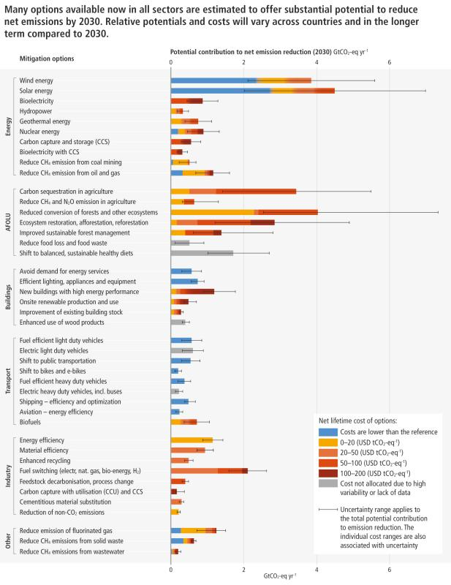
Source: Intergovernmental Panel on Climate Change. “Summary for Policymakers, Figure SPM.7.” AR6 Synthesis Report: Climate Change 2023, IPCC, 2023.

Document 3
Source: International Energy Agency. “Net Zero Roadmap: A Global Pathway to Keep the 1.5° C Goal in Reach.” 2023.
Achieving net zero emissions by 2050 will require nothing short of the complete transformation of the global energy system. By 2050, electricity will become the core of the energy system and will play a key role across all sectors, from transport and buildings to industry.
This will require huge increases in electricity system flexibility – such as batteries, demand response, hydrogen-based fuels, hydropower and more – to ensure reliable supplies. Renewable energy technologies like solar and wind are the key to reducing emissions in the electricity sector, which is today the single largest source of CO2 emissions. In our pathway to net zero, almost 90% of global electricity generation in 2050 comes from renewable sources, with solar PV and wind together accounting for nearly 70%.
We also need to drive huge leaps in clean energy innovation. Most of the reductions in CO2 emissions through 2030 come from technologies already on the market today. But in 2050, almost half the reductions come from technologies that are currently at the demonstration or prototype phase. Major innovation efforts must take place this decade in order to bring these new technologies to market in time. For example, carbon capture, utilization, and storage (CCUS) contributes to the transition to net zero in multiple ways. These include tackling emissions from existing energy assets, providing solutions in some of the sectors where emissions are hardest to reduce like cement, supporting the rapid scaling up of low‐emissions hydrogen production, and enabling some CO2 to be removed from the atmosphere.
Achieving this cleaner, healthier future will rely on a singular, unwavering focus from all governments, working closely with businesses, investors and citizens. It will also require greater international cooperation among countries, notably to ensure that developing economies have the financing and technologies they need to reach net zero in time.

Document 4
Source: Turrentine, Jeff. “What Are the Solutions to Climate Change?” Natural Resources Defense Council. December 2022.
It should go without saying that we, as individuals, are key to solving the climate crisis. This is not just by continuing to lobby our legislators and speak up in our communities but also by taking climate actions in our daily lives. By switching off fossil fuels in our homes and being more mindful of the climate footprint of the food we eat, our shopping habits, how we get around, our use of plastics and fossil fuels, and what businesses we choose to support (or not to support), we can move the needle.
But it’s when we act collectively that real change happens. It is how we can do even more than cut down on carbon pollution. Communities banding together have fought back fracking, pipelines, and oil drilling in people’s backyards. These local wins aren’t just good news for our global climate. They also protect the right to clean air and clean water for everyone. After all, climate change may be a global crisis but climate action starts in your own hometown.
We have a responsibility to consider the implications of our choices. We need to ensure that these choices are actually helping to reduce the burdens of climate change, not merely shifting them somewhere else. It’s important to remember that the impacts of climate change intersect with and intensify so many other environmental, economic, and social issues. These impacts fall disproportionately on certain communities, namely low-income communities and communities of color. That’s why our leaders have a responsibility to prioritize the needs of these communities when creating climate policies. If those on the frontlines aren’t a part of conversations around climate solutions, or do not feel the benefits of things like cleaner air and better job opportunities, then we are not addressing the roots of the climate crisis.

Document 5
Source: “Why Government Policies Matter, Solving for Zero: The Search for Climate Innovation,” Wondrium, 2022.
Is solving climate change challenging? It’s very challenging. Is it possible? Yes, it’s possible, but we need to know that the window of opportunity to do this is quickly closing so we don’t have much time to lose. To reach net zero emissions by 2050, we’ll need innovations across many sectors.
But innovation can be more than inventing a new technology. It can also mean coming up with new policies to help ideas out of the research and development phase and into the marketplace, or rewriting policies to ensure that the technologies we need can compete on a level playing field. Innovation is both new tools and new ways of doing things.
Government is in a unique position to help us reach our climate goals. It can fund the high-risk and potentially high- reward projects that the private sector typically does not because government can take chances on ideas and mega-size projects that might fail or might not pay off right away. And to increase the chances of success, government can also provide the long-term stability that these kinds of projects often need.
In addition to these critical roles, government has many other measures it can deploy: for instance, it can establish policies like a carbon tax or a cap and trade system to limit carbon emissions, as well as a carbon border adjustment tax to limit the presence of countries acting as free riders on the global stage. Each of these send strong signals about the need to limit greenhouse gases and can help to move us closer to net zero.
Finally, government has the power to assist people as we transition away from a fossil fuel-based economy by offering tax incentives for clean technology businesses to build new facilities near affected communities, or by providing retraining opportunities. Government can ensure that everyone can benefit as we address the challenges of climate change.

Document Analysis Tool
Directions: Use the chart to take notes and keep track of the sources as you read.
Source title | Main point of the text | How does this document support, extend, or challenge the argument you hope to make?

