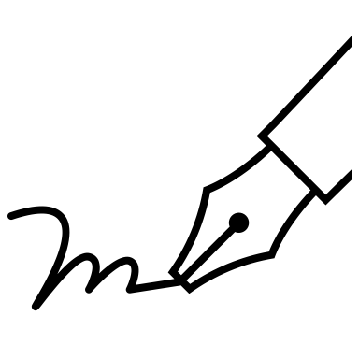
Purpose
We’ve learned a lot about the Grand Challenges in this lesson. Now, it’s time to assess the usefulness of this framework, which will help you to better understand these categories and how they can inform climate change solutions.

Process
For this informal writing activity, you’ll respond to the following questions:
- Is the Grand Challenge framework a helpful way to organize emission sources? Why or why not?
- What do you see as the possible benefits and challenges of working within this framework when it comes to reducing greenhouse gas emissions?
Teachers’ note: If time permits, have one or two students share their reflections with the class, or have students pair up and share with each other.

