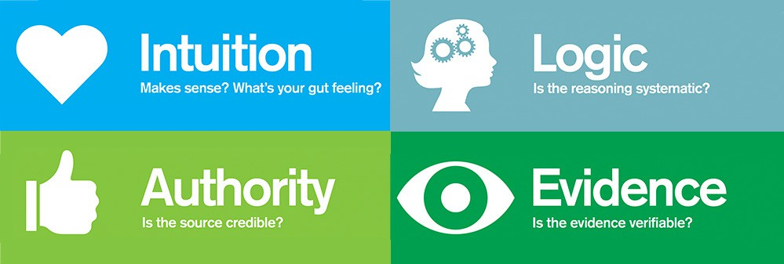
Preparation
Print and cut out the Supporting Statement Cards

Purpose
Claim testing is an important analytical process for assessing the quality and veracity (truthfulness) of claims. It helps you “see” and evaluate people’s assertions and gives shape to one of the most important and useful critical thinking practices in history. Since history is all about making assertions, it’s important that you learn the skill of testing claims early and use it frequently as part of evaluating historical accounts and making historical interpretations.

Process
- In this course, and in everyday life, we encounter assertions or claims. At times, we believe we can trust these claims, but more and more, it is important to question and test the claims that we come across. In this course, we use claim testers to help us check the soundness and strength of our beliefs. The four claim testers are intuition, authority, logic, and evidence.
- Look at the claim testing poster, and get ready to review each claim tester as a class.
- You’re going to evaluate the claim: “There is one true history.” What do you think it means? Do you agree or disagree with it and what led you to believe it or not believe it?
- Your teacher will give you a bunch of statements that support this claim. Your job will be to determine which supporting statements match which claim tester. Before starting, think about the following example with your class: The school board and the government require that we all take the same social studies classes.
- What claim tester do you think is being used in this supporting statement? Discuss your answer with the class.
- Get into small groups and sort the supporting statements cards into the four claim testing categories. You’ll tape each card to the grid your teacher created based on your categorizations.
- You will be asked to defend your categorizations at the end of the activity, especially for those supporting statements that were hard to place in just one claim tester category.
- See if you can come up with any statements or counterclaims that might help debunk the claim, “There is one true history.” Remember that this course encourages us to consider multiple accounts in history. We all have different perspectives, and that is often reflected in how history stories are told. So, while there might be different stories about the same thing, it’s not necessarily because one story is true, and another is false—it’s about our perspective. And often, the story that seems more true is just better supported via claim testers—and that is why you’ll be practicing claim testing all the time in this class.
- Finally, your teacher may share the Feedback Form they will use to evaluate your progress throughout the claim testing progression.

All textbooks are written by historians so they must be true. | “It is remarkable how closely the history of the apple tree is connected with that of man.”  Henry David Thoreau | Teachers wouldn’t teach us things that aren’t factual.
“We are made of star stuff.”  Carl Sagan | Things that are happening right now will be history in 50 years and we know they are true because we have pictures and proof of what is happening. | We have historical records from the invention of writing over 5,000 years ago to today — put it all together and we have one history.

This feels right because history is objective: It tells of things that happen without bias or emotion. | It seems strange to learn an untrue story in school. | My instinct tells me that there is obviously one true history.
If I were to tell my own story it would be true — seems like all history must be true. | I never read or hear things in history like “4 out of 5 historians agree” or “99% of historians believe,” which means they must all agree. | We have primary sources (such as pictures, diaries, and newspaper articles), so it must be true.

People say history is just like science—there is a right and wrong answer for everything. | We all have the same history because we’re all humans. | Everybody knows the history of our country so you can’t just make stuff up.
We’re in a “world history” class so there must be one history of the world. | It seems like we’re all interconnected in the world, so we must share a history. | We have the science to date things and know exactly when they happened, so we all have the same information.

