## Purpose

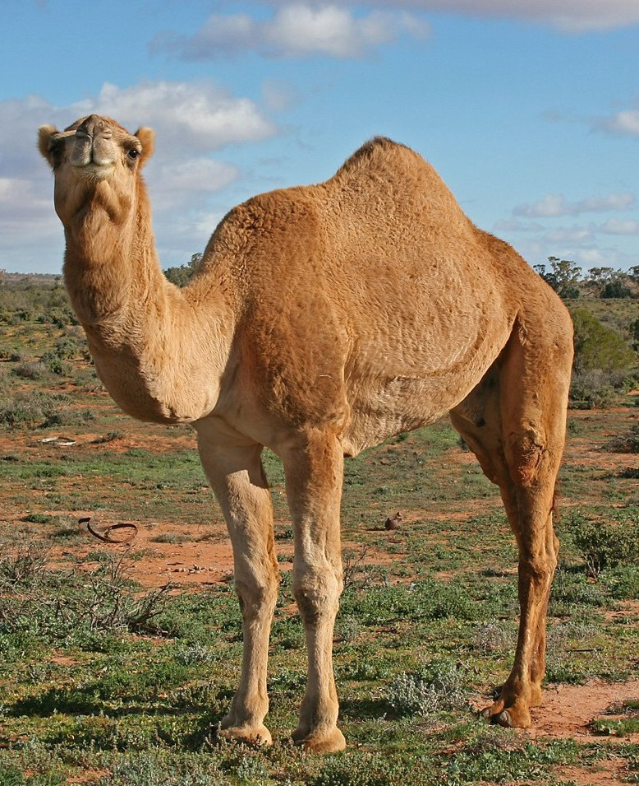In this first activity in the Causation Practice Progression, you’ll get familiar with different ways of understanding cause and consequence, and you’ll learn to use cause and consequence as analytical tools for understanding change over time. Historical events rarely have a single, proximate cause—some happen immediately before an event, some long before an event; some play a central role, and some merely contribute. Some causes may also be considered consequences, and the significance of the event may change depending on your framing of that event. In this activity, you will quickly learn about different types of causes.

Note that “Alphonse the Camel” is a story that was used in the Big History Project course, so you might be familiar with it. Although the story is being reused in this course, the way it’s being used is different, so be sure to pay close attention to the differences!

## Process

1. Start by reading the following story:

**Alphonse the Camel**

Once upon a time, there was a camel (called Alphonse). For various reasons (relating to an unfortunate accident during his birth) the camel had severe back problems. This was not the end of his misfortune, however, because he also had an evil, exploitative owner (called Frank the Camel Killer). Frank had hated camels ever since he experienced a nasty incident in his childhood involving a camel’s hoof and his rear end. He was very bitter and hadn’t trusted camels since.

Frank regularly overloaded his camels prior to taking them on grueling and totally unnecessary round trips up and down mountains on his way to deliver goods to his customers. These customers, shockingly, were completely indifferent to these frequent and gross violations of the rights of camels and even found Frank and his antics vaguely endearing. On top of it all, Alphonse was sometimes his own worst enemy. Camels are very proud creatures, and he would act tough in front of his camel friends, and on his rare breaks he would show off how much he could carry.

Plenty of camels had died doing similar work to Alphonse and his friends. After a particularly nasty few weeks when camels were keeling over left, right, and center, the camels decided to form a union to defend their rights and protect them from evil owners. However, when it comes down to it, camels are selfish creatures who don’t trust each other. They were more worried about looking after themselves than about working together, and the union soon fizzled out.

One Friday, Frank had just finished loading up Alphonse and his poor exploited fellow creatures for yet another grueling and totally unnecessary round trip up and down the mountains. He had piled and piled and piled up the goods onto Alphonse’s back and was taking a break, chewing a straw while thinking smugly about his handiwork. On a whim, he decided to add the bedraggled straw he had been chewing to Alphonse’s load. Alphonse groaned obligingly. He eyed his owner with disgust. He keeled over and died of radical and irreversible back collapse.

1. Now, list all the reasons you can think of for why Alphonse died.
2. Once you and your class have come up with a final list, write all the reasons on sticky notes or cards.
3. Arrange your stickies or cards into three different categories: short-, intermediate-, and long-term causes.
4. Once you’ve arranged your cards by timeframe, look at your short-term cards to identify the *triggering event* in the story. The triggering event is defined as the most immediate cause of an event. Be ready to share your categorizations with the class. You might notice that you didn’t categorize long-, intermediate-, and short-term causes the same way as some of your classmates. That’s OK! Our perspective—in this case, timeframe—can shift how we categorize the causes. Therefore, the definitions of long term, intermediate term, and short term vary and depend on the timeframe or periodization that you use to examine an event.
5. Finally, take a look at the Causation Tool (included in the Causation—Introduction worksheet), which is meant to help you categorize causes and consequences. Although you haven’t been introduced to everything on the tool quite yet, you will become familiar with *role*, *type*, and *effects* soon enough! You can use this tool to create a causal map or other representation of causation. Eventually, you will probably get so used to the tool that you won’t need it anymore. But for now, it will help as you get used to this type of historical analysis.

|  |  |  |  |
| --- | --- | --- | --- |
| Name: |  | Date: |  |

## Causation Tool

**Directions:** First, add the event you are analyzing (in the middle of the page). Be sure to include dates, location, and a brief description of the event. Then, list your causes (at the top of the page) and use the legend to help you label type and role. Finally, list the effects of the event (bottom of page), and again use the legend to help you label type and role. If your teacher asks you to create a causal map, use your answers here to help construct that causal representation.

|  |  |  |
| --- | --- | --- |
| Causes: Long-Term | Intermediate-Term | Short-Term |
|  |  |  |

|  |
| --- |
| Event (include the name, dates, location, and a brief description) |
|  |

|  |
| --- |
| Effects |
|  |

**Legend**

|  |  |
| --- | --- |
| **Type:** | **Role:** |
| (P) Political (I) Innovation ($) Economic (C) Cultural (E) Environmental (S) Social | (**\***) Triggering Event Necessary Relevant |