## Preparation

* Download [“The Chronometric Revolution”](https://www.oerproject.com/OER-Materials/OER-Media/HTML-Articles/Origins/Unit2/The-Chronometric-Revolution?Id=107&share=link) (use the default Lexile level for this activity)
* Download the [WHP Writing Rubric](https://www.oerproject.com/OER-Materials/OER-Media/PDFs/Teacher-Resources/WHP-Writing-Rubric)

## Purpose

Being able to write clearly and convincingly—to write well—helps us communicate our thinking and conclusions. Writing well will help you in many areas of life, and being a good writer is a prerequisite for being a good historical writer. Throughout the course, your historical writing is assessed at the end of each unit through a document-based question (DBQ). To help you become a better writer, we have included a series of rubric-based writing activities in this course. In this activity, you will learn more about the WHP Writing Rubric generally, and you’ll start to examine the areas of claim and focus more specifically as you begin your journey to become a more skilled writer.

## Practices

### Reading

You will read an article, and then identify its claim and focus. Each of the writing progression activities will involve some reading, which probably isn’t surprising, since reading and writing are often considered two sides of the same coin.

## Process

1. Did you know that grammar can save lives? Take a look at these two images, and you’ll see why.

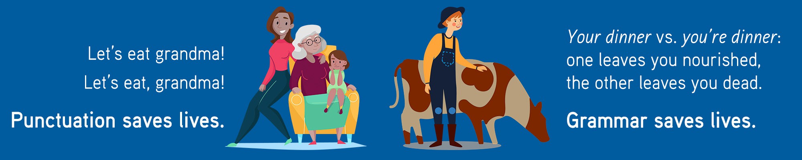

OK, these are silly, but they’re also a good reminder of why being able to write well is an important skill to develop. Throughout the course, you’re going to spend some time focusing on your writing skills. No, this is not your English language arts class, but being a writer who can communicate well is vital to being a historian. Most historians share their ideas through writing, and as student historians, you are asked to do the same. The next activity is a writing assignment, and it’s important that you understand what is expected of you when writing in this course.

1. Take out the WHP Writing Rubric and quickly review it. For this activity, you are going to pay close attention to the Claim and Focus section of the rubric. Review the criteria for claim and focus, and then think about the following questions and discuss them one by one with your class.
   * What is a claim?
   * What does a claim do in an essay?
   * Why should we care about claims?
   * What is a focused essay?
2. Once you’ve covered these concepts, review the article “The Chronometric Revolution,” which you may have read earlier in the course. First, find and circle the major claim in the article. Sometimes finding the claim is hard, and one thing that can help you identify it is to look at the focus of the article to help you figure it out. So, you’ll do that next.
3. Now it’s time to look for focus. The best way to do this is to look for any ideas that are repeated over and over again. Any time you find repeated ideas, underline them. Your teacher may have you do this in pairs or small groups.
4. Once you are done, share your thinking with the class.
5. Finally, would you give this article a grade of advanced, proficient, developing, or emerging based on the Claim and Focus criteria in the WHP Writing Rubric? Be prepared to share your thoughts and reasoning with your class.