Name: |  | Date:

Preparation
- Download "Regional Trade Networks"

Purpose
In this activity, you’ll apply the knowledge you acquired in the “Regional Trade Networks” article by mapping the networks it describes. This will help you better understand the networks frame and how communities are interconnected through trade and exchange. Mapping skills are important for increasing your geographic literacy and provide a visual representation of historical events and processes over time. Examining history through materials other than just text helps reinforce what you are learning.

Process
Regional trade networks in Afro-Eurasia and Mesoamerica connected societies across both of these areas. The exchange of people, goods, ideas, and diseases created interconnections and set the stage for the global connections that would follow. In this activity, you’ll map these exchange networks in order to create a visual representation of how they connected regions such as Afro-Eurasia and Mesoamerica.
First, your teacher will either hand out or have you download the Mapping Regional Trade Networks worksheet and the article “Regional Trade Networks.” Then, outline the area and label the following places on the worksheet maps:
- Mesopotamia (Fertile Crescent) including the Tigris and Euphrates Rivers
- Egypt and the Nile River Valley
- Indus River Valley including Harappa and Mohenjo-Daro
- China including the Yellow and Yangtze Rivers
- Silk Road trade networks
- Indian Ocean trade networks
- Teotihuacan
- Olmec society
- Maya society
- Mesoamerican trade networks
Next, read the article “Regional Trade Networks” and make a list of the goods traded between these societies. Create categories for your goods (for example, pepper and nutmeg could be categorized as spices), and then create symbols for each of these categories. Place these symbols on the map near where these goods originated. For example, the symbol for the category that obsidian fell into would be near the city of Teotihuacan. You should also create a legend (key) for these symbols.
Now, review the article for other items (tangible or intangible) that traveled across these routes. Create symbols for these additional items that moved across these regional exchange networks and add them to your maps. Be sure to also add these symbols to your legend.
Next, use the information in the article to answer the following questions.
- Why was the Afro-Eurasian network larger than the Mesoamerican one?
- How did these goods move along these routes (human or animal power; if animals, what types)?
- How did these networks change communities in these regions?
- How did rulers or societies benefit from trade?
Finally, review your maps and answer the following questions:
- What are the similarities and differences between these two regional exchange networks?
- How did these regional networks lay the foundation for the global networks that emerged later in the fifteenth century?
- How do you think these regional networks are both similar to and different from exchange networks that exist in these regions today?
- Be prepared to share your answers with the class. Your teacher will collect these completed worksheets and maps to assess your understanding of these historical processes.

Directions:
- Label the maps with the following places and either outline or shade the area for each of these societies.
  - Mesopotamia (Fertile Crescent) including the Tigris and Euphrates Rivers
  - Egypt and the Nile River Valley
  - Indus River Valley including Harappa and Mohenjo-Daro
  - China including the Yellow and Yangtze Rivers
  - Silk Road trade networks
  - Indian Ocean trade networks
  - Teotihuacan
  - Olmec society
  - Maya society
  - Mesoamerican trade networks
- Read the article “Regional Trade Networks” and make a list of all the goods that were exchanged across the networks. Create symbols to represent these goods and draw these on your maps near where these goods originated. Remember to create a legend for your symbols.
- Review the article for other items (tangible or intangible) that traveled across these routes. Create symbols for these additional items that moved across these regional exchange networks and add them to your maps. Add these symbols to your legend.
- Use the information in the article to answer the questions in Part 1 of the worksheet.
- Finally, review your maps and answer the questions in Part 2 of the worksheet.

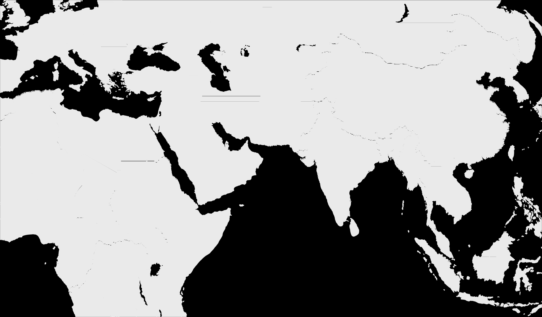
Legend

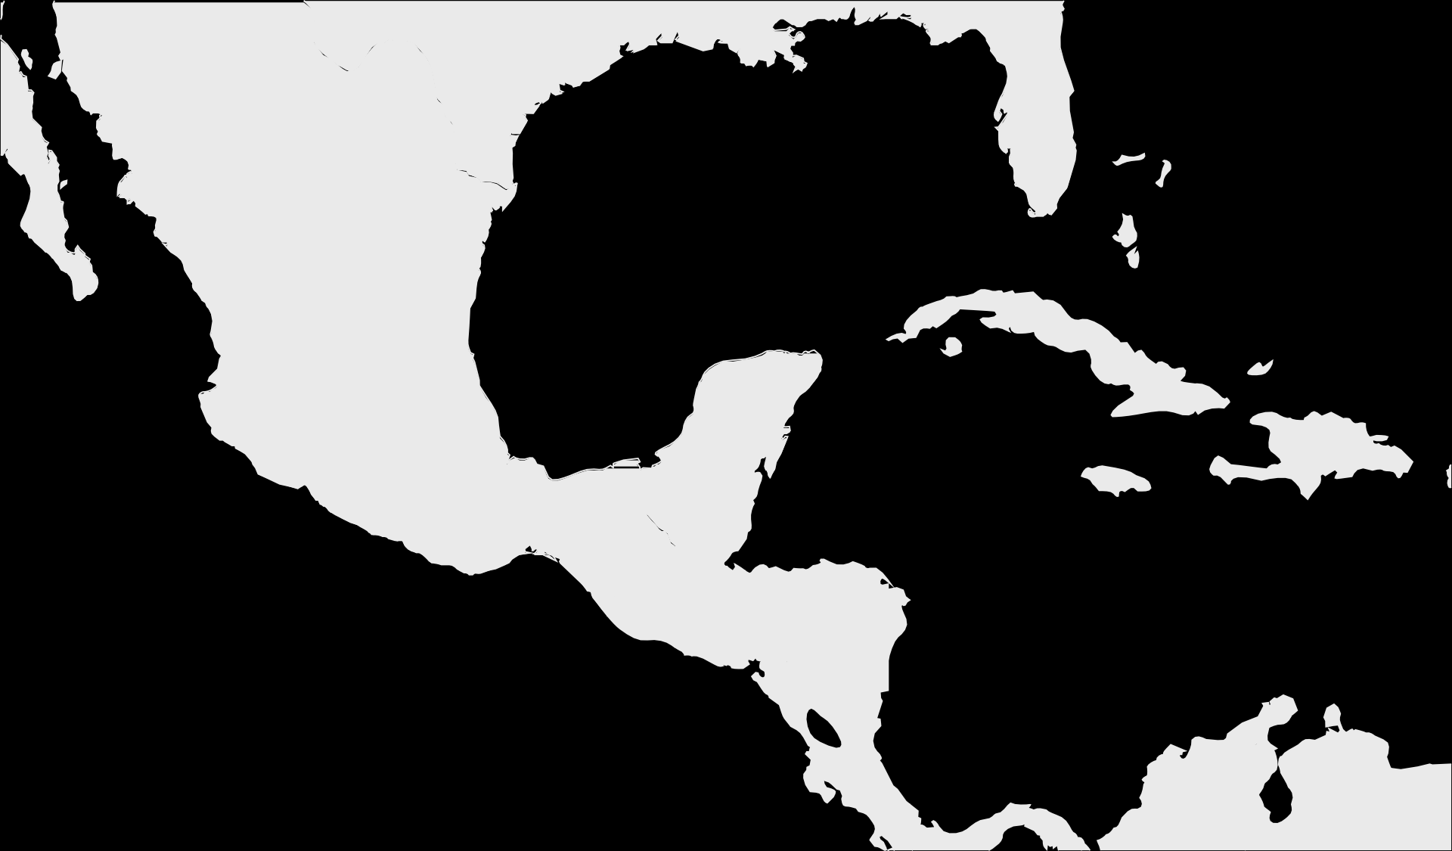
Legend

Part 1
Use the information in the article “Regional Trade Networks” to answer the questions that follow.
Why was the Afro-Eurasian network larger than the Mesoamerican one?
How did these goods move along these routes (human or animal power; if animals, what types)?
How did these networks change communities in these regions?
How did rulers or societies benefit from trade?

Part 2
Review your maps and then answer the questions that follow.
What are the similarities and differences between these two regional exchange networks?
How did these regional networks lay the foundation for the global networks that emerged later in the fifteenth century?
How do you think these regional networks are both similar to and different from exchange networks that exist in these regions today?

