## Purpose

Historical events are usually complicated and rarely have one cause. In fact, they often have multiple causes, some of which occur long before the event while others happen right before the event took place. In addition, some causes are central causes that greatly influence the historical event; others simply contribute to it. Understanding how these causes relate to the historical event or process being studied is central to analyzing change over time. In this activity, you’ll learn to find connections between historical events over time.

## Practices

### Claim testing, contextualization

The focus of this activity is on causation, but in order to fully understand causal relationships, you must be able to place these events in the context of their time and place. Use the language of contextualization in this activity wherever possible. Finally, claim test the assertions you make in the short writing assignment at the end of the activity.

## Process

In this activity, you will focus on population growth in this era to extend your understanding of causation. This will help you create evidence-based explanations or arguments in response to causal questions.

1. Take out the Causation—Population Growth worksheet, which includes the Causation Tool, and review the graphs on population growth and urbanization in Part 1 of the worksheet.
2. Answer the worksheet questions.
3. Discuss your answers with your class.
4. Working together as a class, you’ll create a list of all the causes and effects that you can come up with.
5. Before moving on to Part 2, review a few categories of causation, along with the language we use to describe them:
   * Time: Long term, intermediate term, and short term
   * Historical significance:
     + Amount—How many people’s lives were affected by the cause/effect?
     + Depth—Were people living in the time period being studied deeply affected by the cause/effect?
     + Endurance—Were the changes people experienced as a result of this cause/effect long-lasting and/or recurring?
6. In this activity, you are adding one more category: Type. Categorizing causes by historical type will help you group similar causes together, which is the kind of analysis that historians do when they categorize the economic or political causes of an event or process. Review the different categories for type. There’s also a mnemonic device to help you remember these categories: PIECES.
   * Type: Historical type
     + **(P)** Political—What type of government, organization, or power structure was there? Who was in charge? Did people vote or have a say?
     + **(I)** Innovation—What did they invent? Were there any new developments or technologies?
     + **($)** Economic—What jobs were there? Did they use money? Did they trade?
     + **(C)** Cultural—What/whom did they worship? What/whom did they believe in? Did they have written language? Did they leave any artifacts behind, such as art, customs, sports, dress, language, music, dance, foods, celebrations?
     + **(E)** Environmental—How did they attempt to control or use the environment? What impact did the land, water, and nature around them have on the way they lived?
     + **(S)** Social—Were there different roles for men and women? Did they live in family units? Did they interact with other groups? Did they have a social structure (enslaved, priests, kings)?
7. For Part 2, you’ll work in small groups and use the Causation Tool section of the worksheet to categorize the class list of causes and effects.
8. Either working alone or in groups (your teacher will tell you which), write a response (two to four sentences) to the question: *What was the most significant cause* ***AND*** *what was the most significant effect of population growth?* Remember to use the language of causation to help frame your responses, and be sure to include your categorization from the tool, including time period and type, as well as historical significance. And don’t forget to back up your assertions with evidence!
9. Think about whether your most significant cause and effect are connected and discuss your thoughts with the class. The most significant causes and effects can be quite different and even seem unrelated, which is one of the things that makes causation more complicated than it may seem on the surface!

|  |  |  |  |
| --- | --- | --- | --- |
| Name: |  | Date: |  |

## Part 1

**Directions:** Analyze the charts below, and then respond to the questions using information from the charts as well as what you’ve learned so far in this era.

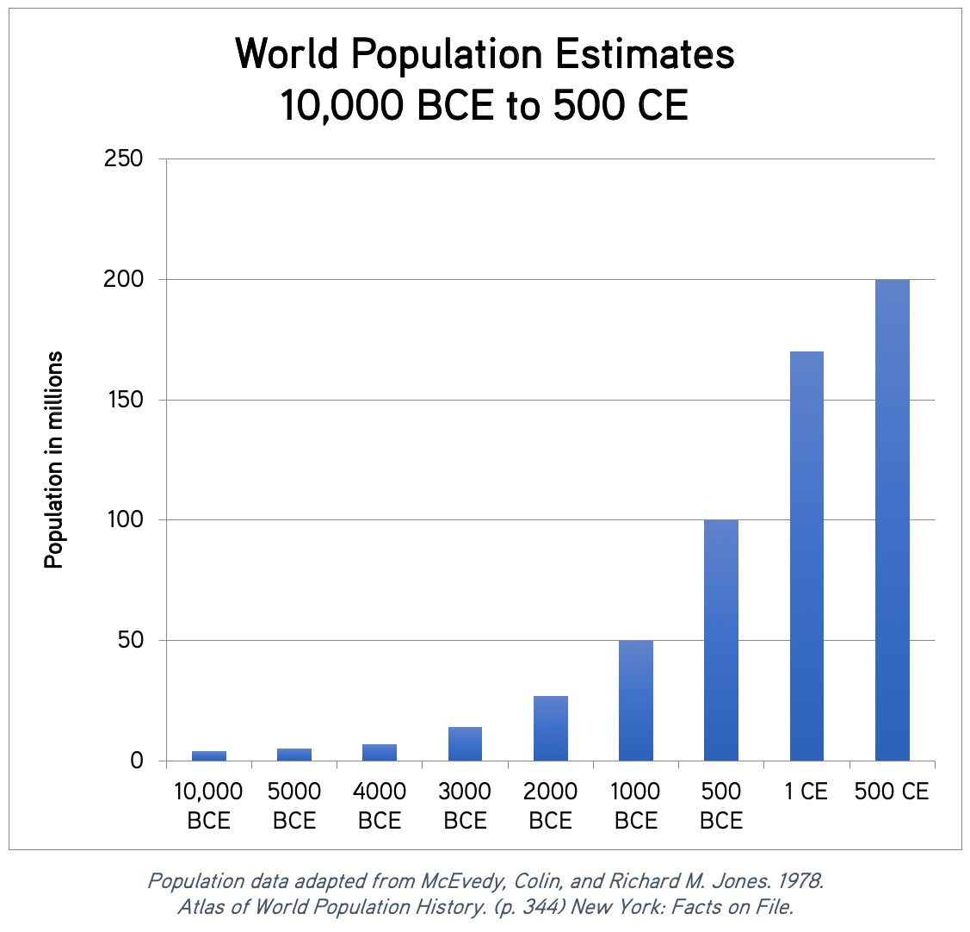

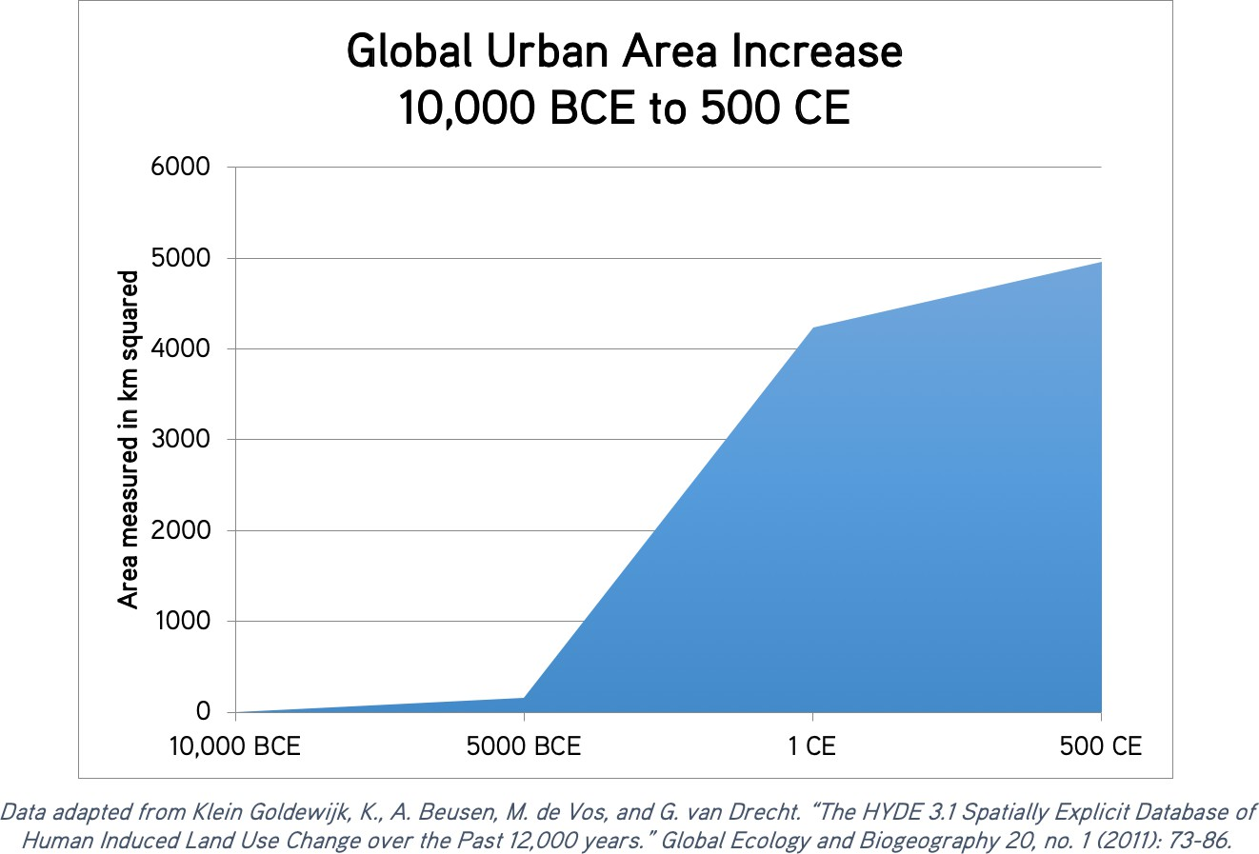

1. Why do you think world population remained relatively constant from 10,000 BCE to 4000 BCE?

|  |
| --- |
|  |

1. Between 10,000 BCE and 4000 BCE, how much did the world population grow?

|  |
| --- |
|  |

1. Between 4000 BCE and 2000 BCE, how much did the world population grow?

|  |
| --- |
|  |

1. Why do you think the population rose rather quickly during this 2,000-year period?

|  |
| --- |
|  |

1. Between 2000 BCE and 500 CE, how much did the world population grow?

|  |
| --- |
|  |

1. Why do you think the population rose even more dramatically over this 2,500-year period?

|  |
| --- |
|  |

1. Based on what you’ve already learned in this era and the graph of urban area growth above, list as many effects of population growth that you can.

|  |
| --- |
|  |

## Part 2: Causation Tool

**Directions:** First, add the event you are analyzing (in the middle of the page). Be sure to include dates, location, and a brief description of the event. Then, list your causes (at the top of the page) and use the legend to help you label *type* and *role*. Finally, list the effects of the event (bottom of page), and again use the legend to help you label *type* and *role*. If your teacher asks you to create a causal map, use your answers here to help construct that causal representation.

|  |  |  |
| --- | --- | --- |
| Causes: Long-Term | Intermediate-Term | Short-Term |
|  |  |  |

|  |
| --- |
| Event (include the name, dates, location, and a brief description) |
|  |

|  |
| --- |
| Effects |
|  |

**Legend**

|  |  |
| --- | --- |
| **Type:** | **Role:** |
| (P) Political (I) Innovation ($) Economic (C) Cultural (E) Environmental (S) Social | (**\***) Triggering Event Necessary Relevant |