Preparation
- Have the Comparison, CCOT, and Causation tools available
- Download the WHP Writing Rubric

Purpose
This assessment will help prepare you for the document-based questions (DBQs) you will probably encounter on exams. It will also give you a better understanding of your skills development and overall progress related to constructing an argument, interpreting historical documents, and employing the historical thinking practices you are using in this course.

Practices

Contextualization, sourcing, reading, writing
All DBQs require you to contextualize, source documents, and of course as part of this, read and write.

Process

Day 1
In this activity, you are going to prepare to respond to a DBQ, or document-based question. In this course, document-based questions give you a prompt or question along with seven source documents, and you’ll use the information in those documents (and any additional knowledge you have) to respond to the prompt. Your responses will be written in essay format, and will usually be five or six paragraphs long.
This DBQ asks you to respond to the following prompt: Develop an argument that evaluates the extent to which complex societies impacted humans inside and outside these communities. To make sure you’re clear on what you’re being asked, take out the Question Parsing Tool. Work with your classmates to deconstruct the prompt.
Next, take out the DBQ and relevant thinking tool to help you analyze the documents. Take a look at the document library. As you do with the Three Close Reads process, quickly skim each of the documents for gist. Then, do a closer read of each one. For each document, write down the information you think you might use in your essay. If possible, also provide a source analysis for each document. Write your ideas on the relevant tool as you work through the documents. Discuss your ideas with the class.
Now, come up with a major claim or thesis statement that responds to the prompt. Use the information from your thinking tool to help you come up with an idea. What you have written should help you support your claim. One common mistake students make when responding to a DBQ is not directly answering the prompt—so, in creating your thesis, make sure that it directly answers and is relevant to the prompt.
Finally, it’s time to contextualize. Remember, that ALL historical essays require you to contextualize. If you need to refresh your memory, contextualization is the process of placing a document, an event, a person, or process within its larger historical setting, and includes situating it in time, space, and sociocultural setting. In this case, you are contextualizing the documents. Contextualization will often come at the beginning of your essay, or at least in the first paragraph, either before or after your thesis statement. As needed, you can use the Contextualization Tool for this part of the process.

Day 2
This second day is your writing day. Feel free to use your tools and notes from any prewriting work you completed as you craft your essay response. Make sure you have a copy of the WHP Writing Rubric available to remind you of what’s important to include in your essay. And don’t forget to contextualize! In doing that, think of the entire time period, not just the time immediately preceding the historical event or process you are writing about. Your teacher will give you a time limit for completing your five- to six-paragraph essay responding to the DBQ.

Name: |  | Date:
Directions: Write a five- to six-paragraph essay in response to the prompt below. Make sure to use the documents provided to help support your argument. In addition to trying to meet the criteria on the WHP Writing Rubric, make sure to address the most relevant of these historical thinking skills in your response: comparison, causation, or CCOT. Finally, make sure you contextualize (describe the broader historical context relevant to the prompt).
We suggest you spend 10-15 minutes reading these documents and 35-45 minutes writing. Sources are edited for brevity and clarity.
Develop an argument that evaluates the extent to which complex societies impacted humans inside and outside these communities.

Document 1
Source: Standard of Ur, found in a royal tomb in southern Mesopotamia, c. 2600–2300 BCE. The top image is the “Peace” side while the bottom image is the “War” side. Public domain.
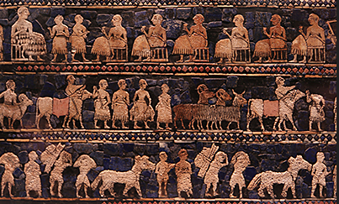
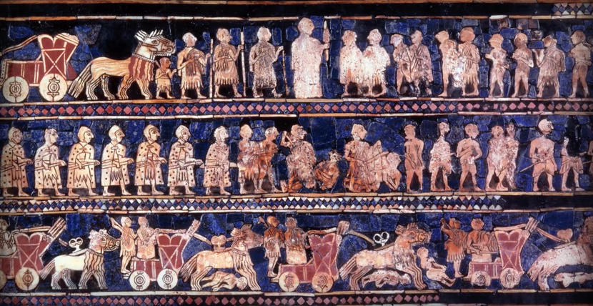

Document 2
Source: “The Code of Hammurabi.” Translated by L.W. King. Yale Law School, Lillian Goldman Law Library, 2008. https://avalon.law.yale.edu/ancient/hamframe.asp. Hammurabi was a Mesopotamian king who ruled over the Old Babylonian Empire from 1792 to 1750 BCE. The Code of Hammurabi is one of the oldest legal codes in the world.
When the god Marduk sent me to rule over men, to give the protection of right to the land, I did right … and brought about the well-being of the oppressed …
5. If a judge try a case, reach a decision, and present his judgment in writing; if later error shall appear in his decision, and it be through his own fault, then he shall pay twelve times the fine set by him in the case, and he shall be publicly removed from the judge’s bench, and never again shall he sit there to render judgment.
6. If any one steal the property of a temple or of the court, he shall be put to death, and also the one who receives the stolen thing from him shall be put to death …
22. If any one is committing a robbery and is caught, then he shall be put to death …
196. If a man put the eye of another man, his eye shall be put out …

Document 3
Source: Lichtheim, Miriam. Ancient Egyptian Literature : A Book of Readings, Volume II: The New Kingdom. Berkeley: University of California Press, 1976. This anonymous Egyptian text known as the Papyrus Lansing was written between 1350 and 1200 BCE. This document served as both a text for student scribes to practice copying and an encouragement of their choice of profession.
See for yourself with your own eye. The occupations lie before you.
The washerman’s day is going up, going down. All his limbs are weak, [from] whitening his neighbors’ clothes every day, from washing their linen.
The maker of pots is smeared with soil. … His hands, his feet are full of clay; he is like one who lives in the bog. …
The watchman … spends a night of toil just as one on whom the sun shines.
The merchants travel downstream and upstream. They are as busy as can be, carrying goods from one two to another. They supply him who has wants. …
The carpenter who is in the shipyard carries the timber and stacks. If he gives today the output of yesterday, woe to his limbs! The shipwright stands behind him to tell him evil things. His outworker who is in the fields, his is the toughest of all the jobs.
He spends the day loaded with his tools, tied to his tool box. When he returns home at night, he is loaded with the tool box and the timbers, his drinking mug, and his whetstones.
The scribe, he alone, records the output of all of them.

Document 4
Source: The Sacred Books of China, The Texts of Confucianism. Translated by James Legge. Oxford: Clarendon Press, 1885. This is part of the Classic of History, a collection of documents that include both Chinese history and legend from 2357 to 731 BCE. The excerpt below was originally written during the Zhou Dynasty (1046–256 BCE) and describes advice given by government minister Yi Yin to a young Shang Dynasty king upon the death of the new king’s father.
In the twelfth month of the first year … Yi Yin sacrificed to the former king, and presented the heir-king reverently before the shrine of his grandfather. …
He said, “Oh! Of old the former kings of Xia worked hard at their goodness, and then there were no calamities from Heaven. The spirits of the hills and rivers alike were all in peacefulness; and the birds and beasts … all enjoyed their existence according to their nature. But their descendant did not follow their example, and great Heaven sent down calamities … Our king of Shang brilliantly displayed his skillfulness; for abuse he substituted his generous gentleness, and the millions of people gave him their hearts. Now your Majesty is entering on the inheritance of his goodness; all depends on how you begin your reign. To set up love, it is for you to love your relations; to set up respect, it is for you to respect your elders. The beginning is the family and the state …

Document 5
Source: Legge, James, ed. The Chinese Classics : Vol. 1: Confucian Analects, the Great Learning, and the Doctrine of the Mean. London: Trubner & Co., 1861. Below are some selections from the thoughts of Confucius (c. 551–479 BCE), a Chinese philosopher. These teachings were collected by Confucius’s students and followers from c. 475 to 221 BCE.
2:3 The Master said, “If the people be led by laws, and uniformity sought to be given them by punishments, they will try to avoid the punishment, but have no sense of shame. If they be led by virtue … they will have the sense of shame and moreover will become good.”
2:5 Mang E asked what filial piety was. The Master said, “It is not being disobedient.”
2:19 The duke Gae asked, “What should be done in order to secure the submission of the people?” Confucius replied, “Advance the upright and set aside the crooked, then the people will submit. Advance the crooked and set aside the upright, then the people will not submit.”
12:2 Rang Yong asked about humaneness. The Master said, “When going abroad, treat everyone as if you were receiving a great guest; when employing the people, do so as if assisting in a great sacrifice. What you do not want for yourself, do not do to others. There should be no resentment in the state, and no resentment in the family.”

Document 6
Source: Scott, James C. The Art of Not Being Governed : An Anarchist History of Upland Southeast Asia. New Haven, CT: Yale University, 2009. James Scott is the Sterling Professor of Political Science and Professor of Anthropology at Yale University. He is also the co-Director of the Agrarian Studies Program at Yale.
At a time when the state seems pervasive and inescapable, it is easy to forget that for much of history, living within or outside the state—or in an intermediate zone—was a choice, one that might be revised as the circumstances warranted. A wealthy and peaceful state center might attract a growing population that found its advantages rewarding. This, of course, fits the standard civilizational narrative of rude barbarians mesmerized by the prosperity made possible by the king’s peace and justice—a narrative shared by most of the world’s salvational religions ...
This narrative ignores two capital facts. First, … it appears that much, if not most, of the population of the early states was unfree; they were subjects under duress. The second fact, most inconvenient for the standard narrative of civilization, is that it was very common for state subjects to run away. Living within the state meant, virtually by definition, taxes, conscription, [forced] labor, and for most, a condition of servitude; these conditions were at the core of the state’s strategic and military advantages. When these burdens became overwhelming, subjects moved with [willingness] to the periphery or to another state. Under premodern conditions, the crowding of population, domesticated animals, and the heavy reliance on a single grain had consequences for both human and crop health that made famines and epidemics more likely. And finally, the early states were warmaking machines as well, producing hemorrhages of subjects fleeing conscription, invasion, and plunder.

Document 7
Source: Fortress and pyramids at Teotihuacan, Mesoamerican city, Mexico, c. 100 BCE to 250 CE. © Getty Images.
