Name:
Date:

Purpose
Portable belief systems were a major human innovation. In the period covered in this unit, belief systems spread to new regions. Today, you can find believers of several huge world religions in every corner of the globe. In this activity, you’re going to map out how three portable belief systems spread during specific periods. Where did Buddhism, Christianity, and Islam spread and by what routes?

Process
- In groups of three, look at the blank map of Afro-Eurasia on the next page.
- Each group member should pick one religion from this list and find the starting point labeled on their map:
- Buddhism (400 BCE to 800 CE)
- Christianity (1 CE to 800 CE)
- Islam (622 CE to 800 CE)
- On your own map (using pencil), sketch out where and by what routes you think the religion you chose spread during the given period.
- Review the maps your partners made, and as a group, decide on any revisions or corrections.
- Be sure to keep your map in a safe place—you’ll use it again this lesson’s closer activity.

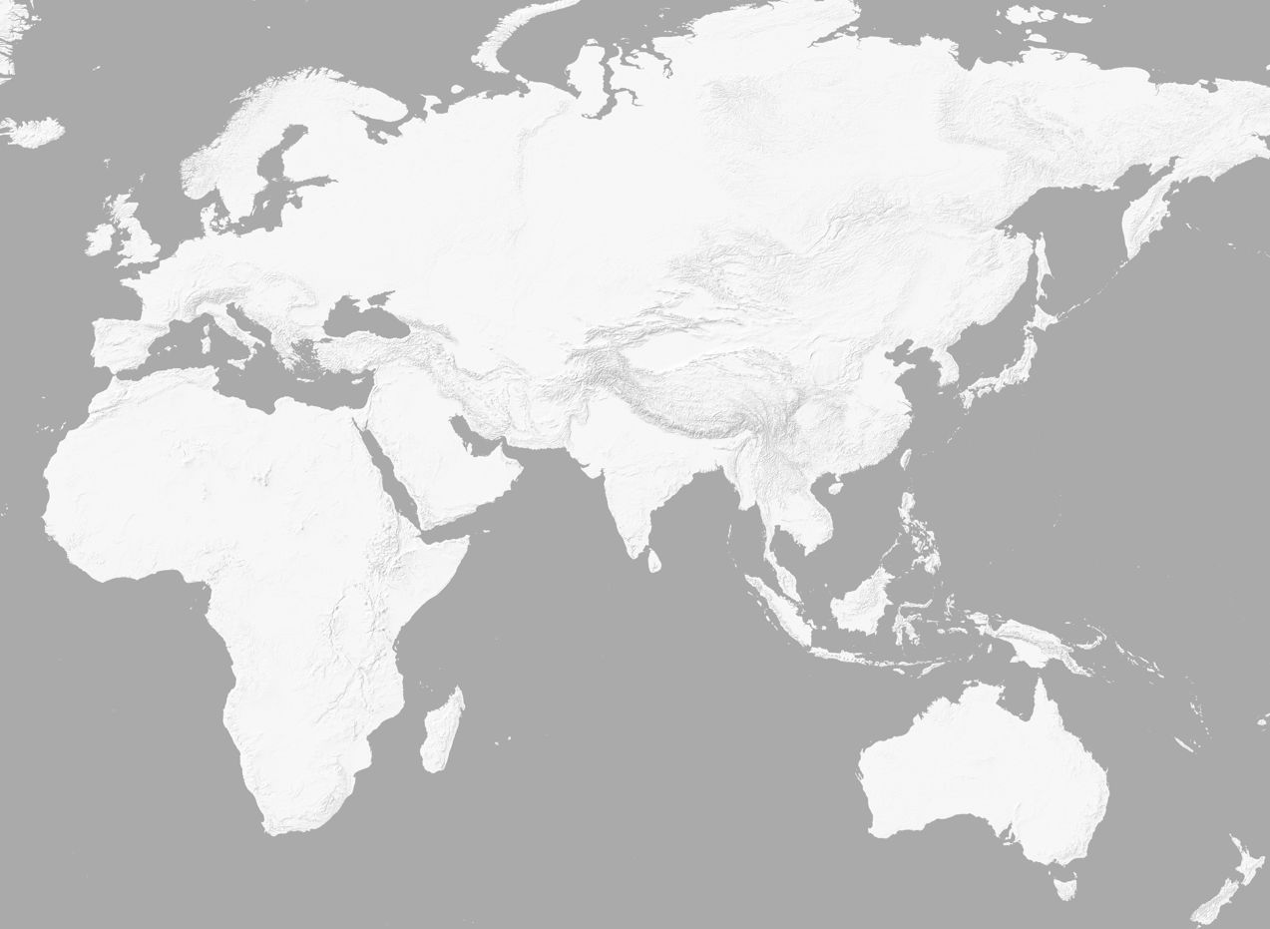
Buddhism
Islam
Christianity

