Name:
Date:

Purpose

You’ve spent this lesson learning about portable belief systems and the blending that often took place when those belief systems interacted. Now, it’s time to revisit the maps you drew at the beginning of this lesson and consider what you’ve learned about why and how beliefs move.

Process
- Take out the map you made tracing the spread of one of the three religions from the lesson opener:
- Buddhism (400 BCE to 800 CE)
- Christianity (1 CE to 800 CE)
- Islam (622 CE to 800 CE)
- Find two partners who each mapped a different religion from you.
- Using the two maps below, check the routes you all drew. Were you close? What did you get wrong? What did you get right?
- With your partners, write a list of five factors that you think influenced the direction and extent to which these three religions spread before 800 CE.
- As a whole class, write all factors on the board. Erase any duplicates. Which do you think were the most important factors? Are there any factors about which you disagree?

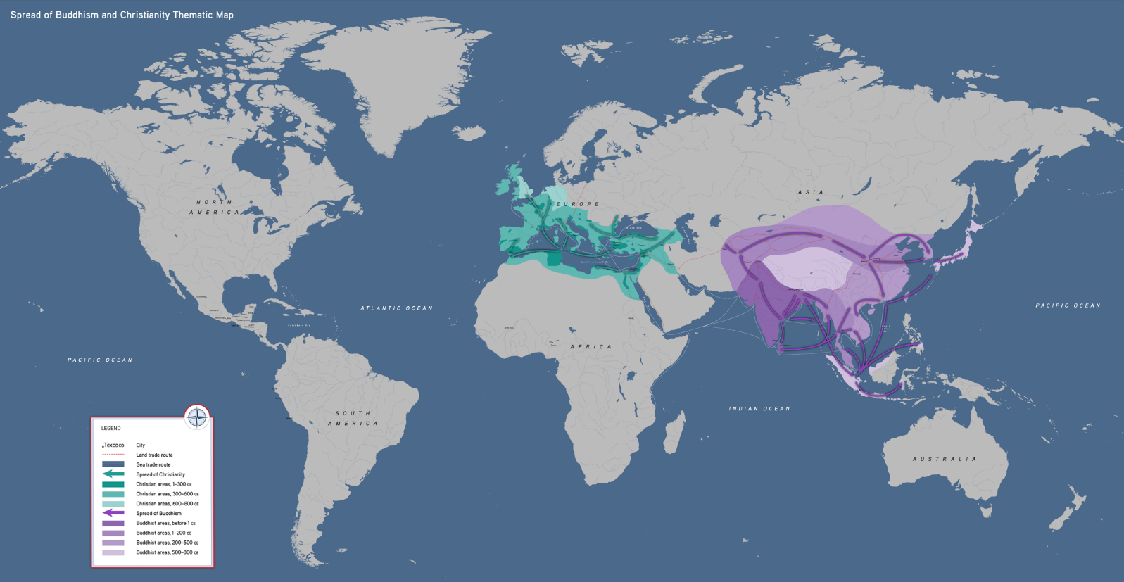
Spread of Buddhism and Christianity
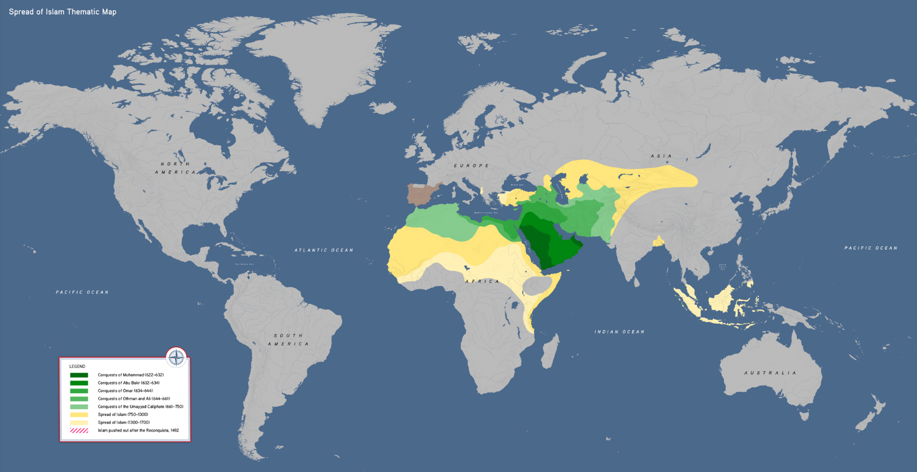
Spread of Islam

