## Farms

**Directions:** Examine the photos and read about each of the farms below. Then, fill out the CCOT Tool.

### Farm of 1700: Ioway Native American Farm

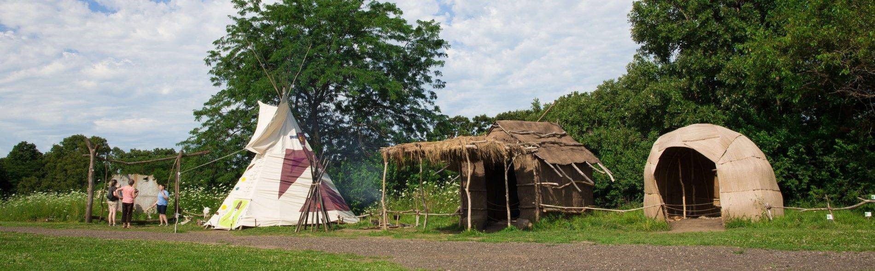

Photo and text courtesy of and © [by Living History Farms](https://creativecommons.org/licenses/by/4.0/)

“The farming techniques practiced by the Ioway Indians in 1700 pre-dated written history and varied somewhat from European methods. Ioway farmers raised corn, beans, and squash. Women did the farming in the Ioway culture while men were responsible for hunting and making tools. Ioway families were subsistence farmers, raising just enough for their family to survive throughout the year and having a little put away in case of a bad year.

“Ioway Indians had separate summer, winter, and traveling lodges. Bark houses called náhachi kept the Ioway cool during hot summer months, while winter mat-houses called chákirutha, made from layers of sewn cattail leaves, protected the Ioway from harsh winters and stayed around 50 degrees inside.

“While traveling on hunting expeditions, the Ioway lived in a chibóthraje, or tipi made from buffalo hides. Their villages also contained sweat lodges, food- drying racks, cooking areas, work areas, hide-scraping racks, pottery pits, and gardens.”

Unless otherwise noted, this work is licensed under [CC BY 4.0](https://creativecommons.org/licenses/by/4.0/). Credit: “CCOT–Introduction”, OER Project, <https://www.oerproject.com/>

## Farm of 1850: Iowan Pioneer Farm

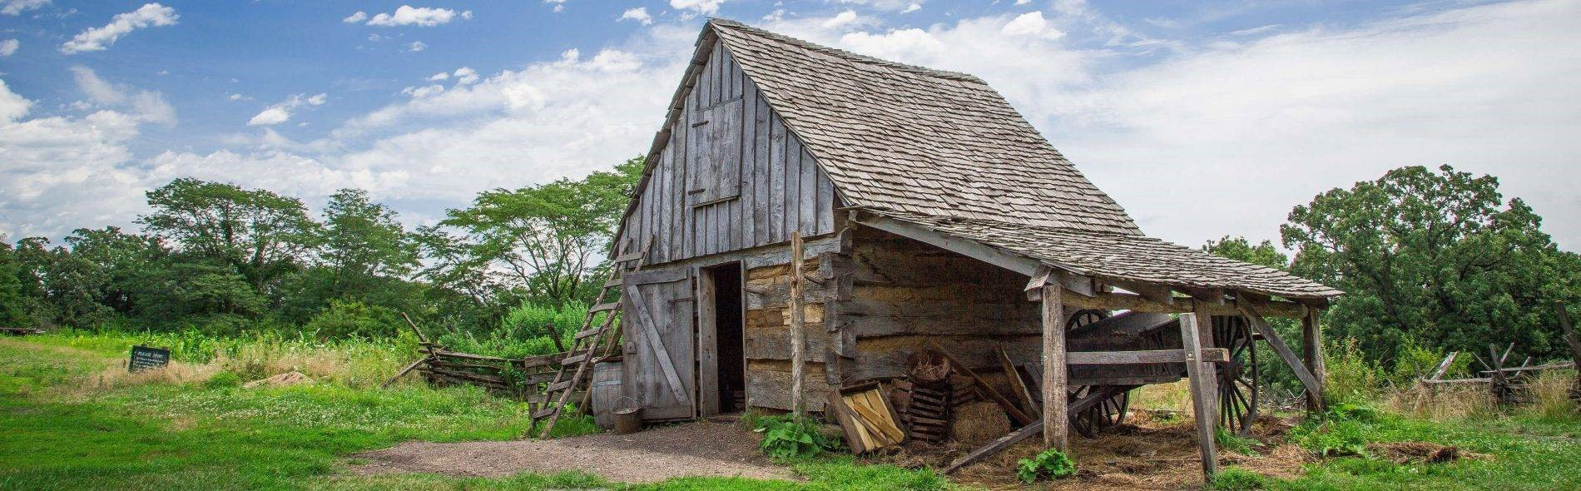

Photo and text courtesy of and © [by Living History Farms](https://creativecommons.org/licenses/by/4.0/)

“The split rail fence, wheat field, rooting pigs, and log house represent a four-year-old farm, established when Iowa became a state in 1846. The farm site is in transition between subsistence agriculture (producing enough for the family to survive) and becoming a profit-making farm. Most farms in 1850 averaged 160 acres in size, with farmers cultivating anywhere from 25 to 40 acres. Corn, wheat, and potatoes were the three major crops in 1850. Most

farmers used their corn crop to feed the pigs that were then sold for profit. Wheat and hogs were cash crops for farmers, and potatoes were a staple with nearly every meal and lasted throughout the winter.

“Until pioneer families earned enough money to purchase modern 1850 technology, they relied on older farming methods. For example, women prepared food over an open fire even though wood-burning cookstoves were available. The majority of people who settled in Iowa in the 1840s and 1850s came from the Eastern United States, and were eager to build a multi-room dwelling like they had lived in before coming west. Log houses were temporary structures that the pioneers improved or replaced once the farm was established.

“Pioneer families relied on poultry for three major purposes: meat, eggs, and money. Most pioneers who raised pigs built a smokehouse to help preserve the pork. In 1850, barns were of less significance to the farm than in later years. Pioneers used barns to store tools and some crops, rather than to house animals. The big barns that are associated with modern farms were not built in Iowa until the 1870s.”

## 2014: Modern Farm in the American Midwest

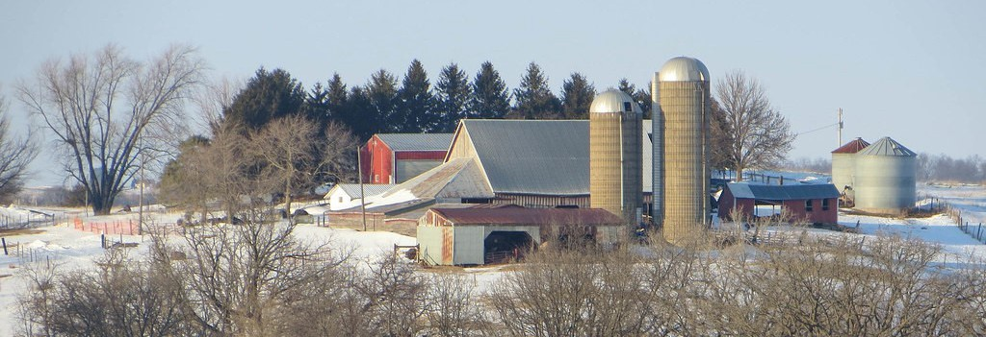

[Near Wyoming, Iowa](https://www.oerproject.com/?WT.mc_id=00_00_2021_x_OER-PDF_&WT.tsrc=OERPDF), by davidwilson1949, CC BY 2.0.

“Today, most of Iowa’s land, about 85 percent, is farmland. The state includes 35.7 million acres of land and over 30 million acres are farmed in Iowa. Most of this, about 26 million acres, is cropland and the other 1.2 million acres is used as pastureland. There are about 88,000 farms in Iowa and the average farm size is 345 acres.

“Production on farms has increased dramatically due to technological advancements. Most farms in the American Midwest use tractors and synthetic pesticides and fertilizers to increase production. About 99 percent of farms in America are family owned but only about two percent of the labor force works in farming. While mostly men are farm operators, women’s participation as farm operators and owners has increased substantially in the last 25 years, from 5 to 12 percent of the total.

“Corn is the crop grown the most throughout the American Midwest, and Iowa ranks first in the United States for producing corn along with soybeans, pork, and eggs. Corn is mainly used in the production of animal feed and in ethanol, which is used to manufacture gasoline. Soybeans and pork are two of America’s largest exports, with the bulk of these products purchased by China. There are also a large number of dairy and cattle farms in the Midwest.

“The number of farms has decreased from 1900 to today but farms have also become more productive as technology has advanced. There are both positive and negative impacts of farm production including environmental concerns such as the release of greenhouse gasses and runoff of chemicals into waterways.”

Source: Living History Farms, Economic Research Service of the United States Department of Agriculture, and the American Farm Bureau Federation.

**Directions 1:** Fill in the following information for the assigned topic.

1. Write the dates for time period being studied. *Sample answer: 1700s to today*
2. Write down on sticky notes as many continuities and changes for the time period that you can find. Write one per sticky note and place each on the graph to show whether it was a continuity or a change, and whether it was positive or negative. Be prepared to explain your thinking.

Positive

*Some of the continuities might include the following:*

* + *Every farm was ultimately about food production.*
  + *Corn was grown.*
  + *Both men and women have worked on farms in Iowa from the 1700s to today. Roles have changed somewhat over the years but participation from both was and is essential.*
  + *Some crops were grown to trade or sell.*

*Some of the changes might include the following:*

* + *The percentage of people who farm in Iowa has decreased dramatically.*
  + *New tools using steam and electricity were developed to improve farming practices.*
  + *Many farmers in Iowa, across the US, and around the world, now belong to organizations that connect them as a network of professionals on a global scale.*

Change

Continuity

Negative

1. Were there more changes or continuities? Explain why there were more of one than the other for this time period.

Historical significance can be determined in several ways. Use the acronym ADE to help you:

* Amount: How many people’s lives were affected by the continuity/change?
* Depth: Were people living in the time period being studied deeply affected by the continuity/change?
* Endurance: Were the changes people

experienced as a result of this continuity/ change long-lasting and/or recurring?

*Sample answer: Student answers will vary depending on how many changes and continuities they identified, but some might say that there were more continuities considering we’re examining farms in a particular location over time.*

1. Look over the changes on your graph.
   * Were they more positive or negative, overall? Explain why these were more positive or negative during this time period.

*Sample answer: Student answers will vary but some might say that the changes were more positive overall since farming became easier with the use of technology and farmers formed organizations to improve practices.*

* + What was the most significant change during this time period? Why?

*Sample answer: Student answers will vary but some students might say that the most significant change has been technological updates to farming practices since that change deeply affects most farmers and technological innovation is long-lasting.*

1. Look over the continuities on your graph.
   * Were they more positive or negative, overall? Explain why these were more positive or negative during this time period.

*Sample answer: Student answers will vary but some might say that the continuities were more positive overall since they relate to the type of food grown and the purpose for growing food.*

* + What was the most significant continuity during this time period? Why?

*Sample answer: Student answers will vary but some might say the most significant continuity is that all these farms are focused on food production, which is essential for all people and if food was not produced then other people would be deeply affected.*

**Directions:** Not all activities require students to meet each criterion. We recommend crossing out any criteria that is not evaluated and communicating that to your students.

|  |  |  |  |  |
| --- | --- | --- | --- | --- |
| **Changes** | * No changes are identified. | * Changes are **identified**. * Positive changes are identified. * Negative changes are identified. | * A **brief** analysis of positive or negative changes is provided. | * An extended analysis of positive or negative changes is provided |
| **Notes** | | | | |

|  |  |  |  |  |
| --- | --- | --- | --- | --- |
| **Continuities** | * No continuities are identified. | * Continuities are **identified**. * Positive continuities are identified. * Negative continuities are identified. | * A **brief** analysis of positive or negative continuities is provided. | * An extended analysis of positive or negative continuities is provided. |
| **Notes** | | | | |

|  |  |  |  |
| --- | --- | --- | --- |
| **Historical Significance** | * No explanation of historical significance provided. | * Attempts but does not fully explain how the changes/continuities are historically significant in terms of amount, depth, and/or endurance.* | * Fully explains how the changes/continuities are historically significant in terms of amount, depth, and/or endurance.* |
| **Notes** | | | |

|  |  |  |  |  |
| --- | --- | --- | --- | --- |
| **Historical accuracy** | * Incorrectly refers to historical content and may include misconceptions of that content. * There are many minor errors or a major error in applying historical content. * Uses many unsupported opinions. | * Avoids explicit misconceptions of the content. * May make an occasional minor error in applying historical content. * Uses some unsupported opinions. | * Avoids misconceptions. * There are no errors in applying historical content. * Avoids using unsupported opinions. | * Incorrectly refers to historical content and may include misconceptions of that content. * There are many minor errors or a major error in applying historical content. * Uses many unsupported opinions. |
| **Notes** | | | | |

* **Amount:** How many people’s lives were affected by the continuity/change? **Depth:** Were people living in the time period being studied deeply affected by

the continuity/change? **Endurance:** Were the changes people experienced as a result of this continuity/change long-lasting and/or recurring.