Directions: Review the article for your assigned empire and follow the steps below. You can record notes on the Autopsy Rough Draft.
- Take notes on the following topics:
  - Important rulers (historical figures)
Sample answer: Augustus was the first emperor of the Roman Empire, but Rome was organized and ruled much like an empire before it officially became one. While there are many important or notable Roman emperors, the ones mentioned in the articles mainly have to do with the empire’s beginnings (Augustus) and its end (the reforms of Diocletian and Constantine).
  - Structure and administration of government and military capabilities
Sample answer: The largest city in the western portion of the empire was Rome, and then later the city of Constantinople in the east. The empire was divided into provinces, each with a number of administrators or officials who were supposed to run the province according to the wishes of the emperor. These administrators collected taxes, enforced Roman laws and customs, and oversaw the military in the provinces.
  - Belief systems
  - Sample answer: The Roman Empire had a number of official gods and goddesses based on those of the Greeks but there were also many different local, community belief systems that were practiced (syncretism). Toward the end of the Western Roman Empire, Christianity became the official faith of the empire (both east and west).
  - Social hierarchy including the role of women
Sample answer: A social hierarchy was in place that separated wealthy from nonwealthy and also Roman citizens from noncitizens. In addition, there were a large number of enslaved people living within the empire. However, these distinctions between wealthy (patrician) and middle class or poor (plebeian) along with those between citizen and noncitizen could be blurred. The enslaved also could be freed or purchase their freedom. Rome was a patriarchal society and therefore, women had limited rights and an inferior status. Even if Roman women were technically citizens, they could not enter into legal agreements and often had to be accompanied by male relatives. However, some widowed women did run businesses and women in the lower social classes had to work outside of the home. In addition, women of upper social classes often exercised power behind the scenes.
  - Networks of exchange and trade
Sample answer: Rome was a vast empire, covering over 2 million square miles at its height. A system of roads connected the empire and facilitated trade, the movement of troops, communication between provinces, and the spread of disease. Networks stretched across and beyond the empire and connected Asia to Africa to Europe. Luxury goods as well as agricultural and metal products along with ideas (and diseases) were exchanged. Rome relied on these exchanges for its wealth from exports and in the collection of taxes.
  - Cultural achievements such as art, architecture, science, and technology
Sample answer: Rome is well-known for many cultural, scientific, and technological achievements such as the production of concrete for roads and buildings, monumental architecture, elements of their government and legal systems, paintings and mosaics, and the manufacture of glass (among many others).
  - Reasons for collapse
Sample answer: There was no single cause for the collapse of Rome. And even when the western portion of the empire collapsed in 476 CE, the eastern portion continued until 1453 CE. Some of the many reasons for collapse of the Western Roman Empire include weak rulers (succession of emperors who were ineffective and often assassinated); the growth in power of the military (which led to many of the assassinations); breakdown of networks and trade; the spread of disease and the plague; territorial expansion that could not be sustained; and external forces such as wars and invasions along its borders.

- As a group, choose and then draw a figure that represents your empire, such as a ruler or important figure.
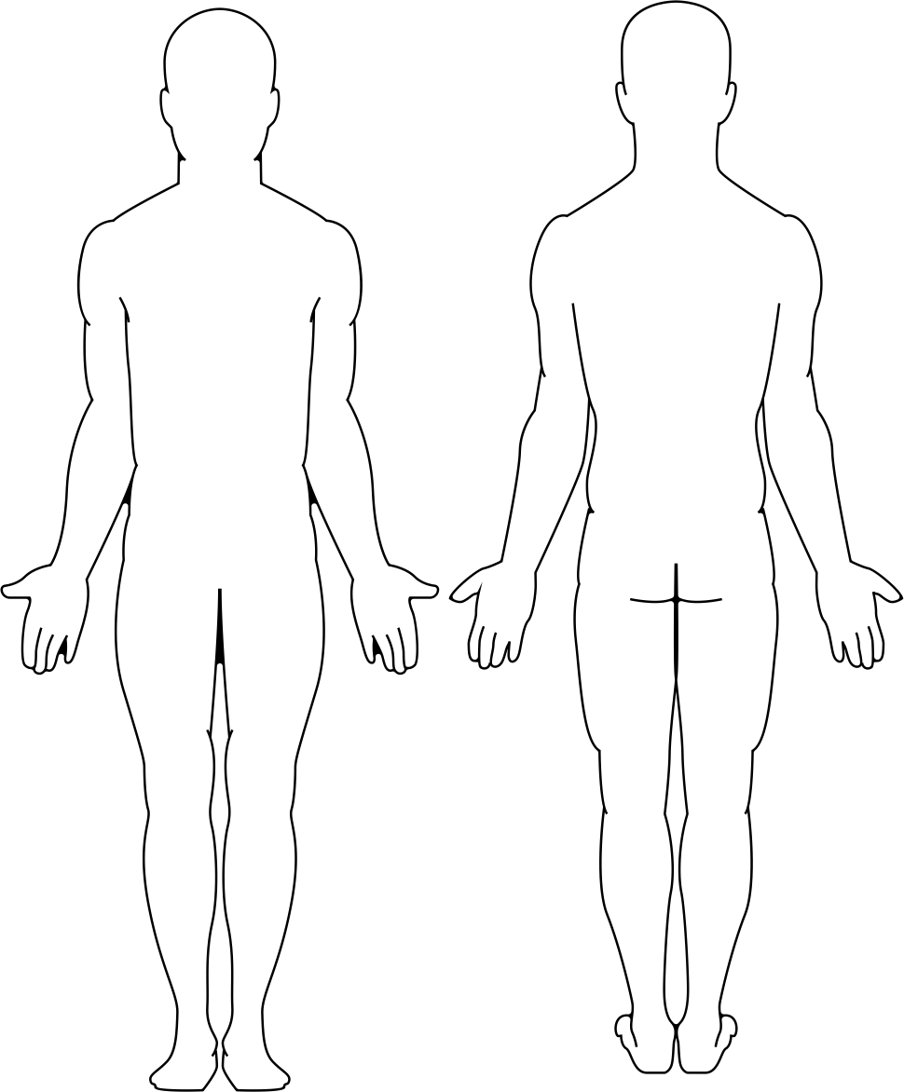 | 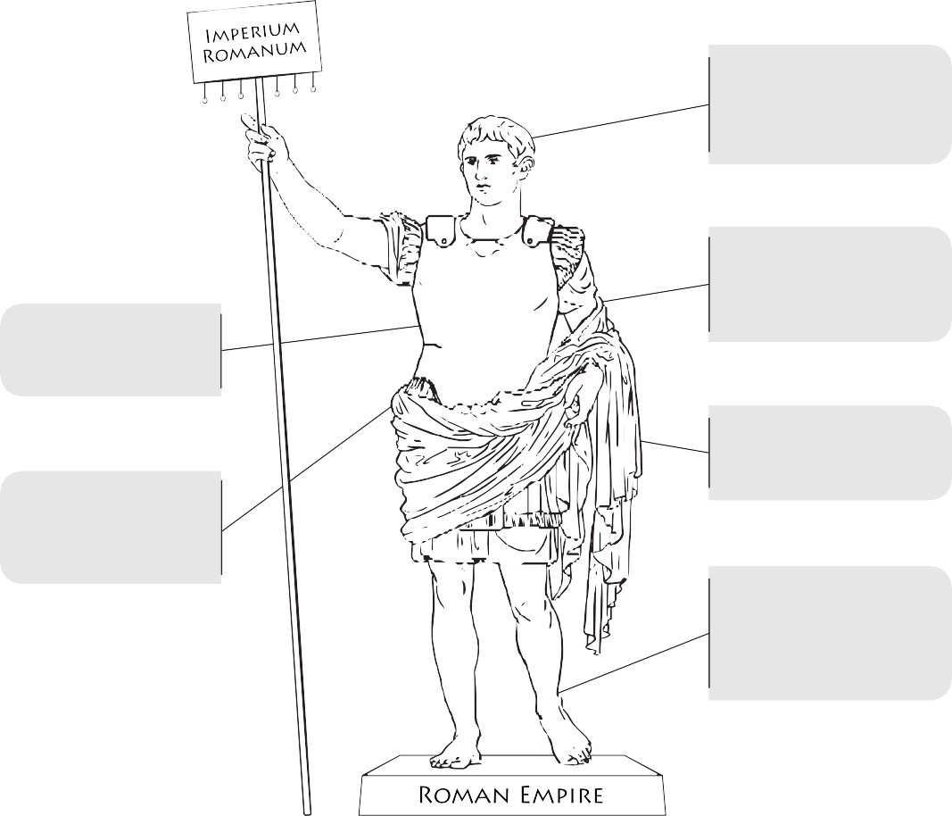  Augustus - first emperor of Rome; many emperors followed (some good and some bad); Diocletian reforms; Constantine - faith  Began as a polytheistic and incorporated many local beliefs; Christianity became official religion c. 313  Roman roads connected the empire; split into many provinces; administrators collected taxes; military was large and conscripted  Patricians (wealthy) and plebeians (all others); citizens vs. non-citizens’ many enslaved; women had few legal rights  Concrete; aqueducts; architecture; mosaics; government structure; legal code; glass; and many others  Empire was over 2 million square miles, connected by a system of roads for trade and communication; networks stretched from Asia to Africa to Europe
- Organize your notes and label your figure:
  - head of your figure = important rulers (historical figures)
  - spine = government, administration, or military
  - heart = the empire’s belief systems
  - arms = the social structure or hierarchy, including the role of women
  - hands = the empire’s cultural achievements
  - legs = networks or systems of exchange and trade
- Fill out the Causation Tool.

Causation Tool
Directions: First, add the event you are analyzing (in the middle of the page). Be sure to include dates, location, and a brief description of the event. Then, list your causes (at the top of the page) and use the legend to help you label type and role. Finally, list the effects of the event (bottom of page), and again use the legend to help you label type and role. If your teacher asks you to create a causal map, use your answers here to help construct that causal representation.
Causes: Long-Term | Intermediate-Term | Short-Term
Sample answer:  - Rome began expanding its territory from its earliest days of the Republic. (P)  - The shift from republic to empire meant that one ruler was now in charge of the empire. (P)  - Roman emperors began passing down the title to their family members, many of whom were not cut out for leading the empire. (P)  - The Roman military increases in size and power. (P) | Sample answer:  - During the Roman Empire, the military is responsible for assassinating many emperors. (P)  - Christianity becomes the official religion of the Roman Empire. (C)  - Taxes became harder to collect as the empire grew and local officials were responsible for collecting the taxes. ($)  - There was a reduction in long-distance trade because the borders were difficult to protect. ($, P, C, I) | Sample answer:  - Weak child emperors on the throne. (P)  - Roman citizenship extended to all free men living within the borders of the empire. (P, C)  - Harsh treatment of Germanic tribes living on the borders of the empire. (P, C)  - Invasions by Germanic tribes along the borders of the empire with some tribes eventually taking over the Western Roman Empire in 476 CE. (*, P)
Event (include the name, dates, location, and a brief description)
Sample answer: Fall of Rome, 476 CE (West) and 1453 CE (East), Roman Empire—what were the causes of the collapse of the Roman Empire?
Effects
Sample answer: Germanic tribes took over the Western Roman Empire. The Catholic Church and Roman law continued in the west long after the Germanic invasions. The Eastern Roman Empire became more powerful and lasted until 1453.
Legend
Type | Role
(P) Political (I) Innovation ($) Economic (C) Cultural (E) Environmental (S) Social | (*) Triggering Event Necessary Relevant
- Write the autopsy for your empire.
Sample answer: The cause of death of the Roman Empire would be a breakdown in all systems. The head of the empire was often troubled by poor leadership. There were also problems with its spine, as the military became too powerful and attempted to wrestle control from the emperor while some of the bureaucrats in the provinces were greedy and corrupt. The heart of the empire underwent a significant change when the belief systems changed from polytheistic beliefs to Christianity. This was not a change that was accepted overnight and led to differences between people within the empire. The arms of the empire were also affected, especially when Caracalla granted citizenship to all people residing within the borders of the empire. Some were happy about this change while others resented it, which caused internal friction. The legs were also infected, in particular with disease and the effects of the plague and the breakdown of trade. This affliction left the empire economically weak and also led to a substantial loss of life, which further weakened the empire. As a result of all these ailments, the hands of the empire also began to feel the effects and cultural, scientific, and technological innovations were not what they once were.
- Write a one- to two-paragraph obituary for your empire (hint: use your completed Causation Tool for this). Be sure to answer the following questions as part of your obituary:
  - What were the main achievements of this empire?
  - What factors led to the collapse or restructuring of this empire and which of these factors were the most historically significant?
  - Were these causes the result of internal struggles or external influences?
Stretching from northwestern Europe across the Mediterranean and into western Asia, the Romans built one of the largest and most powerful empires in history. From its founding as a small kingdom on the Italian peninsula c. 753 BCE to its fall in the west in 476 CE, Romans ruled over this region for
almost a thousand years. In that time, the government transformed from a monarchy to a republic and finally an empire, although it resembled an empire during the republic as well. Roman society was organized into a hierarchical structure with patricians, the wealthy and powerful, leading Rome while the plebians (everyone else) worked to support the empire by paying taxes and serving in the military. At the bottom of this pyramid were the enslaved, who were mainly those conquered by Rome in its expansion. However, many enslaved people eventually bought their freedom and Roman emperors extended citizenship to many conquered people in order to secure their loyalty and taxes. Rome’s cultural contributions extended into all categories of the
arts, philosophy, science, and politics. Known for their innovation in building such as the creation of concrete, arches, and aqueducts, Romans also created a government structure that served as the model for many future nations, such as the United States. But Rome’s accomplishments could not prevent its eventual collapse. The empire grew too large to be governed effectively and many of its emperors were lacking the expertise and leadership skills to solve problems. In addition to these territorial and leadership problems, internal divisions grew as Christianity became the official belief system of the empire and as citizenship was extended to all inhabitants of the empire. These internal problems weakened the empire, which allowed nomadic groups along Rome’s border to successfully invade and sack the capital of the Western Empire in 476 CE. While the Eastern Empire continued to survive for close to a thousand years, falling in 1453 CE, it was not as large or as powerful as it once had been.
- Is it possible that some historians might choose different causes as the most significant ones?
Sample answer: Historians have disagreed about the most significant causes of the fall of the Roman Empire for hundreds of years. Some historians have focused on a wide variety of causes such as those listed above. Others have placed the blame on a few of these causes as the most significant ones.
- Would focusing on a different set of causes change the history of this empire’s collapse, and if so, how?
Sample answer: Student answers will vary but in the case of the fall of the Roman Empire, focusing on a different set of causes for the collapse wouldn’t necessarily change the history of what took place. However, the perspective of the fall might change depending on the causes listed as most significant. For example, if a historian chose to focus on poor leadership as the primary cause, then their history would be different in terms of their perspective and primary focus of the collapse of Rome from one who might instead concentrate on the breakdown of trade or impact of disease as the primary causes.

Causation: Feedback Form
Directions: Not all activities require students to meet each criterion. We recommend crossing out any criteria that is not evaluated and communicating that to your students.
Causes | ☐ No description or analysis of historical causes provided. | ☐ Historical causes identified. | ☐ Historical causes described. | ☐ A brief analysis of the relationships or distinctions between different historical causes provided. | ☐ An extended analysis of the relationships or distinctions between different historical causes provided.
Notes

Effects | ☐ No description or analysis of historical causes provided. | ☐ Historical causes identified. | ☐ Historical causes described. | ☐ A brief analysis of the relationships or distinctions between different historical causes provided. | ☐ An extended analysis of the relationships or distinctions between different historical causes provided.
Notes

Historical Significance | ☐ No explanation of historical significance provided. | ☐ Attempts but does not fully explain how the causes and/or effects are historically significant in terms of amount, depth and/or endurance.* | ☐ Fully explains how the causes and/or effects are historically significant in terms of amount, depth and/or endurance.*
Notes

Historical accuracy | ☐ Incorrectly refers to historical content and may include misconceptions of that content.  ☐ There are many minor errors or a major error in applying historical content.  ☐ Uses many unsupported opinions. | ☐ Avoids explicit misconceptions of the content.  ☐ May make an occasional minor error in applying historical content.  ☐ Uses some unsupported opinions. | ☐ Avoids misconceptions.  ☐ There are no errors in applying historical content.  ☐ Avoids using unsupported opinions.
Notes
* Amount: How many people’s lives were affected by the cause/effect? Depth: Were people living in the time period being studied deeply affected by the cause/effect? Endurance: Were the changes people experienced as a result of this cause/effect long-lasting and/or recurring?

