Name: |  | Date:

Preparation
- Download “Worlds Collide: Persians and Greeks”
- Download “The Macedonian Empire”
- Download “The Ptolemaic Dynasty”
- Download “The Mauryan and Gupta Empires”
- Download “The Zhou and Qin Empires”

Purpose
Causation can be a complicated historical thinking practice to master, especially when the event or process being studied has a number of possible causes (and effects), like the collapse of an empire. In order to help you further develop this skill, you’ll identify what caused an empire to fall. As you become more skilled at understanding causation, you’ll become better at evaluating why historians sometimes come to different conclusions about the same topic, including the cause of an empire’s collapse.

Practices

Claim testing, sourcing
Claim testing is a big part of evaluating causes and effects. You must use your claim testing skills to evaluate sources and the evidence these sources use to explain why these empires collapsed. In addition, you need logic and intuition to decide if the causes and evidence that historians (sources) use to explain these collapses makes sense.

Process
- In this activity, you’ll be evaluating the causes for a society’s collapse by creating an anatomy and autopsy of an empire you learned about in Unit 4.
- Your teacher will start by dividing the class into small groups and assigning you an empire. Then, your teacher will either hand out or have your download the Causation—Autopsy of an Empire worksheet, which includes the Causation Tool.
- Each group member will review your assigned article, taking notes on these topics:
  - Important rulers (historical figures)
  - Structure and administration of government and military capabilities
  - Belief systems
  - Social hierarchy including the role of women
  - Networks of exchange and trade
  - Cultural achievements such as art, architecture, science, and technology
  - Reasons for collapse
- Once you are done taking notes, get together with your group and pick a historical figure that represents your empire. As a team, draw the figure.
- Use your notes from reviewing the article to label the figure, following the key given to you on the worksheet. Make sure to combine everyone’s notes so you include all relevant information.
- After you’re done labeling your anatomy of an empire, work as a group to fill out the Causation Tool.
- Remember that you’ve already categorized by time and type. For this activity, you’ll also be categorizing by role. This categorization process can be difficult, and you may not all agree on the time, type, or role. However, you should be able to back up your claims with evidence. Keep in mind that historians don’t always agree about these topics either, which is why there are often different perspectives or histories written about the same historical event or process.
  - Necessary—These causes were required. The historical event or process would not have occurred without these causes.
  - Relevant—These causes are important but not required. The historical event or process would still happen without these causes.
  - Triggering event—This is the most immediate cause of the historical event or process.
- Explain, using the body parts outlined in the worksheet, what factors led to the collapse or restructuring of this empire.
- Use that information to write an autopsy. What body part (or parts) became “sick” and caused its collapse? In other words, what was the cause of death? A death certificate or an autopsy would list all the possible causes of death along with the main, or most significant, cause. In addition, were all of the causes a result of internal problems (the body parts of their empire) or were there external causes as well (outside the body—maybe another empire or nomadic tribes invading)?
- Now that you’ve analyzed and categorized all the causes for collapse and written your autopsy, you’ll write an obituary for your empire. An obituary is a summary of a person’s life and their accomplishments, or legacy, that’s written after they’ve died. Think about why you are studying this empire and why it is still important. For example, you might include the empire’s beginning and end dates along with its cultural and political achievements, and then briefly explain what led to its downfall. For your empire’s obituary, you’ll write one or two paragraphs that explain this legacy.
- Your teacher will collect your completed worksheets and use them to assess how your causation skills are progressing.

Directions: Review the article for your assigned empire and follow the steps below. You can record notes on the Autopsy Rough Draft.
- Take notes on the following topics:
  - Important rulers (historical figures)
  - Structure and administration of government and military capabilities
  - Belief systems
  - Social hierarchy including the role of women
  - Networks of exchange and trade
  - Cultural achievements such as art, architecture, science, and technology
  - Reasons for collapse
- As a group, choose and then draw a figure that represents your empire, such as a ruler or important figure.
- Organize your notes and label your figure:
  - head of your figure = important rulers (historical figures)
  - spine = government, administration, or military
  - heart = the empire’s belief systems
  - arms = the social structure or hierarchy, including the role of women
  - hands = the empire’s cultural achievements
  - legs = networks or systems of exchange and trade
- Fill out the Causation Tool.

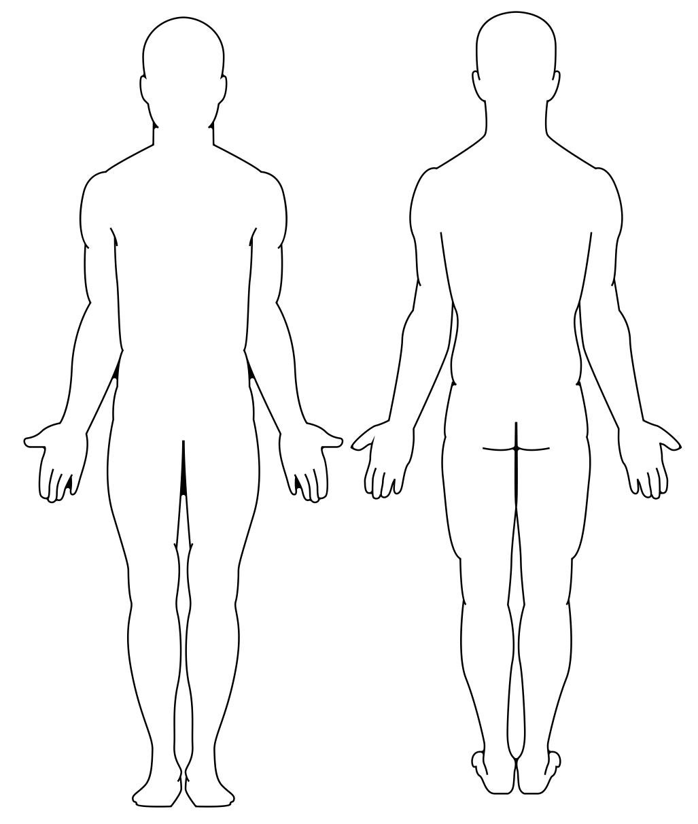

Causation Tool
Directions: First, add the event you are analyzing (in the middle of the page). Be sure to include dates, location, and a brief description of the event. Then, list your causes (at the top of the page) and use the legend to help you label type and role. Finally, list the effects of the event (bottom of page), and again use the legend to help you label type and role. If your teacher asks you to create a causal map, use your answers here to help construct that causal representation.
Causes: Long-Term | Intermediate-Term | Short-Term
Event (include the name, dates, location, and a brief description)
Effects
Legend
Type | Role
(P) Political (I) Innovation ($) Economic (C) Cultural (E) Environmental (S) Social | (*) Triggering Event Necessary Relevant
- Write the autopsy for your empire.
- Write a one- to two-paragraph obituary for your empire (hint: use your completed Causation Tool for this). Be sure to answer the following questions as part of your obituary:
  - What were the main achievements of this empire?
  - What factors led to the collapse or restructuring of this empire and which of these factors were the most historically significant?
  - Were these causes the result of internal struggles or external influences?
- Is it possible that some historians might choose different causes as the most significant ones?
- Would focusing on a different set of causes change the history of this empire’s collapse, and if so, how?

