|  |  |  |  |
| --- | --- | --- | --- |
| Name: |  | Date: |  |

## Preparation

* Have the [Comparison](https://www.oerproject.com/OER-Materials/OER-Media/PDFs/Teacher-Resources/WHP-Comparison-Tool), [CCOT](https://www.oerproject.com/OER-Materials/OER-Media/PDFs/Teacher-Resources/WHP-CCOT-Tool), and [Causation](https://www.oerproject.com/OER-Materials/OER-Media/PDFs/Teacher-Resources/WHP-Causation-Tool) tools available
* Download the [WHP Writing Rubric](https://www.oerproject.com/OER-Materials/OER-Media/PDFs/Teacher-Resources/WHP-Writing-Rubric)

## Purpose

This DBQ is another opportunity to get a sense of your progress in developing your historical thinking and writing skills. Additionally, writing DBQs will help prepare you to be successful on the written portion of standardized tests.

## Process

### Day 1

1. It’s time for another DBQ. This time, you’ll be thinking about trade networks after the fall of the Roman Empire and Han Dynasty. The DBQ prompt is: *Develop an argument that evaluates the extent to which the collapse of the Roman Empire and Han Dynasty China impacted trade networks up to c. 1200 CE*.
2. Start out by using the Question Parsing Tool to help you figure out what this question is really asking, so you can write an appropriate response.
3. Take out the Unit 5 DBQ and skim the documents quickly. Then, pick the thinking tool you want to use to help you analyze the documents (comparison, causation, or CCOT).
4. Once you’ve picked a tool, read each document a bit more closely and write down or underline the information you think you might use in your essay, along with any additional sourcing you have time for. Write your ideas on your chosen tool as you work through the documents.
5. Create a major claim or thesis statement that responds to the prompt. The notes you have taken should help you form a defensible thesis statement.
6. Finally, it’s time to contextualize. As you likely know, all historical essays require this. If needed, you can use the Contextualization Tool to help you decide what to include.

### Day 2

1. This second day is your writing day. Feel free to use your tools and notes from any prewriting work you completed as you craft your essay response.
2. Make sure you have a copy of the WHP Writing Rubric available to remind you of what is important to include in your essay.
3. Don’t forget to contextualize: Think of the entire time period, not just the time immediately preceding the historical event or process you are writing about.
4. Your teacher will give you a time limit for completing your five- to six-paragraph essay responding to the DBQ.

## Unit 5 DBQ

**Directions:** Write a five- to six-paragraph essay in response to the prompt below. Make sure to use the documents provided to help support your argument. In addition to trying to meet the criteria on the WHP Writing Rubric, make sure to address the most relevant of these historical thinking skills in your response: comparison, causation, or CCOT. Finally, make sure you contextualize, or describe the broader historical context relevant to the prompt.

We suggest you spend 10-15 minutes reading these documents and 35-45 minutes writing. Sources are edited for brevity and clarity.

*Develop an argument that evaluates the extent to which the collapse of the Roman Empire and Han Dynasty China impacted trade networks up to c. 1200 CE.*

## Document 1

**Source**: Grenet, Frantz, Nicholas Sims-Williams, and Étienne de la Vaissière. “The Sogdian Ancient Letter V.” *Bulletin of the Asia Institute* 12 (1998 [2001]): 91-104. Reproduced here: <http://depts.washington.edu/silkroad/texts/sogdlet.html>. This excerpt is from a letter written between Sogdian merchants of the Silk Roads, most likely in the fourth century. The Sogdians were Central Asians with roots in Persia (Iran) and based around Samarkand (today Uzbekistan).

To the noble lord, the chief merchant Aspandhat – Sent by your servant Fri-khwataw.

From inside China I have heard worse, not better, news day by day, and … I have become isolated, and, behold, I stay here in Guzang and there is no caravan departing from here. In Guzang there are 4 bundles of white [lead powder for cosmetics] for dispatch, and 2,500 measures of pepper for dispatch [and other goods] … and half a stater of silver. When Ghawtus left Guzang I went after him, and I came to Dunhuang, but I was prevented from leaving China… Many Sogdians were ready to leave, but could not ... I would have remained at Dunhuang, but the Sogdians were destitute. I depend on charity … I am very wretched … And [they] took the silver, for they said thus: We have no money. For according to them it is better that I should be wretched than they! If you should hear how they have done me harm, then you should pay heed to this too.

Sent by your servant Fri-khwataw. This letter was written from Guzang in the third month on the thirtieth day.

## Document 2

**Source**: Hansen, Valerie. “The Impact of the Silk Road Trade on a Local Community: The Turfan Oasis, 500–800.” In *Les Sogdiens en Chine* edited by Etienne de la Vaissière and Eric Trombert. Paris: École Française d’Extrême Orient, 2005, pp. 283-310. [https://history.yale.edu/sites/default/files/files/ hansen-silk-road-trade.pdf](https://history.yale.edu/sites/default/files/files/%20hansen-silk-road-trade.pdf). In this excerpt, historian Valerie Hansen recounts two transactions along the Silk Roads in the eighth-century oasis town of Turfan or Xizhou during the Tang Dynasty.

In 731 the Sogdian merchant Mi Lushan sold an eleven-year-old girl to a resident of Chang’an for forty bolts of silk. Five men served as guarantors, vouching that she was not a free person who had been enslaved (*The Tang Code* banned the enslavement of commoners). Of the four with household registration in Xizhou (Tang-dynasty Turfan), three had Sogdian last names (Shi, Cao, and Kang) and the one with the surname Luo was probably a member of the Tuhuoluo tribe, whose primary home was Tokharistan. The fifth guarantor, also with the surname Kang, was designated a temporary resident of Xizhou.

In 733 a Sogdian commoner resident in Xizhou, Shi Randian bought a horse for eighteen bolts of silk from a Sogdian named Kang. Historian, Jonathan Skaff has pieced together information from different documents to follow Shi Randian’s route from Hami to Dunhuang, and concluded that he may have traveled the entire route specified by his travel permit from Guazhou, Gansu, to Kucha. When Shi Randian purchased the horse, three guarantors vouched that the horse was not stolen: one Tuhuoluo non-resident merchant, one non-resident merchant from Bukhara and one commoner resident in Xizhou, a Sogdian named Shi.

Although no document says so explicitly, it seems likely that the seller paid the guarantors a small fee to vouch for the legality of the goods being sold, since the guarantors were financially liable should the slave or animal in question turn out to be stolen. The presence of resident and non-resident Sogdian guarantors indicates that Sogdian trade networks included both non-resident merchants as well as those entered on the household registers of Xizhou and other localities as commoners.

## Document 3

**Source**: Procopius. *The Secret History*. Translated by G.A. Williamson. Baltimore, MD: Penguin Books, 1966, pp. 167-68. This excerpt is from Procopius’ (c. 500–570 CE) *Secret History* (c. 550), unpublished in the Byzantine historian’s lifetime, but considered to be a sensational reflection of Procopius’s disillusionment with the rulers of the Byzantine Empire.

The manufacture of silken garments had for many generations been a staple industry of Beirut and Tyre, two cities of Phoenicia. The merchants who handled these and the skilled and semi-skilled workmen who produced them had lived there from time immemorial, and their wares were carried from there into every land. When Justinian was on the throne, those engaged in this business in Byzantium and the other cities began to charge a higher price for dress materials of this kind, justifying themselves on the ground that they were now having to pay the Persians more for it than in the past, and that it was no longer possible to avoid paying the ten per cent duty on imports.

The importers who had hitherto been occupied with this trade in Byzantium and all the other cities, whether operating on sea or on land, naturally had to endure the hardships resulting from these operations. And in the cities referred to almost the whole population suddenly found themselves beggars. Mechanics and handicraftsmen were inevitably compelled to struggle against starvation, and many in consequence abandoned the community to which they belonged and fled to refuge to the land of Persia. Year after year the whole profit from this trade came into the hands of one man, the Treasurer, who as we have said was good enough to hand a portion of his receipts from this source to the Emperor, but secured the bulk for himself and grew rich at the cost of public misery.

## Document 4

**Source**: Beal, Samuel. *Buddhist Records of the Western World*. London: Trubner & Co. Ltd., 1884. Reproduced here: [https://depts.washington.edu/silkroad/ texts/xuanzang.html](https://depts.washington.edu/silkroad/%20texts/xuanzang.html). The Chinese Buddhist pilgrim, Xuanzang (602–664 CE), traveled from China to the west (present day Tibet, Xinjiang, Central Asia, and India), and recorded his trip in “Record of the Western Regions.”

The country of Sa-mo-kien [Samarkand, today Uzbekistan] is … completely enclosed by rugged land and very populous. The precious merchandise of many foreign countries is stored up here. The soil is rich and productive, and yields abundant harvests. The forest trees afford a thick vegetation, and flowers and fruits are plentiful. The Shen horses are bred here. The inhabitants are skillful in the arts and trades beyond those of other countries. The climate is agreeable and temperate. The people are brave and energetic. This country is in the middle of the Hu people … They are copied by all surrounding people in point of politeness and propriety. The king is full of courage, and the neighboring countries obey his commands. The soldiers and the horses are strong and numerous, … naturally brave and fierce, and meet death as a refuge (escape or salvation). When they attack, no enemy can stand before them.

In the country of “the lord of treasures” [a region of northern India] the people have no politeness or justice. They accumulate wealth. Their dress is short, with a left skirt. They cut their hair and cultivate their moustache. They dwell in walled towns and are eager in profiting by trade.

## Document 5

**Source**: Mackeras, Colin. *The Uighur Empire According to the T’ang Dynastic Histories: A Study in Sino-Uighur Relations 744–840*. Columbia, South Carolina: University of South Carolina Press, 1972. Reproduced here <https://depts.washington.edu/silkroad/texts/tangshu/tangshu.html>. These excerpts from *The New Tang History* describe interactions between China and its neighbors to the northwest, the Uighurs (Uyghurs).

Following on the Ch’ien-yüan period (758–60), the Uighurs took even more advantage of their services to China by taking as a price forty pieces of silk for every horse they brought in as tribute ... The horses were inferior, weak, and unusable. The emperor gave them generous presents, wanting by this means to shame them, but they did not recognize this …

In the thirteenth year (778), the Uighurs made a surprise attack on Chen-wu, they made an onslaught on Tung-hsing and invaded T’ai-yüan. The Military Governor of Ho-tung, Pao Fang, had a battle with them in Yang-ch’ü. Fang was defeated. The injured and dead numbered 10,000. The Governor-general of Tai-chou, Chang Kuang-sheng, again had a battle with them in the Yang-hu Valley and defeated them, whereupon the barbarians went away …

[From an 814 memorial to the emperor by the Minister of Rites] The Uighurs are very strong and the northern borders are deserted. Once they stir up trouble, our weak soldiers will not be able to withstand them, and there will be no one to guard the isolated cities … The northern barbarians are covetous and grasping. All they care about is profit. This is the second year that their normal yearly consignment of horses has not arrived. Can it be that they have become satiated with the profit of silken fabrics? ... Our armies have not yet reached full strength, our patrol system is not yet effective, our lances and armor are not yet ready, our walls and moats are not yet firmly established… and the evacuation of the Western [Shou-hsiang] Fortress has left the desert roads with nothing to depend on …

## Document 6

**Source**: Monks from Central Asia and China wearing traditional kāṣāya. Bezeklik Caves, eastern Tarim Basin, 9th–10th century. Reproduced here <http://dsr.nii.ac.jp/toyobunko/LFc-42/V-1/page/0089.html.en>. The postures of the two figures reveal that the Central Asian Buddhist monk (possibly Sogdian) on the left is teaching the East Asian monk (possibly Chinese) on the right. The image is from the “Thousand-Buddha Cave” in the oasis town of Turfan (today Xinjiang in northwestern China).

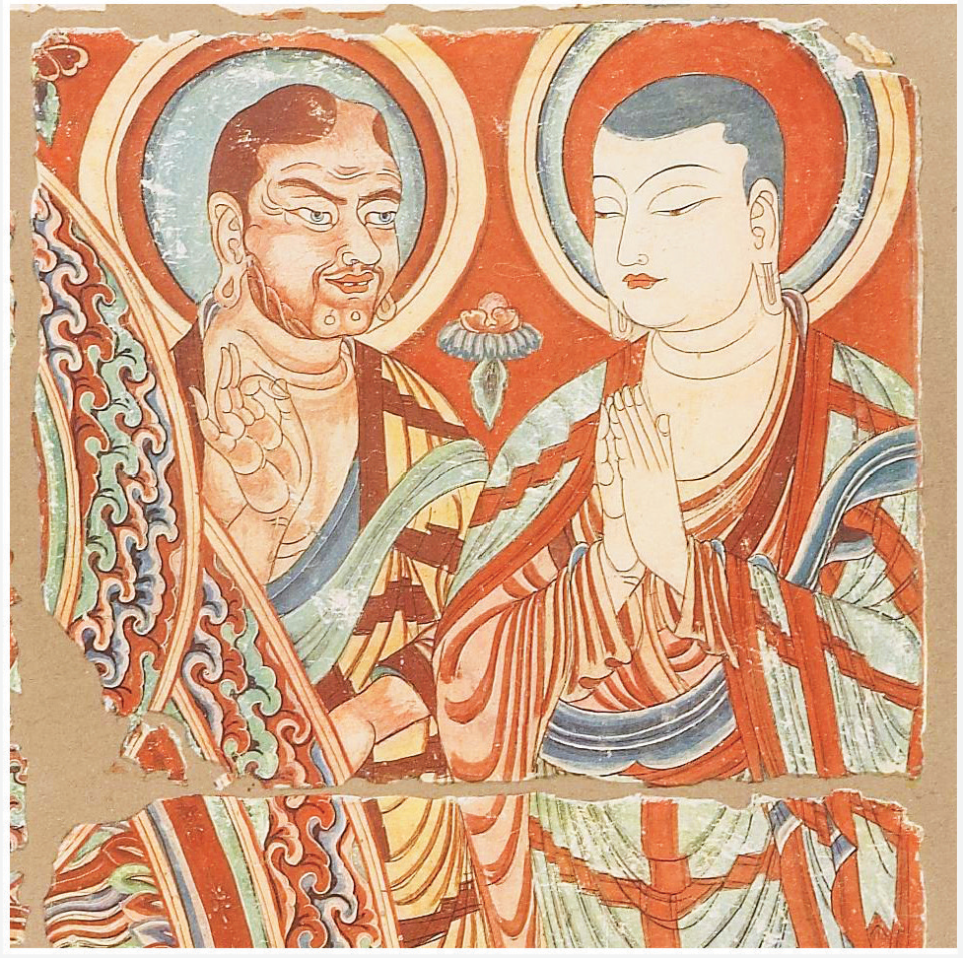

## Document 7

**Source**: Adler, Marcus Nathan. *The Itinerary of Benjamin of Tudela: Critical Text, Translation and Commentary*. New York: Phillip Feldheim, Inc., 1907. Reproduced here <https://depts.washington.edu/silkroad/texts/tudela.html>. Benjamin of Tudela (1130–1173 CE) was a Jewish traveler whose “itinerary” took him through Europe, the Middle East and northern Africa. This is an account of Constantinople (today Istanbul).

All sorts of merchants come here from the land of Babylon, from the land of Shinar, from Persia, Media, and all the sovereignty of the land of Egypt, from the land of Canaan, and the empire of Russia, from Hungaria, Patzinakia, Khazaria, and the land of Lombardy and Sepharad. It is a busy city, and merchants come to it from every country by sea or land, and there is none like it in the world except Bagdad, the great city of Islam. In Constantinople is the church of Santa Sophia, and the seat of the Pope of the Greeks, since the Greeks do not obey the Pope of Rome. There are also churches according to the number of the days of the year … And in this church there are pillars of gold and silver, and lamps of silver and gold more than a man can count. Close to the walls of the palace is also a place of amusement belonging to the king, which is called the Hippodrome, and every year on the anniversary of the birth of Jesus the king gives a great entertainment there. And in that place men from all the races of the world come before the king and queen with jugglery and without jugglery, and they introduce lions, leopards, bears, and wild asses, and they engage them in combat with one another; and the same thing is done with birds. No entertainment like this is to be found in any other land.

## Question Parsing Tool

**Directions**: Follow the steps to parse the prompt you are presented with. Use the key at the bottom to help you with the historical reasoning practice and composition questions.

1. **Prompt**:

|  |
| --- |
|  |

1. Rewrite the prompt in your own words:

|  |
| --- |
|  |

1. **Periodization**: What is the time period you are being asked to consider? Write out the years if you are given something in terms of century (for example, twentieth century = 1900s).

|  |
| --- |
|  |

1. **Location**: What areas of the world are included in this prompt?

|  |
| --- |
|  |

1. **Topic**: What is the main topic being asked about in this prompt?

|  |
| --- |
|  |

1. **Historical reasoning practice**: What historical reasoning practice is this prompt asking you to engage in? Provide justification for why you chose the one you did.

|  |
| --- |
|  |

1. **Composition**: What is the prompt stem asking you to do as part of your response? Remember the prompt stem is usually a verb.

|  |
| --- |
|  |

## Key

|  |  |
| --- | --- |
| Historical Reasoning Practice | Words/Phrases to Look For |
| Causation | Cause, effect, led to, lead to, emergence, resulted, bring about, give rise to, be the cause of, result in, produce, generate, spawn, precipitate, prompt, induce, promote, foster, provoke, trigger |
| Comparison | Similarities, differences, compare, contrast, set side-by-side, juxtapose, differentiate, liken, equate |
| CCOT | Continuities, changes, continuation, persistence, consistent, over time, two points in time |
| Prompt Stem Examples | **What It’s Asking in Simpler Language** |
| To what extent | Weigh, evaluate, assess |
| Evaluate, assess | How much—needs a quantitative answer/thesis/claim (Note: A quantitative answer is one that includes an amount or a number. For example: a lot, a little) |
| Analyze, develop | Describe and explain |
| Argue, argument | Make a claim |