|  |  |  |  |
| --- | --- | --- | --- |
| Name: |  | Date: |  |

## Preparation

* Have the [Comparison](https://www.oerproject.com/OER-Materials/OER-Media/PDFs/Teacher-Resources/WHP-Comparison-Tool), [CCOT](https://www.oerproject.com/OER-Materials/OER-Media/PDFs/Teacher-Resources/WHP-CCOT-Tool), and [Causation](https://www.oerproject.com/OER-Materials/OER-Media/PDFs/Teacher-Resources/WHP-Causation-Tool) tools available
* Download the [WHP Writing Rubric](https://www.oerproject.com/OER-Materials/OER-Media/PDFs/Teacher-Resources/WHP-Writing-Rubric)

## Purpose

This DBQ is another opportunity for you to show how your historical thinking skills and reasoning practices are developing. This will help you become better at making and supporting historical claims and will also help you on standardized tests that ask you to analyze documents in response to a specific prompt.

## Process

### Day 1

1. Start out by using the Question Parsing Tool to help you figure out what the prompt is really asking so you can write an appropriate response. The prompt for this DBQ is: *Develop an argument that evaluates which revolution of the long nineteenth century caused the greatest enduring change for the most people.*
2. Take out the DBQ and skim the documents quickly.
3. Pick the thinking tool you want to use to help you analyze the documents (comparison, causation, or CCOT).
4. Read each document a bit more closely and write down or underline the information you think you might use in your essay, along with any additional sourcing you have time for. Write your ideas in your chosen tool as you work through the documents.
5. Create a major claim or thesis statement that responds to the prompt. The notes you have taken should help you form a defensible thesis statement.
6. Finally, it’s time to contextualize. As you likely know, all historical essays require this. If needed, you can use the Contextualization Tool to help you decide what to include.

### Day 2

1. This second day is your writing day. Feel free to use your tools and notes from any prewriting work you completed as you craft your essay response.
2. Make sure you have a copy of the WHP Writing Rubric available to remind you of what is important to include in your essay.
3. Don’t forget to contextualize: Think of the entire time period, not just the time immediately preceding the historical event or process you are writing about.
4. Your teacher will give you a time limit for completing your five- to six-paragraph essay responding to the DBQ.

## Document 1

**Source**: Stearns, Peter N. *World History in Documents*: A Comparative Reader. New York: New York University Press, 1998. Excerpts are edited for clarity and brevity.

The excerpts below were written by Simon Bolivar. The first excerpt is from the 1813 Proclamation, written about Spanish occupation of Venezuela. The second excerpt is taken from Bolivar’s 1819 speech to the Venezuelan legislature.

We are sent to destroy the Spaniards, to protect the Americans, and to reestablish the republican governments that once formed the Confederation of Venezuela. The states defended by our arms are again governed by their former constitutions and tribunals, in full enjoyment of their liberty and independence, for our mission is designed only to break the chains of servitude which still shackle some of our towns. … (1813)

Passing from ancient to modern times, we find England and France attracting the attention of all nations and affording them a variety of lessons in matters of government. The revolution of these two great peoples, like a flaming meteor, has flooded the world with such a profusion of political enlightenment that today every thinking person is aware of the rights and duties of man and the nature of the virtues and vices of governments. …

May the teachings of experience be not lost; and may the schools of Greece, Rome, France, England, and North America instruct us in the difficult science of creating and preserving nations through laws that are proper, just, legitimate, and, above all, useful. (1819)

## Document 2

**Source**: Louverture, Toussaint. “Haitian Constitution of 1801.” Translated by Charmant Theodore. The Louverture Project, 2007. <https://thelouvertureproject.org/index.php?title=Haitian_Constitution_of_1801_(English)#Full_text_of_.27Toussaint.27s_Constitution.27>

Article 3 — There cannot exist slaves on this territory, servitude is therein forever abolished. All men are born, live and die free and French.

Article 4 — All men, regardless of color, are eligible to all employment.

Article 5 — There shall exist no distinction other than those based on virtue and talent, and other superiority afforded by law in the exercise of a public function. The law is the same for all whether in punishment or in protection. …

Article 12 — The Constitution guarantees freedom and individual security. No one shall be arrested unless a formally expressed mandate, issued from a functionary to whom the law grants the right to order arrest and detention in a publicly designated location.

Article 13 — Property is sacred and inviolable. All people, either by himself, or by his representatives, has the free right to dispose and to administer property that is recognized as belonging to him. Anyone who attempts to deny this right shall become guilty of crime towards society and responsible towards the person troubled in his property.

## Document 3

**Source**: Ure, Andrew. *The Philosophy of Manufactures*. London, Charles Knight, 1836.

Andrew Ure (1778–1857) was a professor at the University of Glasgow. His book *The Philosophy of Manufactures* was first published in 1835.

The grand object therefore of the modern manufacturer is, through the union of capital and science, to reduce the task of his work-people to the exercise of vigilance and dexterity …

It is, in fact, the constant aim and tendency of every improvement in machinery to supersede human labour altogether, or to diminish its cost, by substituting the industry of women and children for that of men; or that of ordinary labourers for trained artisans. … The proprietor of a factory near Stockport states, in evidence to the commissioners, that, by such substitution, he would save *50l*. [pounds] a week in wages, in consequence of dispensing with nearly forty male spinners, at about *25s*. [shillings] of wages each. …

Steam-engines furnish the means not only of their support but of their multiplication. They create a vast demand for fuel; and, while they lend their powerful arms to drain the pits and to raise the coals, they call into employment multitudes of miners, engineers, shipbuilders, and sailors, and cause the construction of canals and railways. Thus therefore, in enabling these rich fields of industry to be cultivated to the utmost, they leave thousands of fine arable fields free for the production of food to man, which must have been otherwise allotted to the food of horses. Steam-engines moreover, by the cheapness and steadiness of their action, fabricate cheap goods, and procure in their exchange a liberal supply of the necessaries and comforts of life produced in foreign lands.

## Document 4

**Source**: Jefferson, Thomas, et al. “The Declaration of Independence.” July 4, 1776. <https://www.archives.gov/founding-docs/declaration-transcript>

We hold these truths to be self-evident, that all men are created equal, that they are endowed by their Creator with certain unalienable Rights, that among these are Life, Liberty and the pursuit of Happiness.--That to secure these rights, Governments are instituted among Men, deriving their just powers from the consent of the governed, --That whenever any Form of Government becomes destructive of these ends, it is the Right of the People to alter or to abolish it, and to institute new Government, laying its foundation on such principles and organizing its powers in such form, as to them shall seem most likely to effect their Safety and Happiness. Prudence, indeed, will dictate that Governments long established should not be changed for light and transient causes. . .But when a long train of abuses and usurpations, pursuing invariably the same Object evinces a design to reduce them under absolute Despotism, it is their right, it is their duty, to throw off such Government, and to provide new Guards for their future security.--Such has been the patient sufferance of these Colonies; and such is now the necessity which constrains them to alter their former Systems of Government. The history of the present King of Great Britain is a history of repeated injuries and usurpations, all having in direct object the establishment of an absolute Tyranny over these States.

## Document 5

**Source**: Hutchison, Elizabeth Q., Thomas Miller Klubock, Nara B. Milanich, and Peter Winn. *The Chile Reader: History, Culture, Politics*. Durham, NC: Duke University Press, 2013. Excerpts are edited for clarity and brevity.

Camilo Henríquez (1769–1825) was a Chilean priest, journalist, and politician. Below is an excerpt of an essay which was featured in the first edition of Chile’s first newspaper, *La Aurora de Chile*, in 1812.

Let us establish as a principle, then, that supreme authority finds its origin in the free consent of the people, which we may call a social pact or alliance. …

The parties to the contract are the people and the executive authority. In a monarchy, these are the people and the king.

The king agrees to guarantee and preserve safety, property, liberty, and order. This guarantee comprises all the monarch’s duties. …

… one of the rights of the people was to reform the constitution of the state. In fact, the constitution should be adjusted to the people’s current circumstances and needs at any given time; whenever circumstances vary, the constitution should vary. There is no law or custom that should endure if it can bring any detriment, inconvenience, or preoccupation to the political body. The health of the people is the supreme law. …

I say here to the people: such are the principles from which your eternal rights emanate. They ennoble your being: you owe them to the sovereign Author of nature. …

Have no doubt: ignorance of these rights keeps the chains of slavery intact. Countries have been moaning under the weight of despotism for as long as they have been under this reign of ignorance and barbarity. …

## Document 6

**Source**: Humphreys, R. A. and John Lynch. *The Origins of the Latin American Revolutions, 1808–1826*. New York: Knopf, 1965. Excerpts are edited for clarity and brevity.

Manuel Belgrano (1770-1820) was an Argentine lawyer who attained his law degree in Spain and then became a revolutionary. Below is an excerpt from his 1814 autobiography.

… I was fortunate to meet men dedicated to the common good who introduced me to their useful ideas, I was seized with the desire to promote public welfare. . .to the advantage especially of my own country.

Since I was in Spain in 1789 at a time when the French Revolution was causing a change in ideas, particularly among the men of letters with whom I associated, the ideas of liberty, equality, security, and property, took a firm hold on me, and I saw only tyrants in those who would prevent a man, whatever his origin, from enjoying the rights with which God and Nature had endowed him. …

… from the beginning of 1794 to July 1806 I passed my time in futile efforts to promote the public good. All foundered on the opposition of the government of Buenos Aires, of Madrid. …

… it was painful to me to see my country under foreign domination, and above all in such a state of degradation. …

[The British general] told me his ideas about our independence, perhaps in the hope of forming new links with this country … when I had shown how we lacked the means for winning independence, he was of the opinion that it would take a century to achieve. … A year

passed, and behold, without effort on our part to become independent … the ideals of liberty and independence came to life in America, and Americans for the first time began to speak openly of their rights.

## Document 7

**Source**: Gillam, Victor. “A Thing Well Begun Is Half Done.” Judge Magazine, October 7, 1899. Cornell University – PJ Mode Collection of Persuasive Cartography. <https://digital.library.cornell.edu/catalog/ss:3293822>

This cartoon by the American cartoonist Victor Gillam (1858–1920). It was published in *Judge* magazine, an American satirical magazine that was published weekly from 1881 to 1947, which was a rival to *Puck* magazine.

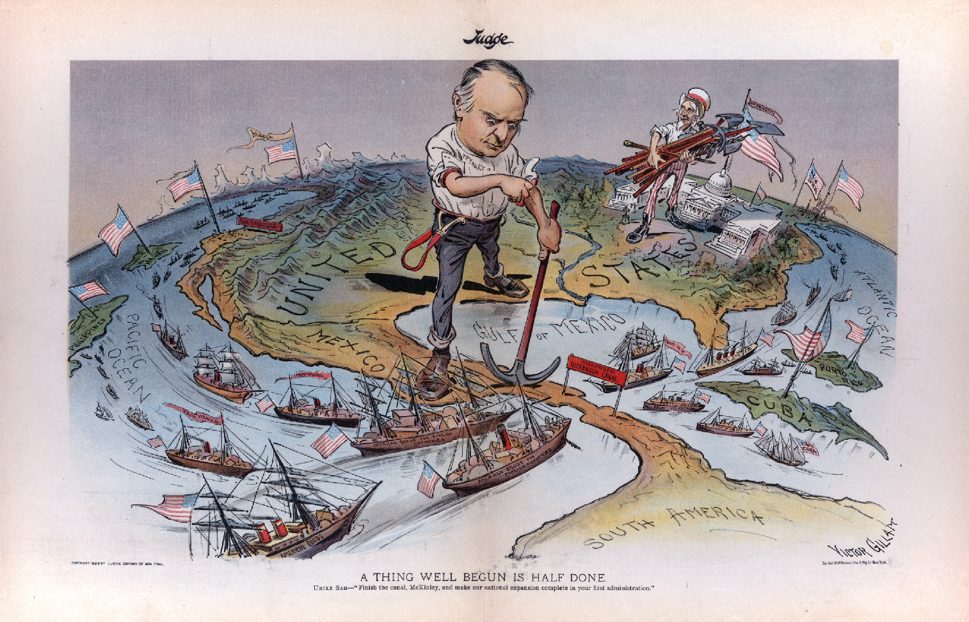

## Question Parsing Tool

**Directions**: Follow the steps to parse the prompt you are presented with. Use the key at the bottom to help you with the historical reasoning practice and composition questions.

1. **Prompt**:

|  |
| --- |
|  |

1. Rewrite the prompt in your own words:

|  |
| --- |
|  |

1. **Periodization**: What is the time period you are being asked to consider? Write out the years if you are given something in terms of century (for example, twentieth century = 1900s).

|  |
| --- |
|  |

1. **Location**: What areas of the world are included in this prompt?

|  |
| --- |
|  |

1. **Topic**: What is the main topic being asked about in this prompt?

|  |
| --- |
|  |

1. **Historical reasoning practice**: What historical reasoning practice is this prompt asking you to engage in? Provide justification for why you chose the one you did.

|  |
| --- |
|  |

1. **Composition**: What is the prompt stem asking you to do as part of your response? Remember the prompt stem is usually a verb.

|  |
| --- |
|  |

## Key

|  |  |
| --- | --- |
| Historical Reasoning Practice | Words/Phrases to Look For |
| Causation | Cause, effect, led to, lead to, emergence, resulted, bring about, give rise to, be the cause of, result in, produce, generate, spawn, precipitate, prompt, induce, promote, foster, provoke, trigger |
| Comparison | Similarities, differences, compare, contrast, set side-by-side, juxtapose, differentiate, liken, equate |
| CCOT | Continuities, changes, continuation, persistence, consistent, over time, two points in time |
| Prompt Stem Examples | **What It’s Asking in Simpler Language** |
| To what extent | Weigh, evaluate, assess |
| Evaluate, assess | How much—needs a quantitative answer/thesis/claim (Note: A quantitative answer is one that includes an amount or a number. For example: a lot, a little) |
| Analyze, develop | Describe and explain |
| Argue, argument | Make a claim |