Name: |  | Date:

Purpose
In this activity, you will examine images from before and after the Industrial Revolution, which should give you a sense of how quickly change accelerated once the Industrial Revolution began. Seeing these changes through image analysis will also help reinforce the specific impacts on communities, networks, and production and distribution.

Process
In this activity, you will look at images from before and after the Industrial Revolution, and then answer questions about how these pictures can help us see changes in communities, networks, and production and distribution.
Start by looking at the images from Denis Diderot’s Encyclopédie. Diderot’s Encyclopédie was published from 1751 to 1772, and is famous for representing the philosophy of the Enlightenment. Diderot’s goal was to create an encyclopedia of knowledge that included intellectual topics as well as everyday themes, such as the tools people used in their work. In addition, he wanted to influence the way people thought and some of the entries on politics and religion were revolutionary for the time. When you look at the Encyclopédie images, what do you notice and what do you think each picture represents? Now, look at the images from after the Industrial Revolution. Try to get a sense of what each one is about, and how they are different from Diderot’s Encyclopédie illustrations.
Now, look at the images side by side, comparing pre- and post-industrialization. After you’ve looked at the pictures, answer the following question:
When examining these images, what kinds of changes do you see happening rather quickly to communities, networks, and production and distribution as a result of industrialization?
Note that this is really three questions, since you need to respond in relation to each of the frames. Also, in answering the question, you should refer back to the illustrations and the specifics of the images that influenced your answers. Once you’re done, be prepared to discuss your responses as a class.
Do you think one frame was more impacted than another, or was the change similar across all three? While we usually think about the frames separately, they do overlap, and it’s hard for one to grow and change without the others being impacted. Your teacher will either have you discuss this last question as a class, or, create a chalkboard splash. To do that, you’ll answer the question in 15 words or less. When you are ready, write your response on the board.
This is a good way to share your thinking and see what your classmates are thinking, too.

Images from Denis Diderot’s Encyclopédie
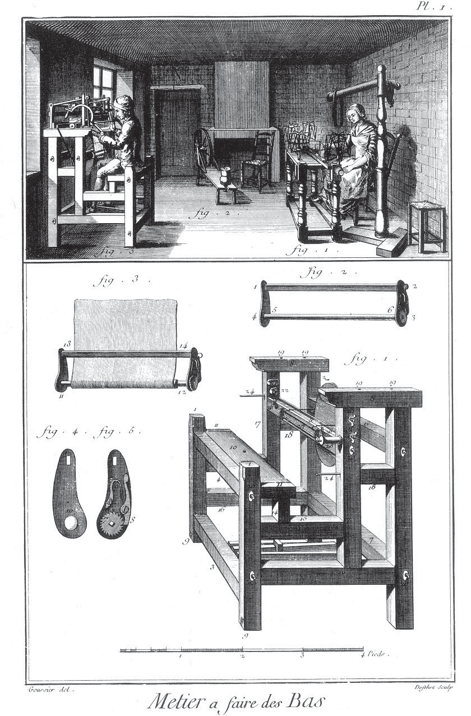
Image 1: Stocking loom. Public domain.
https://quod.lib.umich.edu/cgi/t/text/text-idx?c=did;cc=did;rgn=main;view=text;idno=did2222.0001.385
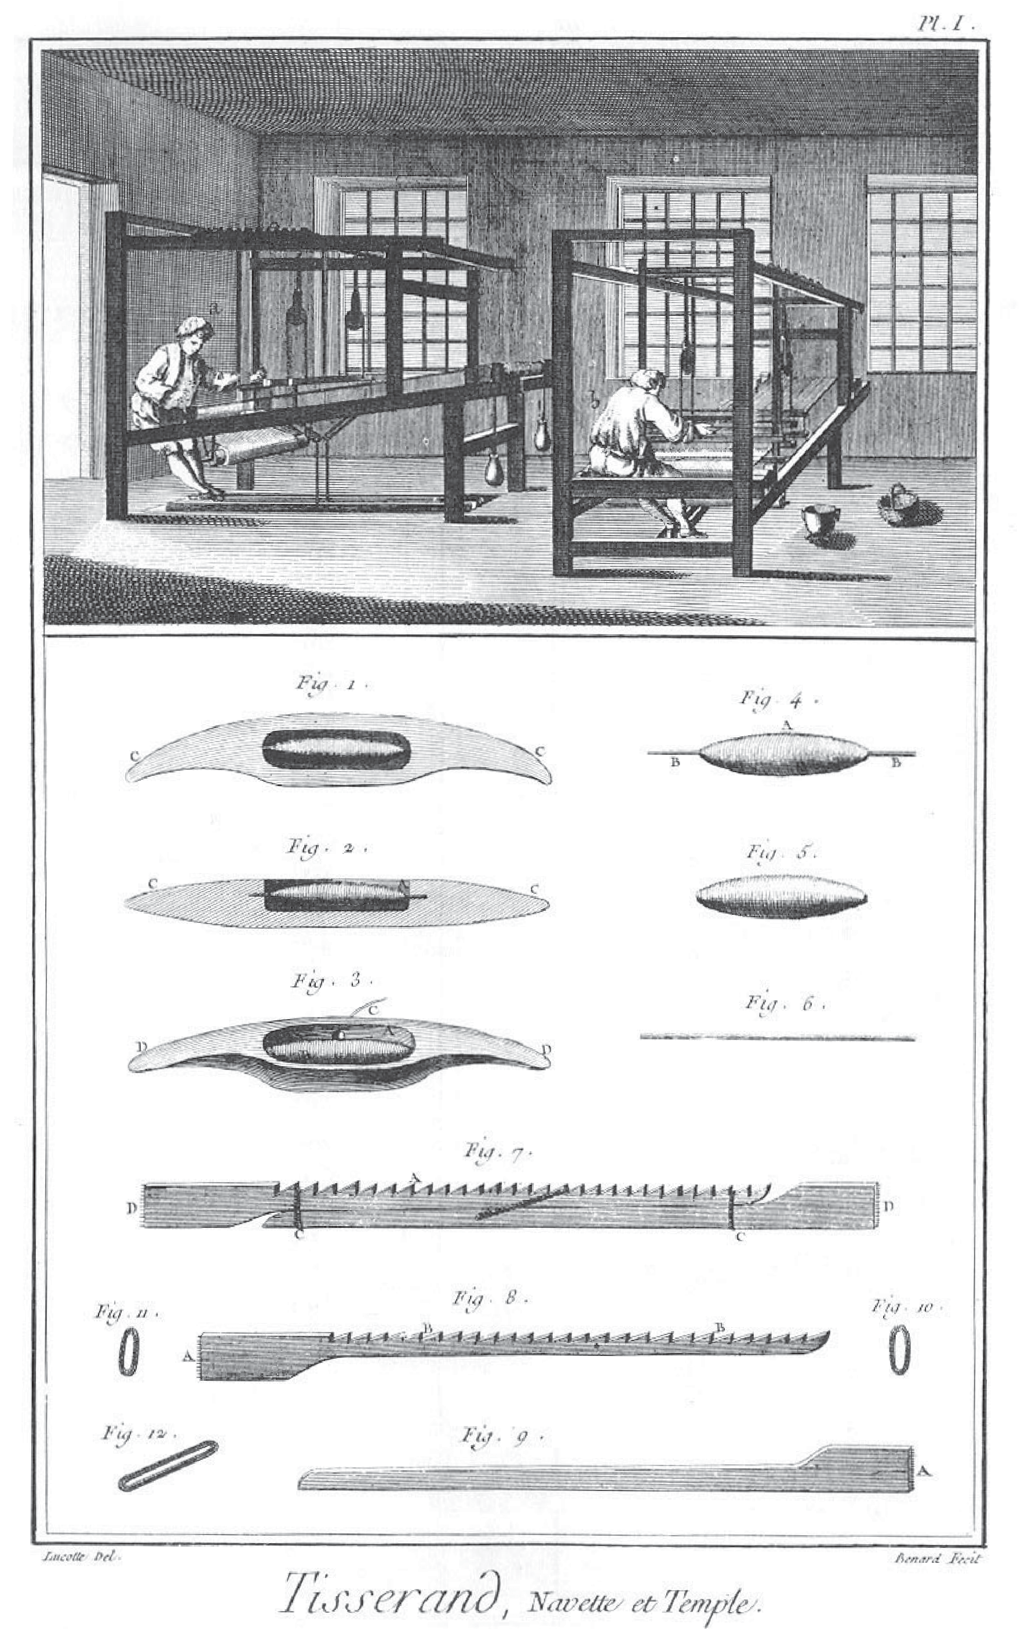
Image 2: Weaving. Public domain.
https://quod.lib.umich.edu/cgi/t/text/text-idx?c=did;cc=did;rgn=main;view=text;idno=did2222.0001.648
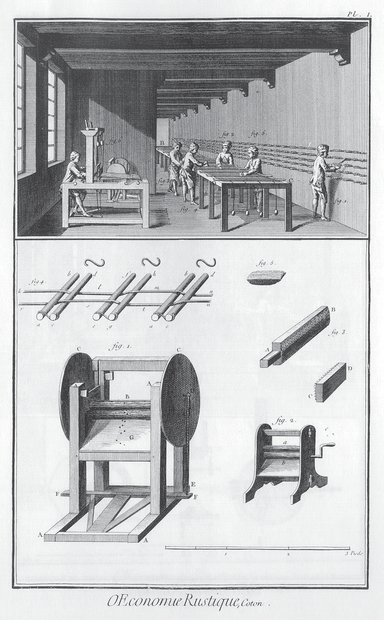
Image 3: Rural economy, cotton production. Public domain.
https://quod.lib.umich.edu/d/did/did2222.0001.339/--agriculture-and-rural-economy-processing-and-uses-of-cotton?rgn=main;view=fulltext;q1=cotton
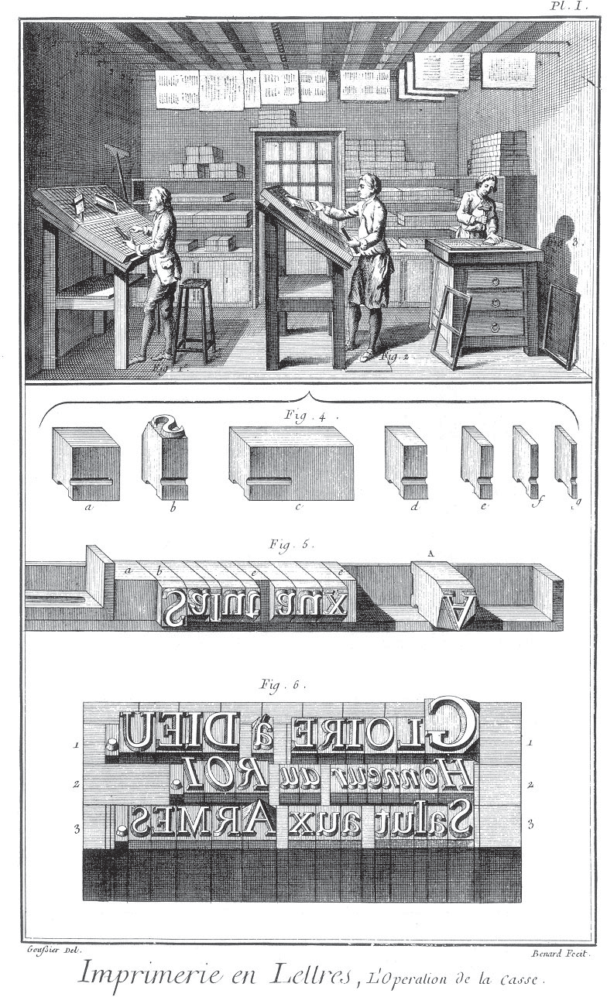
Image 5: Letterpress printing. Public domain.
https://quod.lib.umich.edu/cgi/t/text/text-idx?c=did;cc=did;rgn=main;view=text;idno=did2222.0001.562

Images of eighteenth- and nineteenth-century industrialization
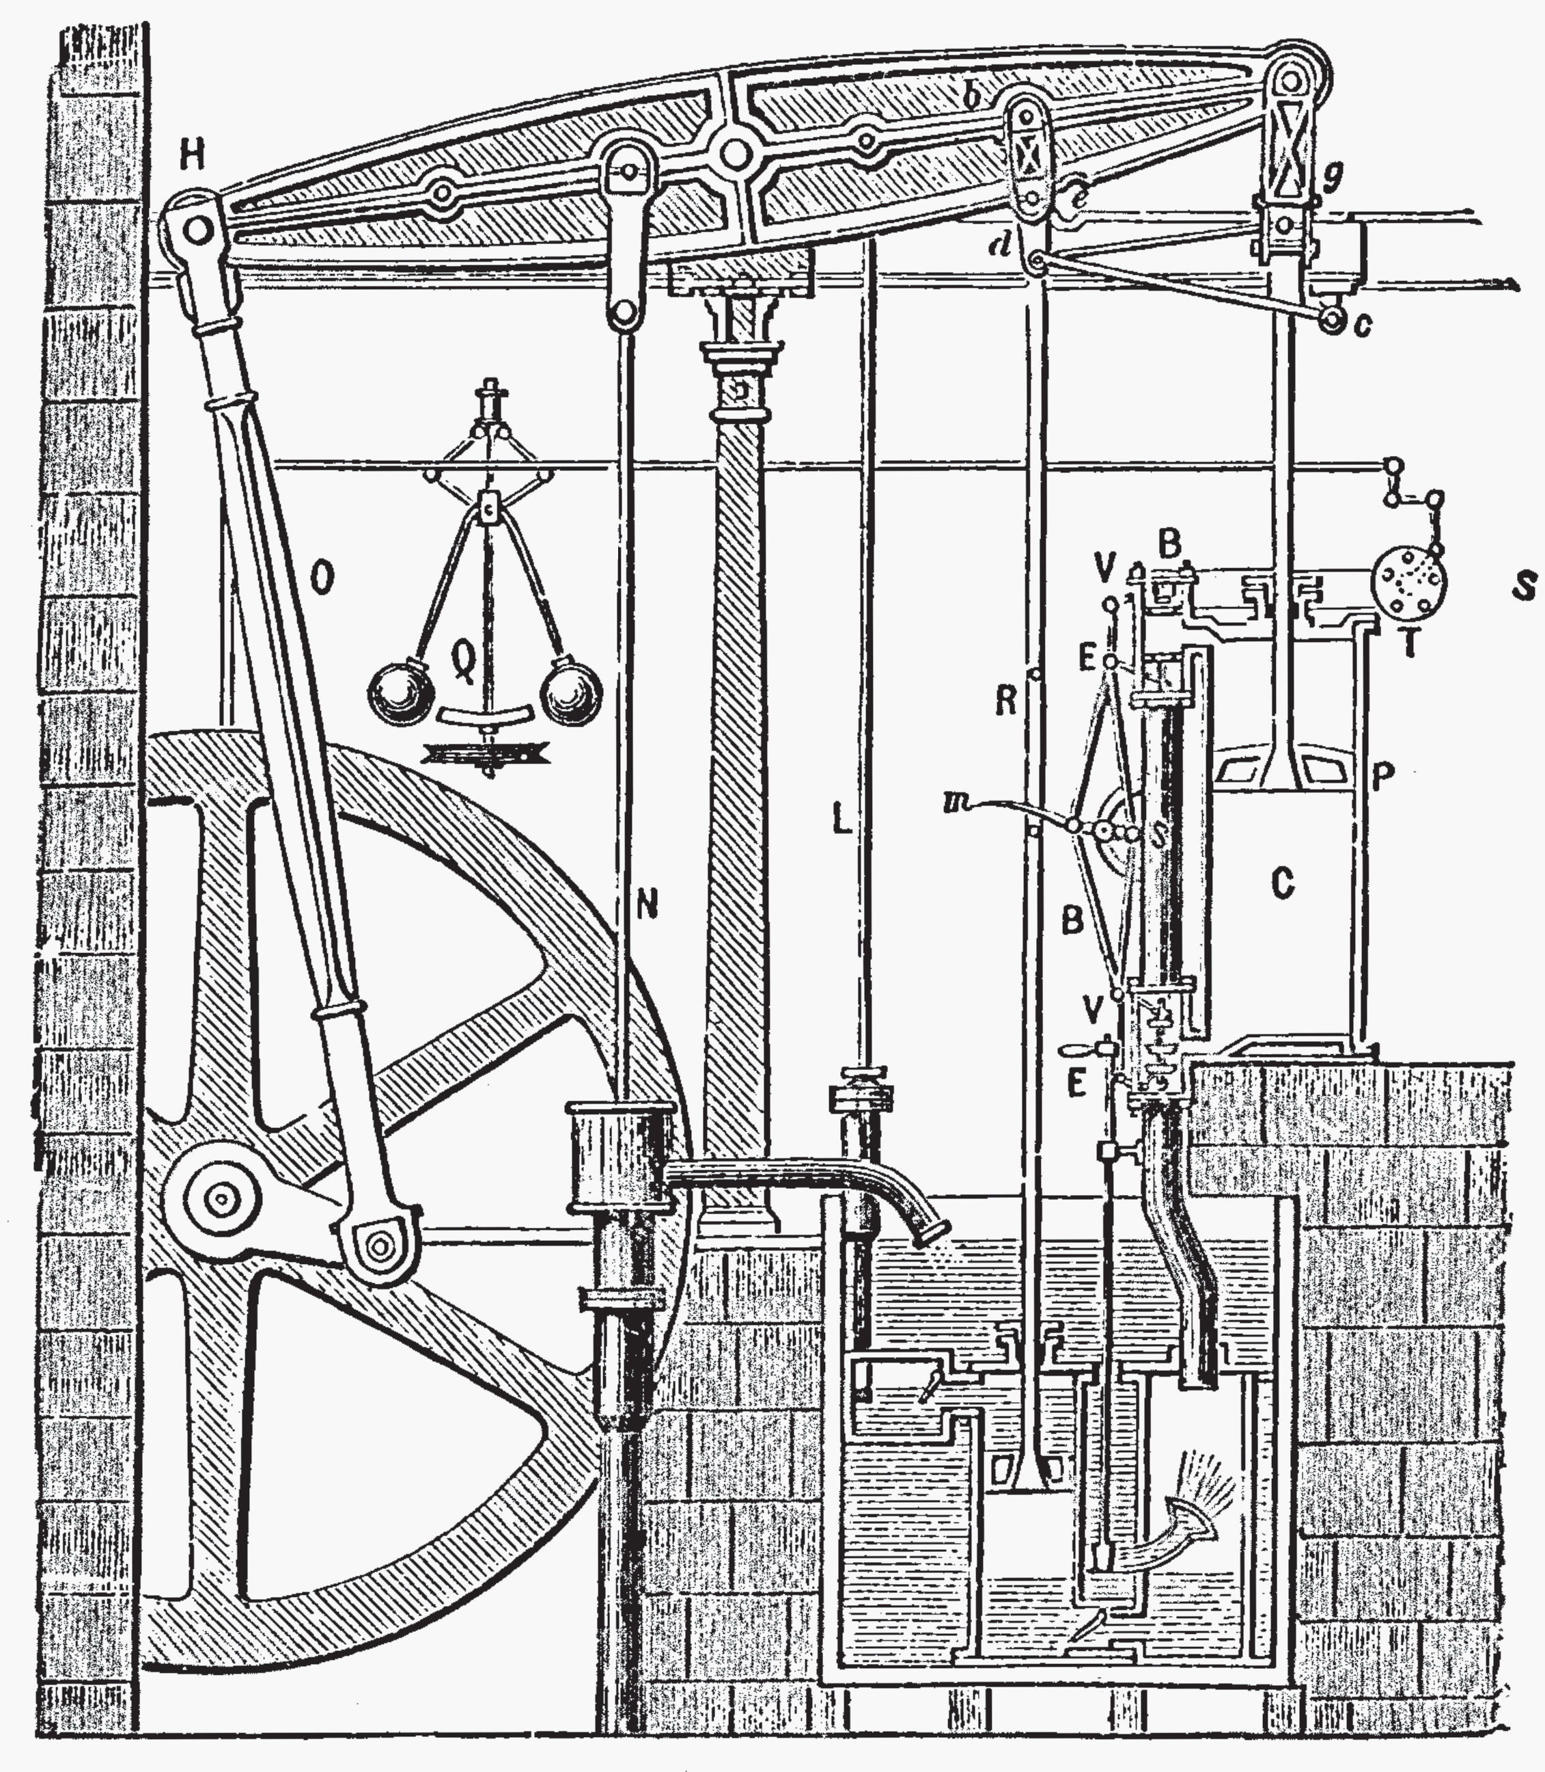
Image 6: Boulton and Watt’s steam engine, 1781, from Thurston, Robert Henry. A History of the Growth of the Steam Engine.
New York: D. Appleton, 1878 (p. 104). Public domain.
https://commons.wikimedia.org/wiki/File:SteamEngine_Boulton%26Watt_1784.png

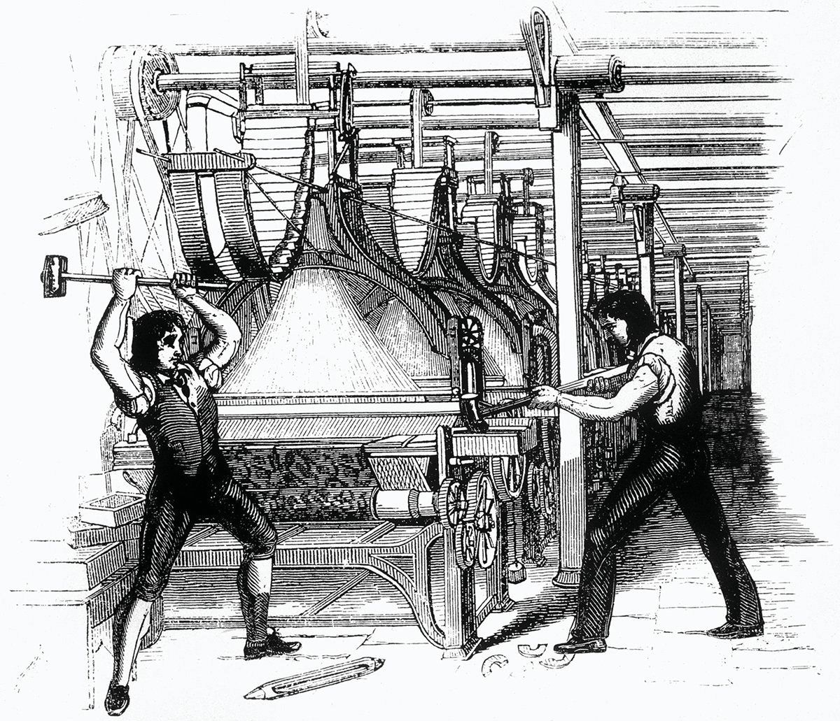
Image 7: Luddites smashing a loom. An 1812 engraving of Luddites (skilled weavers and machine operators in Britain) who were angry that unskilled people were being hired because they could be paid less. In protest, the Luddites smashed machines like looms at factories around Britain. Public domain.
https://commons.wikimedia.org/wiki/File:FrameBreaking-1812.jpg
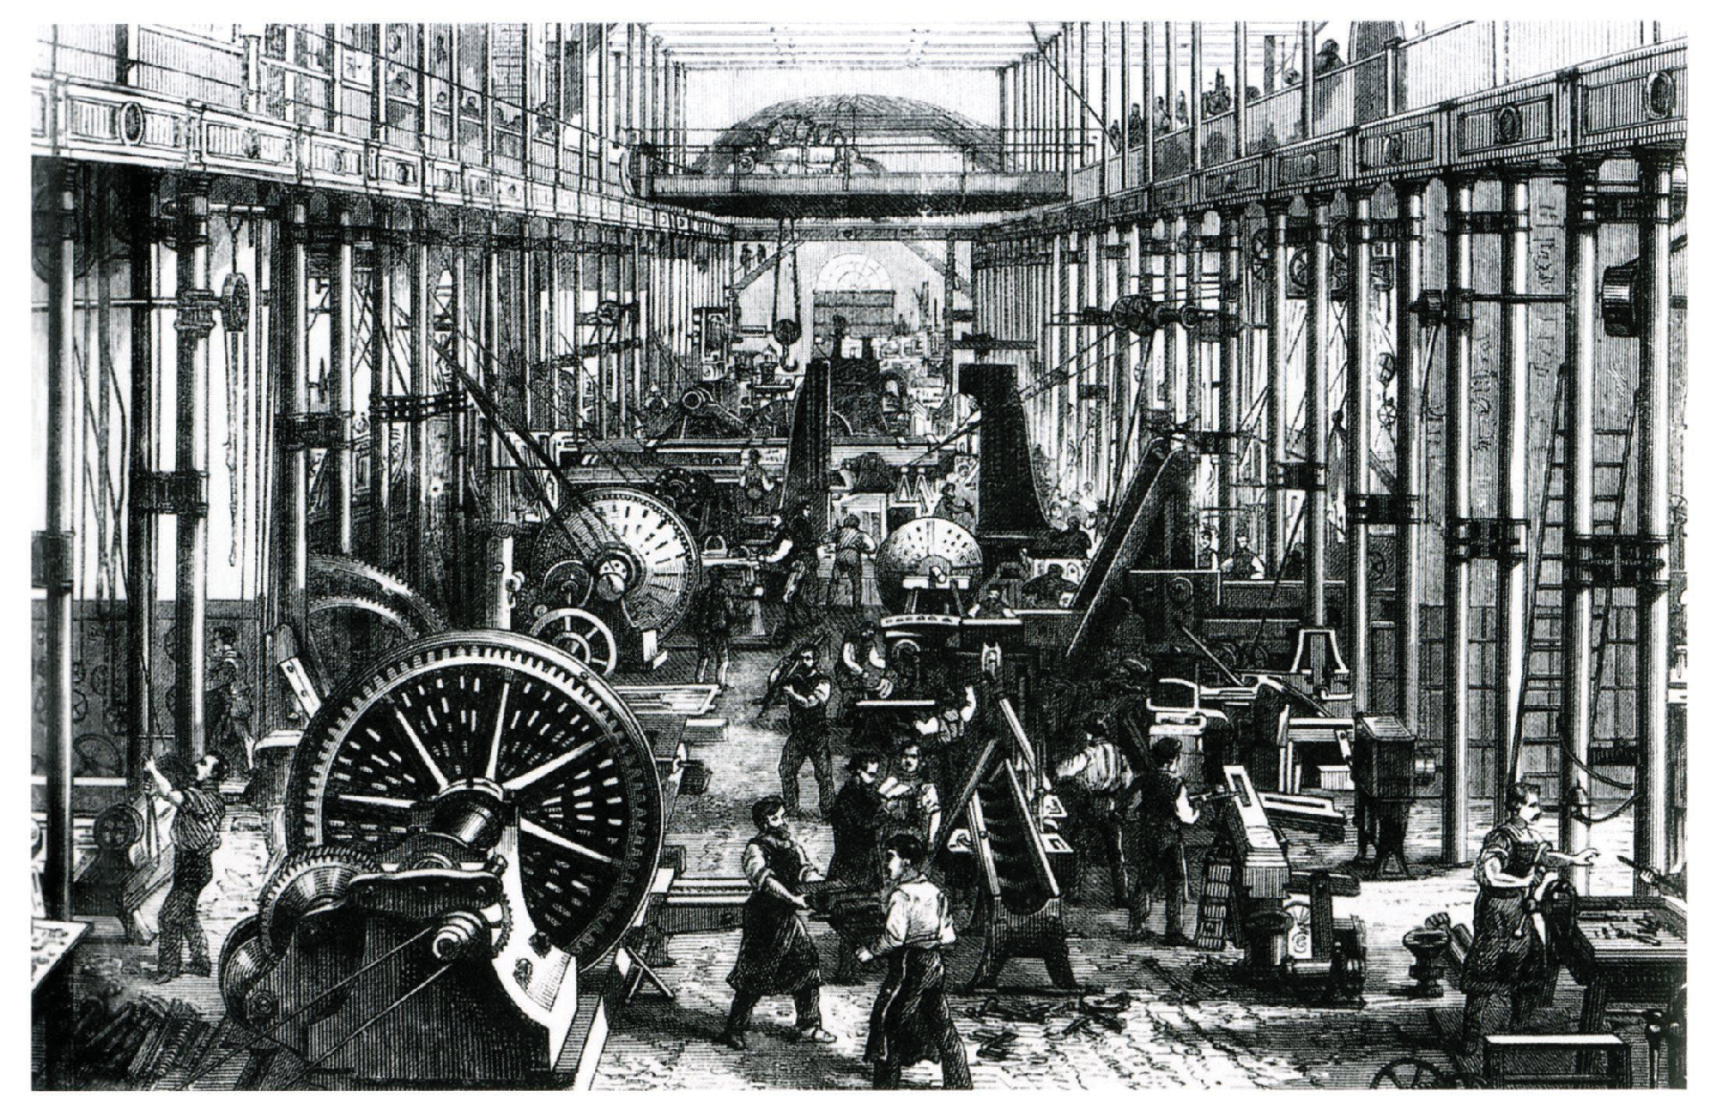
Image 8: Manufacturing heavy machinery. This woodcut shows the machine works of Richard Hartmann in Chemnitz in modern-day Germany, which manufactured heavy machinery. Hartmann was one of the most successful entrepreneurs and largest employers in the Kingdom of Saxony, 1868. Public domain. https://en.wikipedia.org/wiki/File:Hartmann_Maschinenhalle_1868_(01).jpg
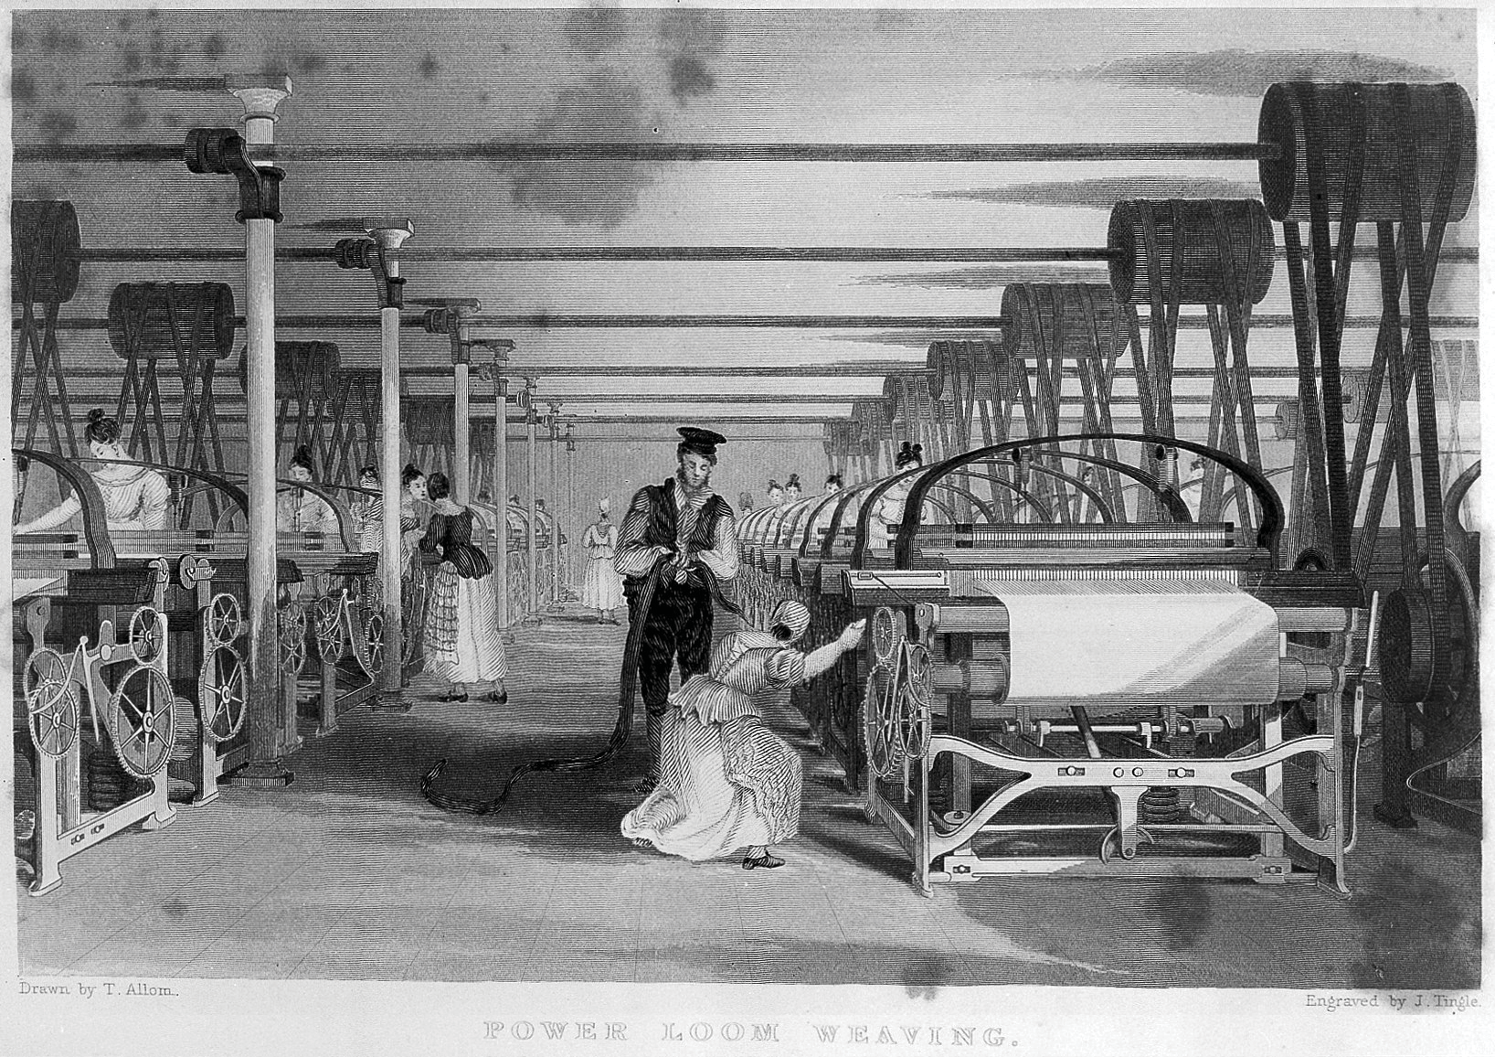
Image 9: Power loom weaving Illustration of power loom weaving, 1835. Baines, Edward. History of the Cotton Manufacture in Great Britain.
London: H. Fisher, R. Fisher, and P. Jackson, 1835. Credit: Wellcome Collection. CC BY 4.0.
https://wellcomecollection.org/works/ujmvhmkw
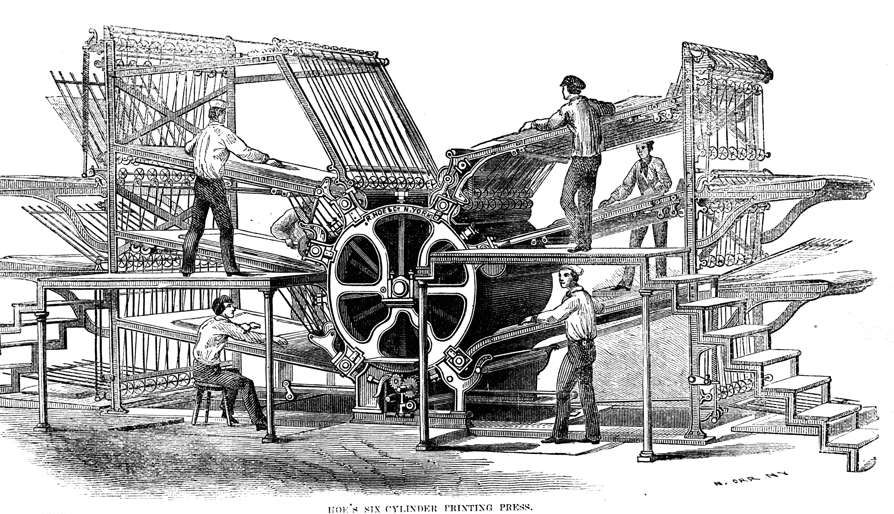
Image 10: Rotary press. Hoe’s six-cylinder rotary press from the 1860s. The printing plates are located on the large cylinder in the middle.
From Encyclopaedia Britannica, Inc., The History of the Processes of Manufacture and Uses of Printing, Gas-Light, Pottery, Glass, and Iron.
New York: John Bradburn, 1864. Public domain.
https://commons.wikimedia.org/wiki/File:Hoe%27s_six-cylinder_press.png

