|  |  |  |  |
| --- | --- | --- | --- |
| Name: |  | Date: |  |

## Purpose

In this activity, you will analyze and then create cartoons about imperialism. This will help reinforce what you’ve already learned about imperialism and will give you more insight into both the minds of the imperialists as well as those who rejected this type of domination. Additionally, engaging in image analysis will continue to help you build this important analytical skill, and producing an image will help your visual presentation skills.

## Process

In this activity, you will first analyze political cartoons about imperialism, and then create your own anti-imperialist cartoon.

Take out the Imperialism Cartoons Worksheet and either individually or in small groups, look at the pictures and answer the questions to determine what these cartoons tell us about the era of imperialism. You will probably need to use the links or conduct additional research to find the information to answer these questions.

Once you’re done analyzing the images, be prepared to have a discussion about what you learned. What was the overall sentiment of the cartoons?

Now, it’s time to come up with your own anti-imperialist cartoon to share with the class. Get into small groups, and make sure to think about the following as you plan your cartoon:

* Whom or what did you include or leave out of the image?
* What imperialist practices are you rallying against (taking of raw materials, manipulation of trade, colonialism, violence, etc.)?
* What are the motivations/justifications for this anti-imperialism?

You may need to do some research to complete these cartoons, so make sure you keep a list of any articles or pictures you referenced in creating your cartoon. Be prepared to share your final products with the class.

## Picture #1: The Berlin Conference

Who is present in this cartoon—or perhaps a better question is, who is *not* present? Explain the message of this particular cartoon using the details the cartoonist has included.

|  |
| --- |
|  |

Does the artist portray imperialism in a positive or negative light? Explain your reasoning.

|  |
| --- |
|  |

What historical event or imperialist practice is this cartoon referencing?

“Cutting of Africa at the Berlin Conference” published in L’Illustration, January 1885. Image credit. [Zoomable Image](https://www.dw.com/en/130-years-ago-carving-up-africa-in-berlin/a-18278894). [More info](https://www.thoughtco.com/berlin-conference-1884-1885-divide-africa-1433556).

|  |
| --- |
|  |

## Picture #2: In the Rubber Coils

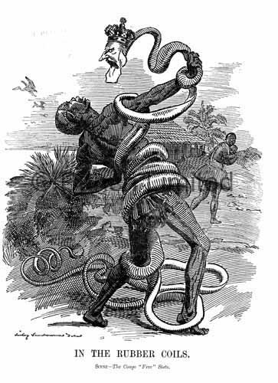Explain the message within this particular cartoon using the details the cartoonist has included in it.

|  |
| --- |
|  |

Does the artist portray imperialism in a positive or negative light? Explain your reasoning.

|  |
| --- |
|  |

What historical event or imperialist practice is this cartoon referencing?

|  |
| --- |
|  |

What were the effects of Belgian imperialism?

In the Rubber Coils. Scene - The Congo Free State; artist: Linley Sambourne. Published in Punch Magazine 28, November 1906. Image credit. [Zoomable Image](https://www.loc.gov/resource/cph.3g08791/)..

|  |
| --- |
|  |

## Picture #3: The Real Trouble Will Come with the “Wake”

Explain the message within this particular cartoon using the details the cartoonist has included in it.

|  |
| --- |
|  |

What were the effects on China, as portrayed in the cartoon?

J. Ottman Lithographic Company, Printer, and Udo J Keppler. “The Real Trouble Will Come with the ‘Wake’” / J. Ottmann Lith. Co., Puck Bldg., NY [New York: Published by Keppler & Schwarzmann, NY. J. Ottmann Lith. Co.. Puck Bldg.. NY] Photograph. Retrieved from the [Library of Congress](http://www.loc.gov/item/2002718142/). Image credit. [Zoomable Image](https://www.loc.gov/resource/ds.09327/).

|  |
| --- |
|  |

|  |  |  |
| --- | --- | --- |
| Does the artist portray imperialism in a positive or negative light? Explain your reasoning. |  | What historical event or imperialist practice is this referencing? |
|  |  |  |

## Picture #4: Colossus of Rhodes: Cape to Cairo, 1892

Explain the message within this particular cartoon using the details the cartoonist has included in it.

|  |
| --- |
|  |

Does the artist portray imperialism in a positive or negative light? Explain your reasoning.

|  |
| --- |
|  |

Based on the image or your research, what historical event or imperialist practice is this referencing?

Colossus of Rhodes: Cape to Cairo, 1892. Image credit. [More info A](https://www.history.com/this-day-in-history/boer-war-begins-in-south-africa). [More info B](https://www.arcgis.com/apps/MapJournal/index.html?appid=e7ac4793f575497b9a38ec07ef5f4cfa).

|  |
| --- |
|  |

## Picture #5: The Sepoy Rebellion

Explain the message within this particular cartoon using the details the cartoonist has included in it.

|  |
| --- |
|  |

Explain the Sepoy rebellion and the reaction to this rebellion as detailed in the cartoon.

|  |
| --- |
|  |

Does the artist portray imperialism in a positive or negative light? Explain your reasoning.

|  |
| --- |
|  |

What historical event or imperialist practice is this referencing?

The Sepoy Rebellion. [Image credit](https://archive.org/details/punch32a33lemouoft/page/384). [More info](https://www.thoughtco.com/the-british-raj-in-india-195275).

|  |
| --- |
|  |

## Picture #6: American Imperialism

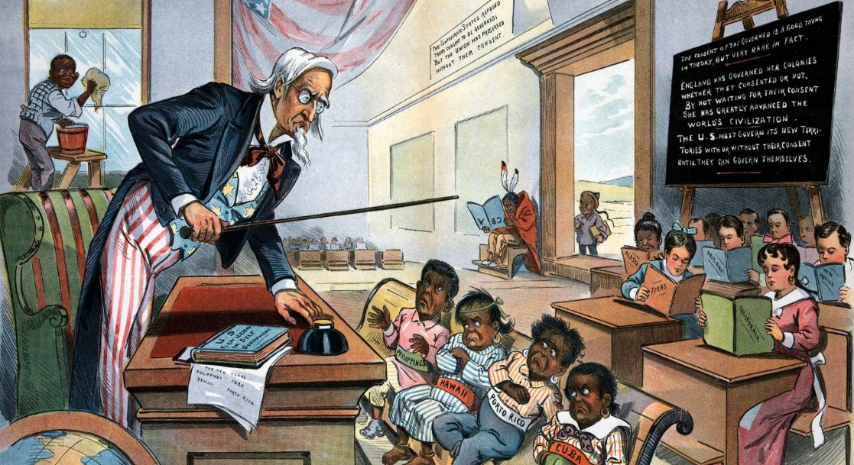Explain the message within this particular cartoon using the details the cartoonist has included in it.

|  |
| --- |
|  |

How did the US attempt to justify Imperialism?

American Imperialism. Image credit. [More info A](http://www.americanyawp.com/text/19-american-empire). [More info B](https://www.youtube.com/watch?v=QfsfoFqsFk4).

|  |
| --- |
|  |

|  |  |  |
| --- | --- | --- |
| Does the artist portray imperialism in a positive or negative light? Explain your reasoning. |  | What historical event or imperialist practice is this referencing? |
|  |  |  |