Name: |  | Date:

Preparation
- Have the Comparison, CCOT, and Causation tools available
- Download the WHP Writing Rubric

Purpose
This DBQ is another opportunity for you to show how your historical thinking skills and reasoning practices are developing. This will help you become better at making and supporting historical claims and will also help you on standardized tests that ask you to analyze documents in response to a specific prompt.

Process

Day 1
- Your teacher may decide to have you prepare for the DBQ in pairs, or even individually. The DBQ prompt is: Analyze how and why the Nazi Party rose to power in prewar Germany.
- Start out by using the Question Parsing Tool to help you figure out what this question is really asking, so you can write an appropriate response.
- Take out the Unit 8 DBQ and skim the documents quickly.
- Pick the thinking tool you want to use to help you analyze the documents (comparison, causation, or CCOT).
- Once you’ve picked a tool, read each document a bit more closely and write down or underline the information you think you might use in your essay, along with any additional sourcing you have time for. Write your ideas on your chosen tool as you work through the documents.
- Create a major claim or thesis statement that responds to the prompt. The notes you have taken should help you form a defensible thesis statement.
- Finally, it’s time to contextualize. As you likely know, all historical essays require this. If needed, you can use the Contextualization Tool to help you decide what to include.

Day 2
- This second day is your writing day. Feel free to use your tools and notes from any prewriting work you completed as you craft your essay response.
- Make sure you have a copy of the WHP Writing Rubric available to remind you of what is important to include in your essay.
- Don’t forget to contextualize: Think of the entire time period, not just the time immediately preceding the historical event or process you are writing about.
- Your teacher will give you a time limit for completing your five- to six-paragraph essay responding to the DBQ.

Unit 8 DBQ
Directions: Write a five- to six-paragraph essay in response to the prompt below. Make sure to use the documents provided to help support your argument. In addition to trying to meet the criteria on the WHP Writing Rubric, make sure to address the most relevant of these historical thinking skills in your response: comparison, causation, or CCOT. Finally, make sure you contextualize (describe the broader historical context relevant to the prompt).
We suggest you spend 10-15 minutes reading these documents and 35-45 minutes writing. Sources are edited for brevity and clarity.
Analyze how and why the Nazi Party rose to power in prewar Germany.

Document 1
Source: Map illustrated by J.F. Horrabin “Germany after the Peace Treaty of 1919” on page 572 of Wells, H.G. The Outline of History: Being a Plain History of Life and Mankind. London: Cassell and Company, Ltd., 1923.
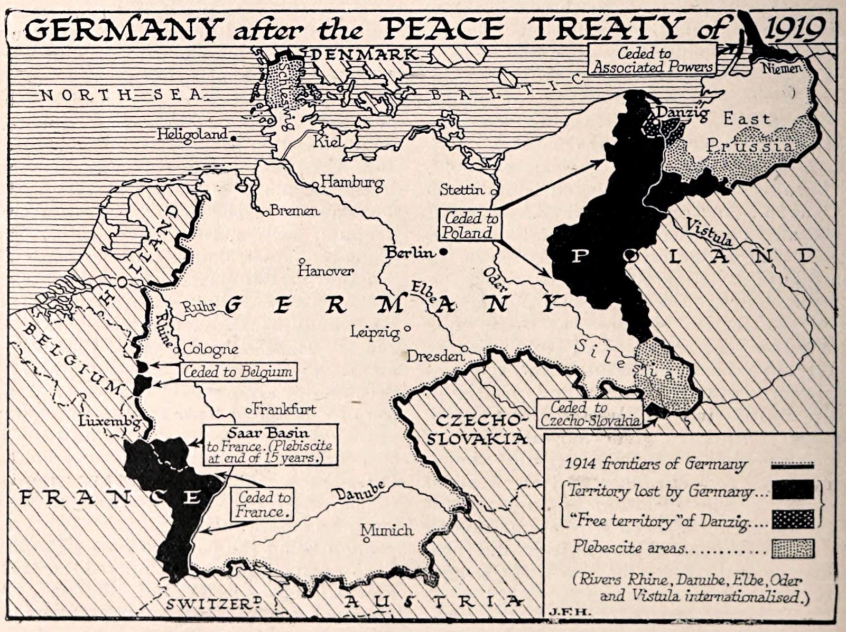

Document 2
Source: Madison Grant, The Passing of the Great Race, or, the Racial Basis of European History, 4th ed. (New York: Charles Scribner’s Sons, 1936), xxxi, 50–52. Note: The first edition of this book was published in 1916. https://archive.org/stream/passingofgreatra00granuoft/passingofgreatra00granuoft_djvu.txt.
These excerpts are by the American zoologist and eugenicist, Madison Grant (1865–1937). In response to Grant’s book, The Passing of the Great Race, or, the Racial Basis of European History, Adolf Hitler (1889–1945) sent him a fond letter noting that this book was his “Bible.”
The resurgence of inferior races and classes throughout not merely Europe but the world, is evident in every dispatch from Egypt, Ireland, Poland, Romania, India and Mexico. … it is everywhere the phenomenon of the long-suppressed, conquered servile classes rising against the master race. … if the valuable elements in the Nordic race mix with inferior strains or die out through race suicide, then the citadel of civilization will fall for mere lack of defenders. …
Those who read these pages will feel that there is little hope for humanity, but the remedy has been found, and can be quickly and mercifully applied. A rigid system of selection through the elimination of those who are weak or unfit—in other words, social failures— would solve the whole question in a century, as well as enable us to get rid of the undesirables who crowd our jails, hospitals and insane asylums.

Document 3
Source: Papers Relating to the Foreign Relations of the United States (FRUS), 1930, Volume III, 862.00/2509: Telegram, https://history.state.gov/historicaldocuments/frus1930v03/d49.
This telegram is a report on German election results in 1930. It was sent by the US Chargé in Germany (Gordon) to the US Secretary of State, Henry L. Stimson (sent from Berlin, September 15, 1930).
Election results up to 5 o’clock this morning constituting substantially complete returns give following approximate results in round figures: 35,000,000 votes cast by eligible electorate of 43,000,000.
Approximate popular votes:
Social Democrats | 8,600,000
National Socialists (Hitler, Fascist) | 6,400,000
Center and Bavarian Peoples Party combined | 5,200,000
Communists | 4,600,000
Nationalists (Hugenberg) | 2,500,000
Peoples Party | 1,600,000
Economic Party | 1,400,000
State Party (former Democratic Party) | 1,300,000
… The first strong impression from the election is that the predominant factors were disgust and recklessness. The enormous gains made by the Hitler supporters and the Communists indicate this. The Hitler vote, which in 1928 was 800,000, reached 6,400,000 yesterday resulting in an increase in Reichstag [Parliament] seats from 12 to 107. This is … an indication that a multitude [many] of voters are so disgusted at the failure of both the coalition of moderate parties and the Social Democrats to run the government machinery smoothly and to relieve the economic depression that they are ready to try anything else for a change, even giving their support to a party whose leaders and promises are irresponsible.

Document 4
Source: Robert Ley, ed., “The Program of the NSDAP [Nazi Party].” Originally published by Central Publishing House of the NSDAP. “The 25 Points 1920: An Early Nazi Program,” reproduced in the Modern History Sourcebook, Fordham University, https://sourcebooks.fordham.edu/mod/25points.asp. Text edited for brevity and clarity.
This excerpt includes some significant items from the 25-point program of the Nazi Party (NSDAP), produced in February 1920.
1. We demand the unification of all Germans in the Greater Germany on the basis of the right of self-determination of peoples.
2. We demand equality of rights for the German people in respect to the other nations; including breaking the peace treaties of Versailles and St. Germain.
3. We demand land and territory (colonies) for the sustenance of our people, and colonization for our surplus population.
4. Only a member of the race can be a citizen. A member of the race can only be one who is of German blood, without consideration of creed. Consequently no Jew can be a member of the race. …
8. Any further immigration of non-citizens is to be prevented. We demand that all non-Germans, who have immigrated to Germany since the 2 August 1914, be forced immediately to leave the Reich. …
23. We demand legal opposition to known lies and their spread through the press. Publications which are counter to the general good are to be forbidden. We demand legal prosecution of artistic and literary forms which exert a destructive influence on our national life, and the closure of organizations opposing the above made demands.

Document 5
Source: The Speeches of Adolf Hitler, 1921–1941 (Open Source Collection at The Internet Archive, https://archive.org/details/TheSpeechesOfAdolfHitler19211941), pages 40–41.
This excerpt is from a speech by Adolf Hitler (1889–1945) given in Berlin at the Reichstag (Parliament) on March 23, 1933.
…the elimination of communism in Germany is a purely domestic German affair. Simultaneously with this political purification of our public life, the Government of the Reich will undertake a thorough moral purging of the … nation. The entire educational system, the theater, the cinema, literature, the Press, and the wireless—all these will be used as means to this end … They must all serve for the maintenance of the eternal values present in the essential character of our people.

Document 6
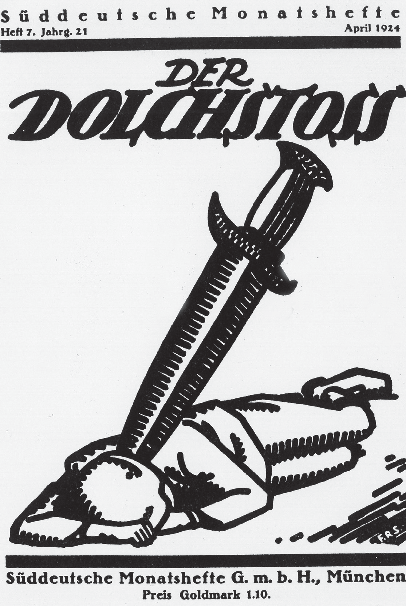
Source: “Sueddeutsche Monatshefte”, Munich. © Archiv Gerstenberg/ullstein bild via Getty Images.
There were many illustrations of the “stab-in-the-back” myth in German propaganda. This myth blamed military defeat in World War I on betrayal or a lack of support for the war effort. The persecution of Jewish people and other groups within the Nazi regime in the 1930s and 1940s revived the “stab-in-the- back” myth.

Document 7
Source: US National Archives and Records Administration, Item from Record Group 208: Records of the Office of War Information, 1926–1951, February 1933, https://commons.wikimedia.org/wiki/File:Reichstagsbrand.jpg.
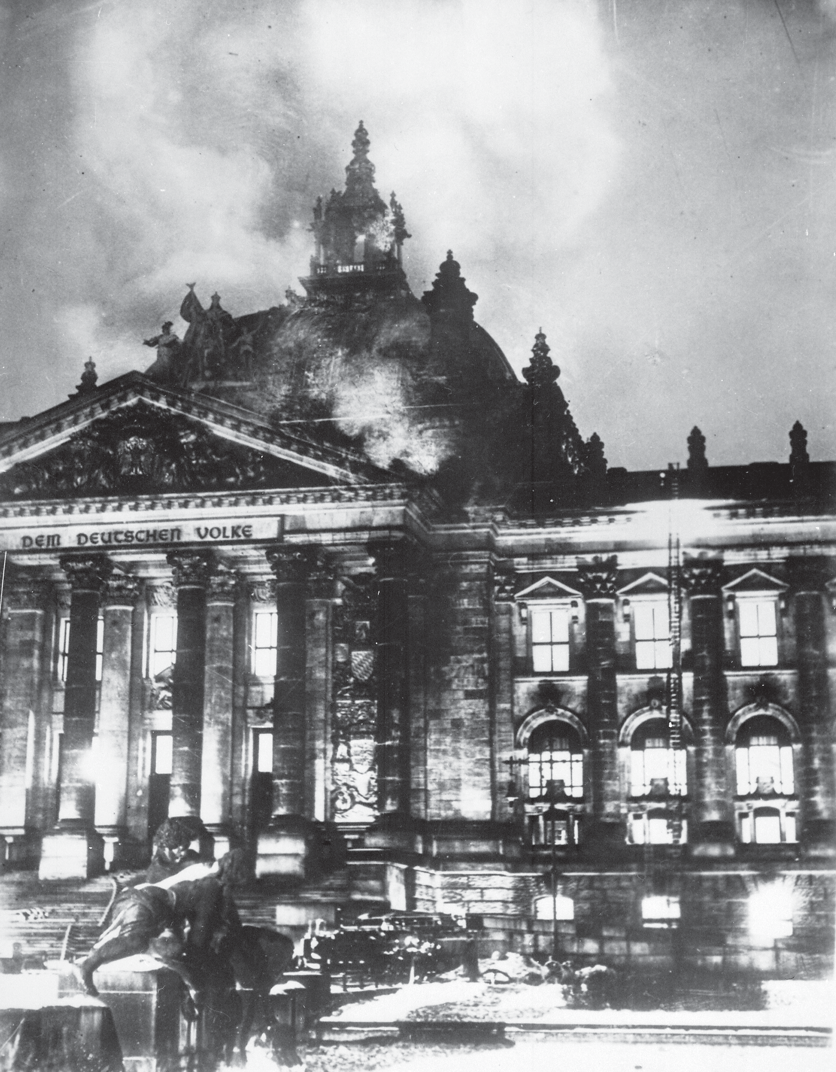
This image is of firefighters at the Reichstag fire in Berlin, February 1933. The fire in the German parliament building broke out a month after Hitler became Chancellor of Germany.

Question Parsing Tool
Directions: Follow the steps to parse the prompt you are presented with. Use the key at the bottom to help you with the historical reasoning practice and composition questions.
- Prompt:
- Rewrite the prompt in your own words:
- Periodization: What is the time period you are being asked to consider? Write out the years if you are given something in terms of century (for example, twentieth century = 1900s).
- Location: What areas of the world are included in this prompt?
- Topic: What is the main topic being asked about in this prompt?
- Historical reasoning practice: What historical reasoning practice is this prompt asking you to engage in? Provide justification for why you chose the one you did.
- Composition: What is the prompt stem asking you to do as part of your response? Remember the prompt stem is usually a verb.

Key
Historical Reasoning Practice | Words/Phrases to Look For
Causation | Cause, effect, led to, lead to, emergence, resulted, bring about, give rise to, be the cause of, result in, produce, generate, spawn, precipitate, prompt, induce, promote, foster, provoke, trigger
Comparison | Similarities, differences, compare, contrast, set side-by-side, juxtapose, differentiate, liken, equate
CCOT | Continuities, changes, continuation, persistence, consistent, over time, two points in time
Prompt Stem Examples | What It’s Asking in Simpler Language
To what extent | Weigh, evaluate, assess
Evaluate, assess | How much—needs a quantitative answer/thesis/claim (Note: A quantitative answer is one that includes an amount or a number. For example: a lot, a little)
Analyze, develop | Describe and explain
Argue, argument | Make a claim

