Name: |  | Date:

Purpose
During World War I, propaganda posters were used throughout the world to influence people during this time of great conflict. You will analyze examples of these posters to gain a better sense of why governments were trying to influence people, and how this could have impacted citizens of different countries. While the focus is World War I, the lessons learned here can help you decipher the messages you encounter today as part of modern political campaigns and advertisements, and on social media. The development of these skills can help you decide what to believe—not only historically, but in your everyday life.

Practices

Sourcing, comparison, claim testing
Each of the posters used in this activity is considered a primary source, and analysis of these sources pushes you to think about the historical context, audience, purpose, point of view, and importance of each of poster. This process expands your sourcing skills beyond those used to analyze text-based primary sources. Additionally, you will be comparing posters within particular categories, engaging in the practice of historical comparison using images. After comparing the posters, you’ll answer questions and make assertions, and you’ll use your claim testing skills to support your answers.

Process
In this activity, you will examine a variety of posters from World War I as a way of trying to develop an understanding of propaganda, nationalism, total war, and gender and social class during World War I.
Take out the World War I Poster Analysis worksheet and pick two posters from each category and compare them. The categories are:
- Total war
- Women, minorities, and colonial subjects
- Nationalism
Answer the questions provided for each set of posters as best you can. You might not always have precise answers for each poster, but you should examine the images and try to infer meaning from them.
Once you’re done, be prepared to share your impressions with your class as well as discuss the following questions: How were different groups of people valued during this time period? How might these posters have encouraged people to support and participate in the war effort? What types of tactics did governments use to encourage citizens’ support of the war? Note that for this particular exercise, there are not necessarily “right” answers—however, you should use your claim-testing skills to provide evidence to support any claims you make.
To wrap up, think about the kinds of messages that governments from around the world have put out in more recent history. Do the more current messages qualify as propaganda or are they generally more informational? How do we as citizens of a country determine which is which? Remember that claim testing and sourcing are both great ways to try to discern the intent of different types of government-produced documents.

Directions: Pick two posters from each category and answer the questions below.

Total War
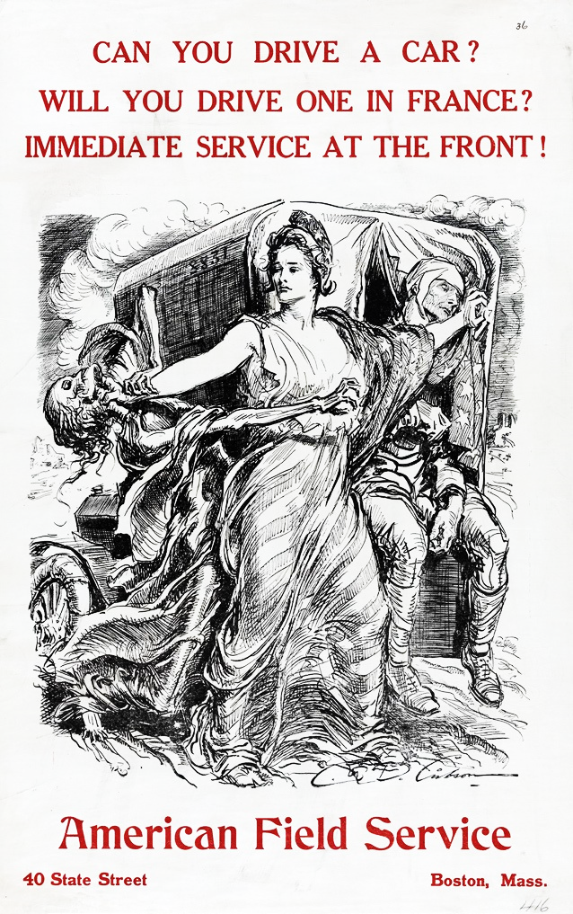 | 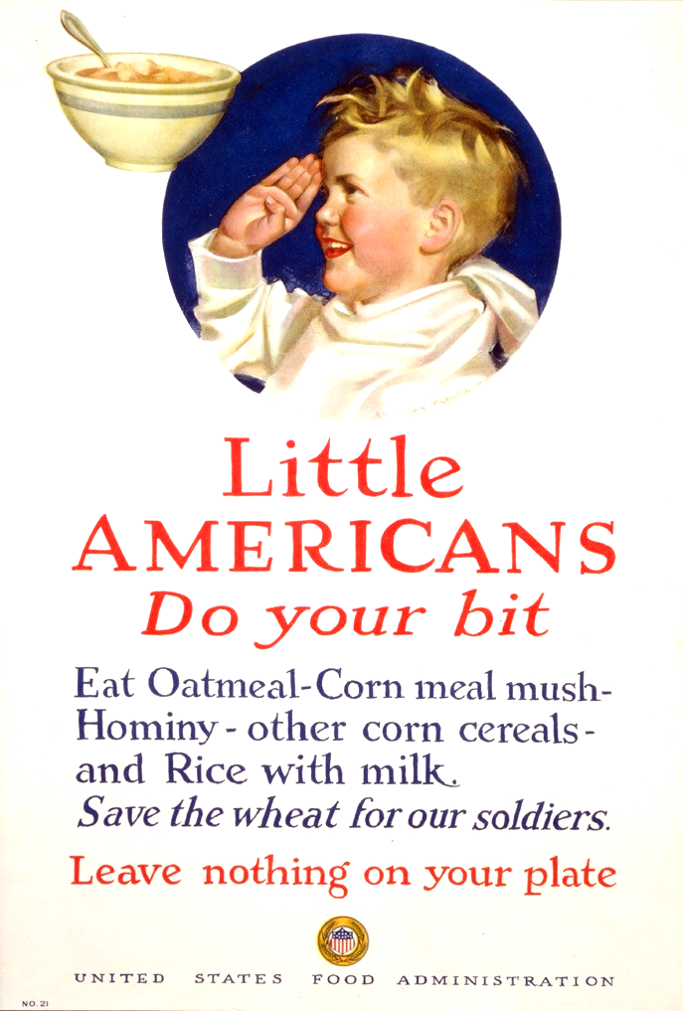
Can You Drive a Car? Will You Drive One in France? Immediate Service at the Front!  Poster showing Liberty fending off Death as she protects a wounded soldier. | Little Americans Do Your Bit  Poster showing a young boy saluting a bowl of cereal.

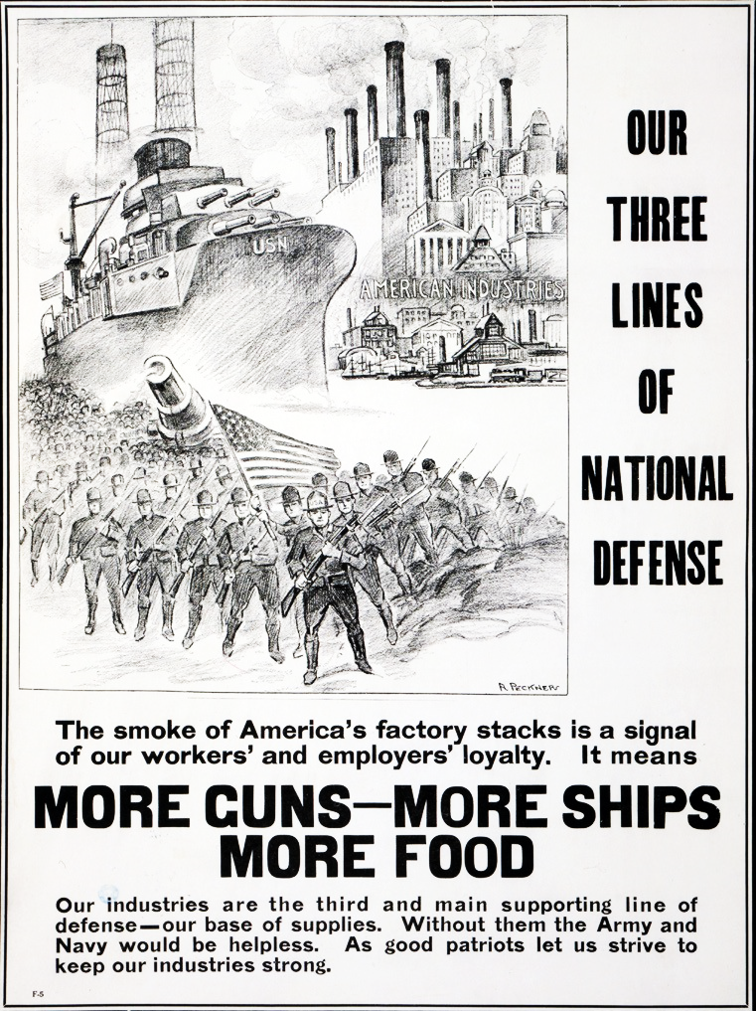 | 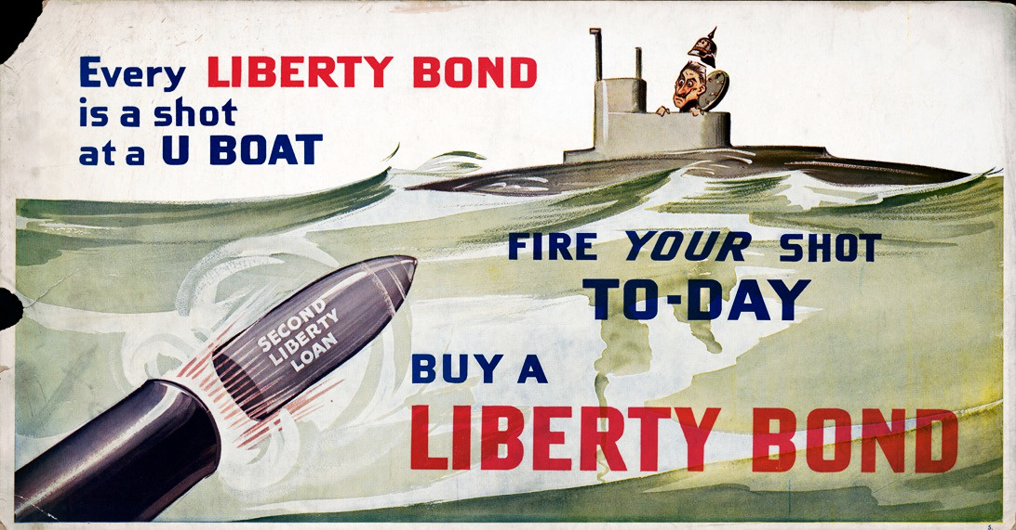
Our Three Lines of National Defense  Poster showing a battleship, an industrial cityscape, and military personnel behind an American flag. | Every Liberty Bond Is a Shot at a U-boat.  Poster showing a shell, marked Second Liberty Loan, being shot toward German submarine.

Women, Minorities, and Colonial Subjects
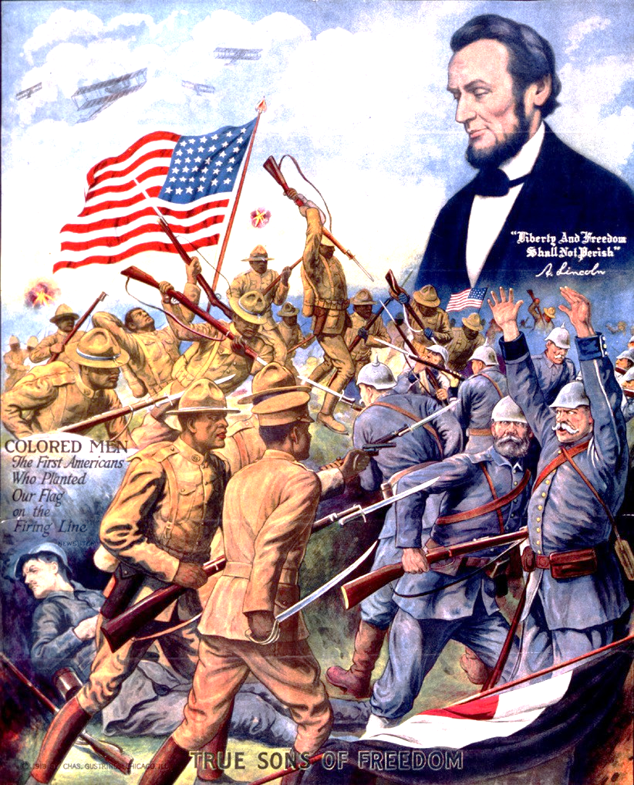 | 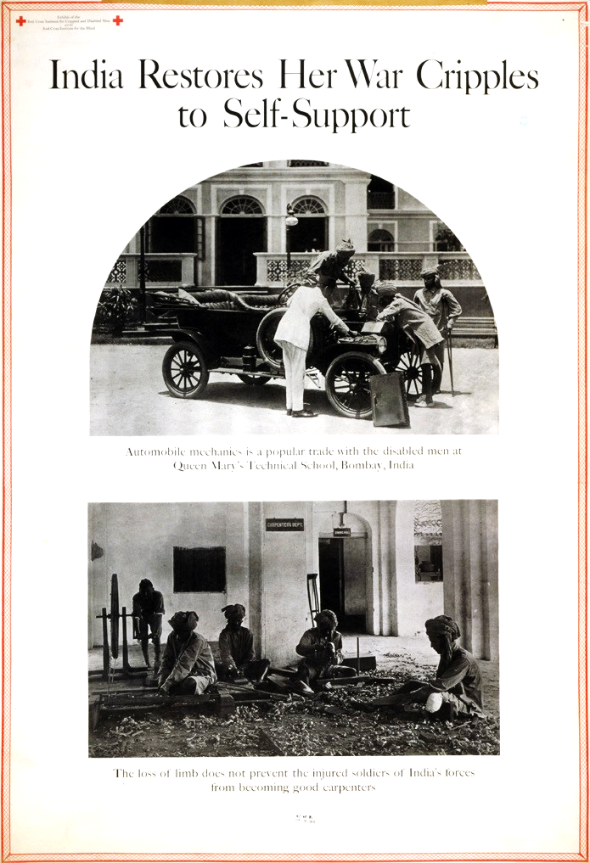
True Sons of Freedom  Print shows African American soldiers fighting German soldiers in World War I, and head-and- shoulders portrait of Abraham Lincoln above. | India Restores Her War Cripples to Self-Support  Exhibit poster showing two scenes in which disabled veterans learn trades.

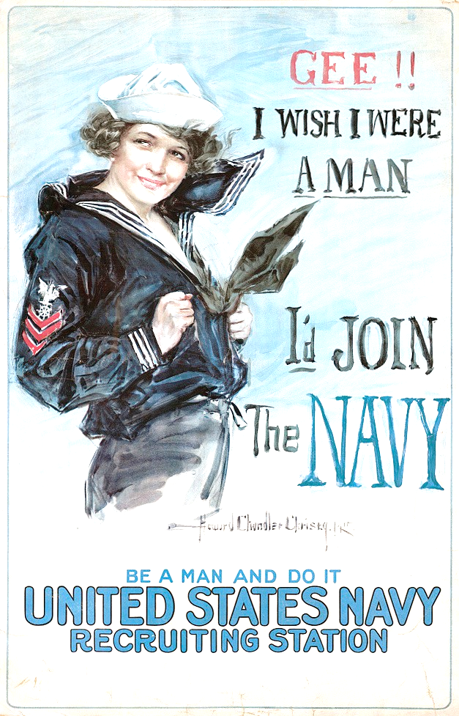 | 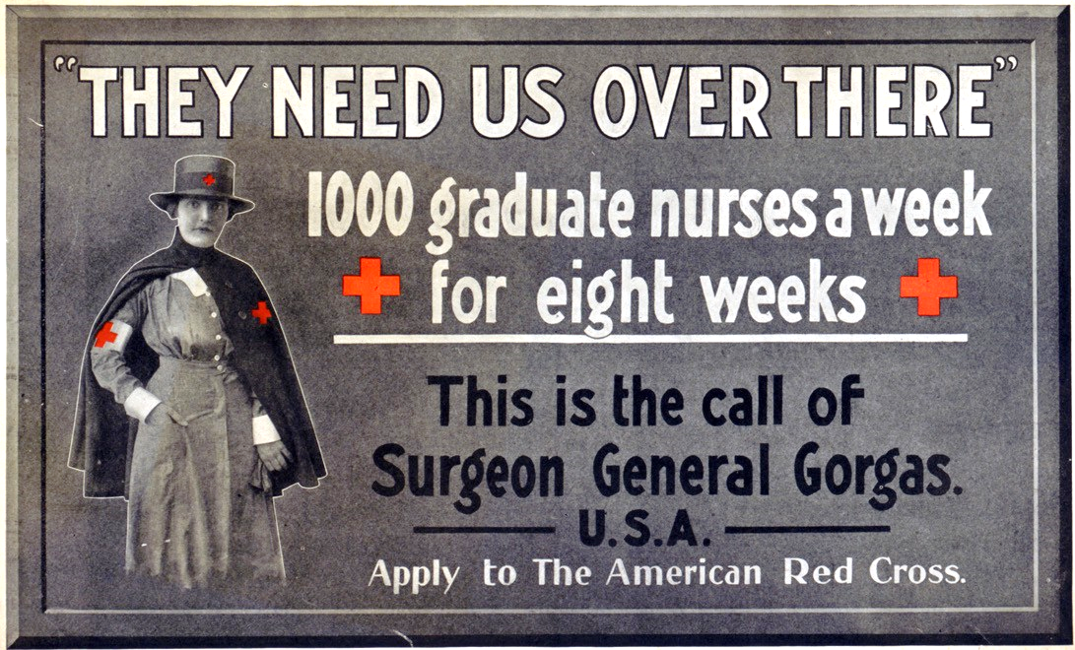
Gee!! I Wish I Were a Man  Poster showing a young woman in a Navy uniform. | They Need Us Over There  American Red Cross recruitment poster showing a three-quarter length portrait of a nurse.

Nationalism
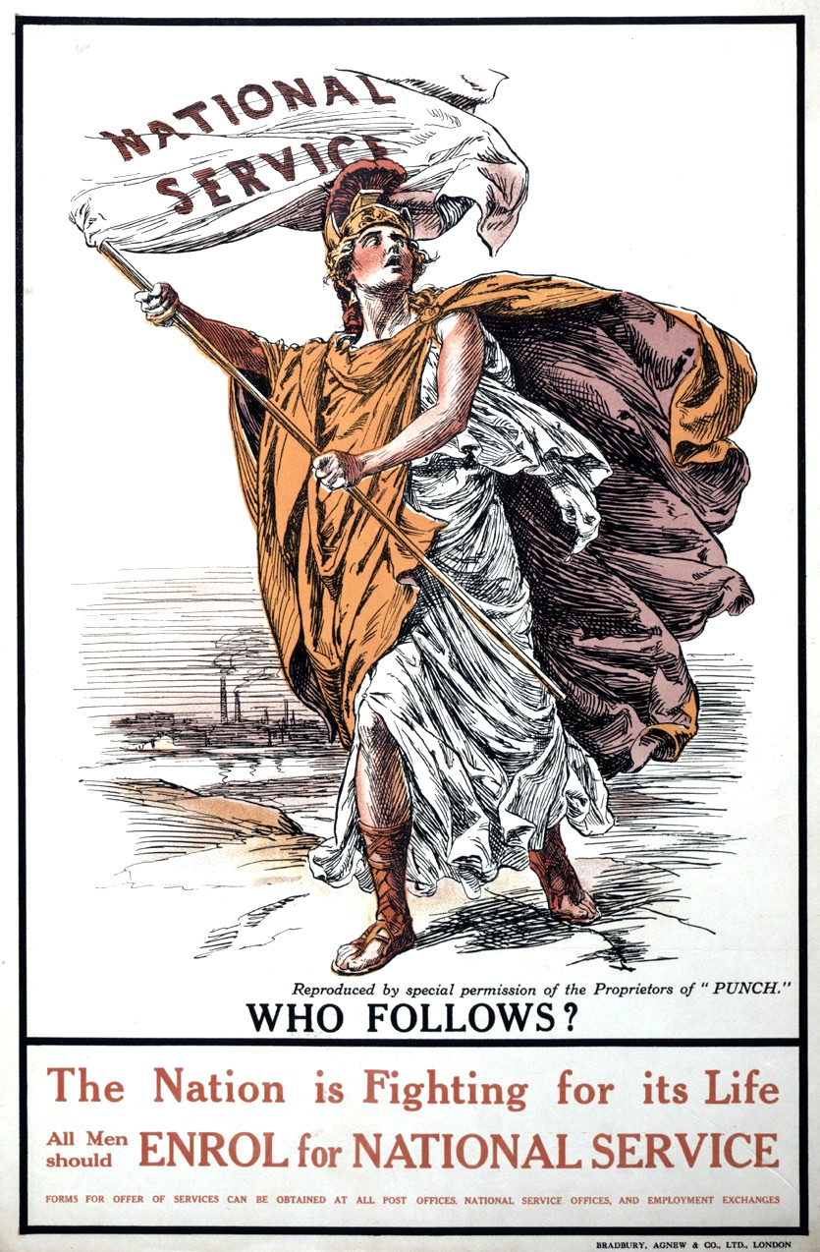 | 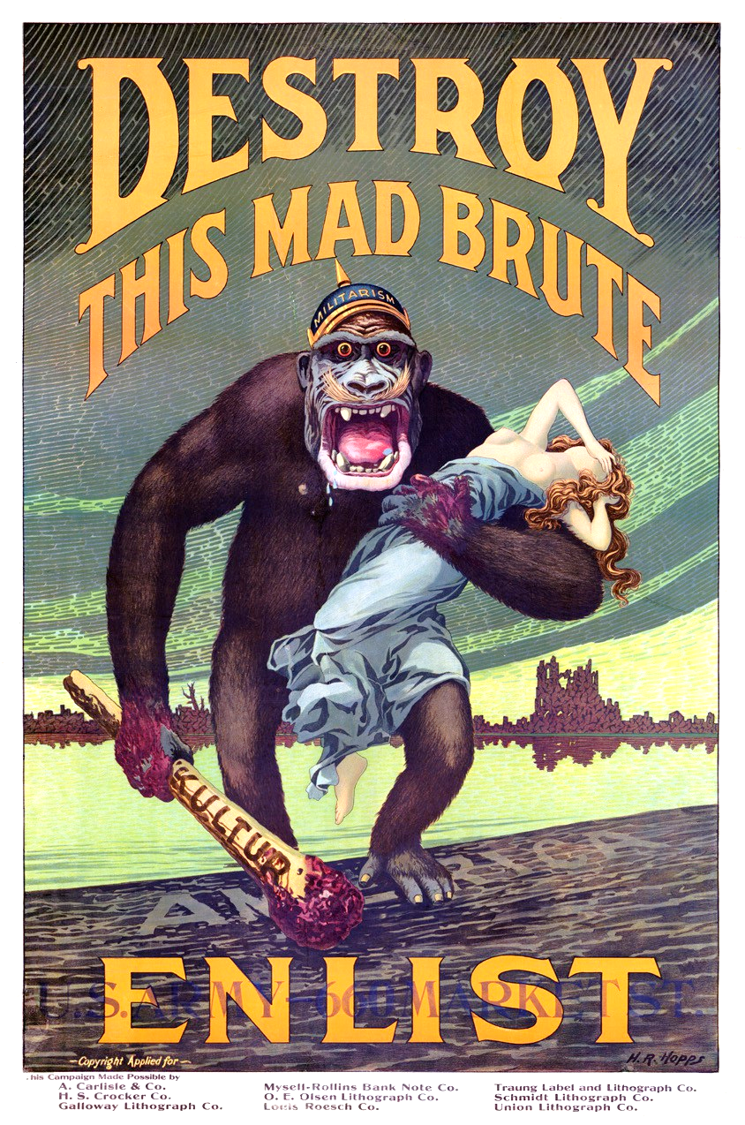 | 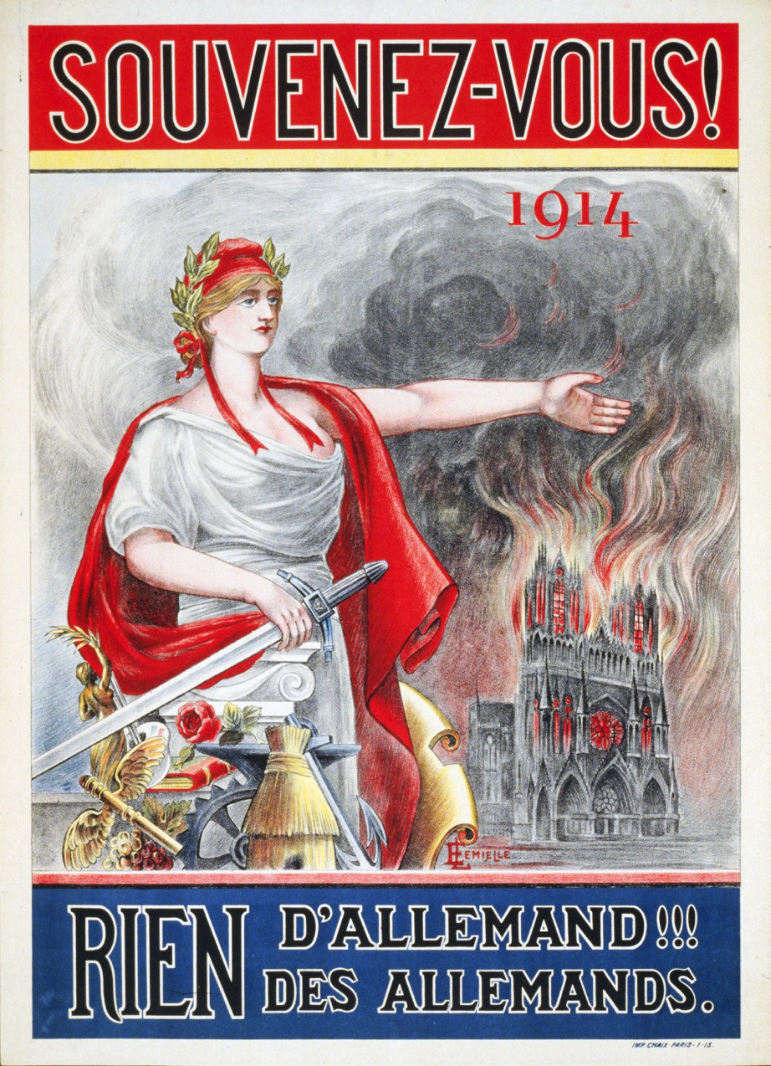
The Nation Is Fighting for Its Life. All Men Should Enroll for National Service.  Poster showing Britannia waving a “National service” flag. | Destroy This Mad Brute  Propaganda poster shows a terrifying gorilla with a helmet labeled “militarism” holding a bloody club labeled “kultur” and a half-naked woman as he stomps onto the shore of America. | Remember 1914  Marianne, the personification of France, and Rheims Cathedral burning in the background.

Total War
Poster Title
What do you think this poster is trying to convey and why?
What about the poster makes you think this (consider the author, words, images, and colors)?
What were people supposed to do or think once they read or saw this poster?
How are the two posters similar?
How are the two posters different?
Overall, how might these posters have encouraged people to support and participate in the war effort?

Women, Minorities, and Colonial Subjects
Poster Title
What do you think this poster is trying to convey and why?
What about the poster makes you think this (consider the author, words, images, and colors)?
What were people supposed to do or think once they read or saw this poster?
How are the two posters similar?
How are the two posters different?
Overall, what do these posters tell you about what people thought about women, minorities, and colonial subjects during this time period?

Nationalism
Poster Title
What do you think this poster is trying to convey and why?
What about the poster makes you think this (consider the author, words, images, and colors)?
What were people supposed to do or think once they read or saw this poster?
How are the two posters similar?
How are the two posters different?
What types of tactics did governments use to encourage citizens’ support of the war?

