## The Cost of World War I Worksheet

**Directions:** Use the Internet to determine the financial and human cost of World War I for each of the following countries. You can use the links below or do your own research to find these numbers.

### Step 1

* <https://spartacus-educational.com/FWWcosts.htm>
* <https://www.dva.gov.au/newsroom/media-centre/media-backgrounders/overview-australias-involvement-first-world-war>
* <https://en.wikipedia.org/wiki/World_War_I_casualties>
* <https://www.census.gov/history/pdf/reperes112018.pdf>
* <https://encyclopedia.1914-1918-online.net/article/non-european_soldiers>
* <https://scottmanning.com/content/world-war-i-troop-statistics/>

| Country | World War I expenditures (in US dollars) 1914-1918 | Deaths from World War I (civilian and military) | Deaths as percent of population | Number of soldiers mobilized for the war effort | Number of colonial soldiers who participated in the war* |
| --- | --- | --- | --- | --- | --- |
| France | $24 billion | ~1.7 million | 4.3 | ~8.4 million | ~300,000-500,000 colonial soldiers, mainly from North Africa, with a total of over 2 million working as soldiers and laborers |
| Belgium | $1.1 billion | ~130,000 | 1.8 | ~267,000 | ~20,000 colonial soldiers or porters killed in African campaign |
| Germany | $38 billion | ~2.5 million | 3.8 | ~11 million | ~80,000 soldiers, mainly from Africa but a regiment from Asia fought as well |
| Great Britain | $35 billion | ~1 million | 2 | ~8.9 million (British Empire) | ~2.8 million colonial subjects were recruited to fight for the British Empire; these included soldiers from India, Australia, New Zealand, Canada, South Africa, and Newfoundland |
| United States | $23 billion | ~117,000 | .13 | ~4.7 million | ~400,000 African-Americans served in the US armed forces (in segregated units) |
| India (under the British Raj) | $600 million | ~74,000 | .02 | ~1.3 million served as soldiers under the British Empire in overseas campaigns | N/A (in total about 136,000 Indian troops were killed or wounded in the war) |
| Japan | $40 million | ~2,000 | .01 | ~800,000 | N/A |
| Russia | $22 billion | ~3 million | 1.75 | ~12 million | The Russian military was composed of a number of different ethnic groups that made up the empire including Slavs, Armenians, Caucasians, and others. |
| Australia (part of the Commonwealth of the British Empire) | $1.5 billion | ~60,000 | 1.2 | ~330,000 Australians volunteered and joined the overseas campaigns (15% of the total population) | N/A (~60,000 Australian soldiers died fighting in WW I) |
| South Africa (part of the Commonwealth of the British Empire) | $300 million | ~8,000 | .14 | ~55,000 soldiers in total | ~25,000 African soldiers were part of the SA military but were not allowed to fight in Europe, only in Africa |
| Austria-Hungary | $20 billion | ~1.9 million | 3.8 | 7.8 million | The Austro-Hungarian empire was composed of a number of different ethnic groups that made up the empire including Slavs, Magyars, Germans, Poles, Ukrainians, Romanians, and Italians, among others. |

*\*****Note****: Only some of these countries had colonies.*

1. What countries included in the table were members of the Central Powers?

|  |
| --- |
| Sample answer: Germany and Austria-Hungary |

1. What countries included in the table were members of the Allied Powers?

|  |
| --- |
| Sample answer: France, Belgium, Great Britain, Japan, Russia, Australia, and South Africa. |

1. What country spent the most money on the war?

|  |
| --- |
| Sample answer: Germany spent the most money on the war with a price tag of $38 billion dollars. |

1. What country had the largest number of casualties?

|  |
| --- |
| Sample answer: Russia had the most casualties overall at 3 million. |

1. What country had the highest percentage of casualties?

|  |
| --- |
| Sample answer: France had the largest percent of casualties losing over 4% of its total population. |

1. What country had the largest number of colonial troops participating in the war?

|  |
| --- |
| Sample answer: Great Britain had almost 3 million colonial subjects participate in the war. |

1. Overall, which country fared worst and why?

|  |
| --- |
| Sample answer: Answers may vary. |

1. Overall, which country fared best and why?

|  |
| --- |
| Sample answer: Answers may vary. |

## World War I Terms Worksheet

|  |  |
| --- | --- |
| Country/Point of View: |  |

| Issues | Terms: A, B, or C? | Our Country’s Reasoning: |
| --- | --- | --- |
| **War Guilt**  Which country or countries should be blamed for causing World War I? | Sample answer: Answers may vary. | Sample answer: Answers may vary. |
| **Reparations**  Which country or countries should pay for the damages of war? How much? | Sample answer: Answers may vary. | Sample answer: Answers may vary. |
| **Military Power**  Should all countries be permitted to keep a powerful military in peacetime? | Sample answer: Answers may vary. | Sample answer: Answers may vary. |
| **Colonial Possessions**  Should countries be permitted to keep their colonial possessions in the wake of World War I? | Sample answer: Answers may vary. | Sample answer: Answers may vary. |
| **League of Nations**  Should countries join an international peacekeeping & decision-making organization? | Sample answer: Answers may vary. | Sample answer: Answers may vary. |

## World War I Flags − Belgium

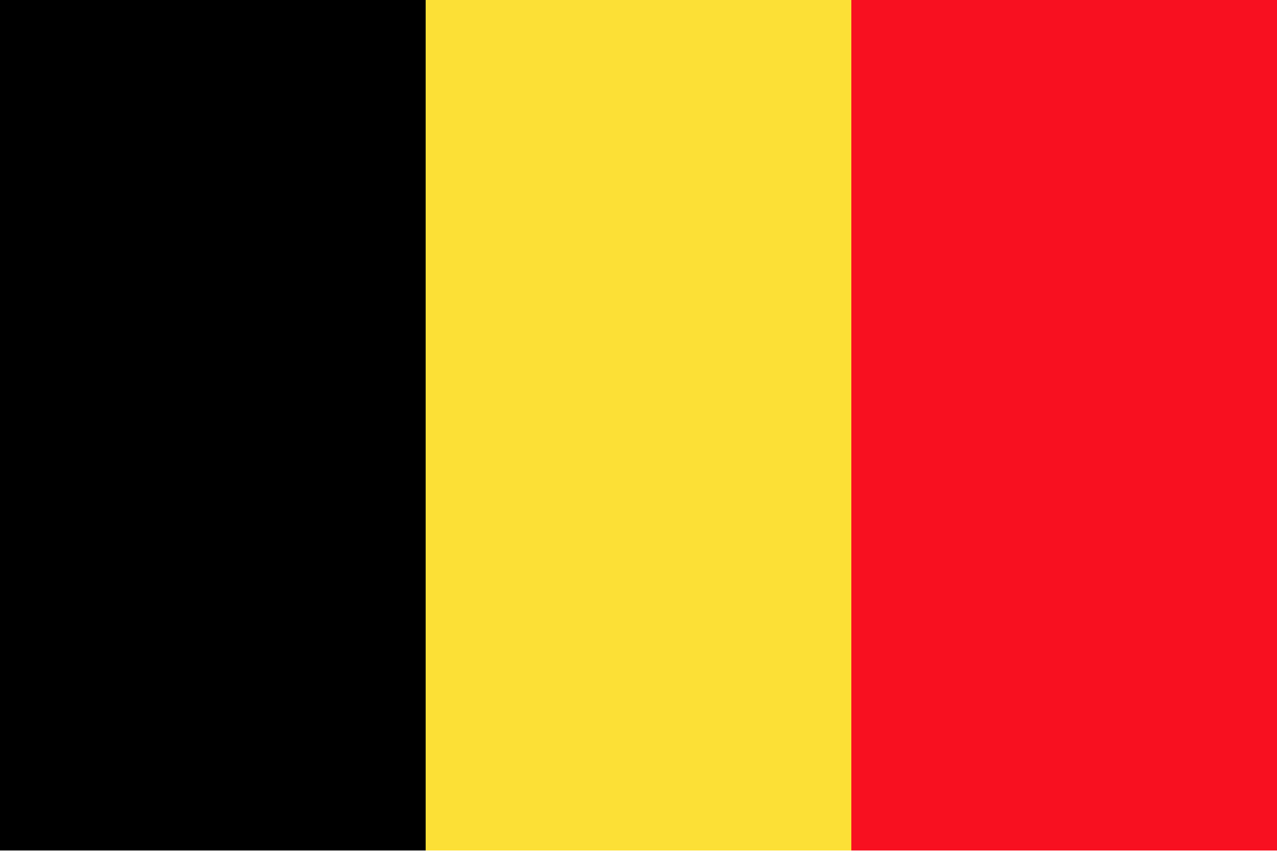

## France

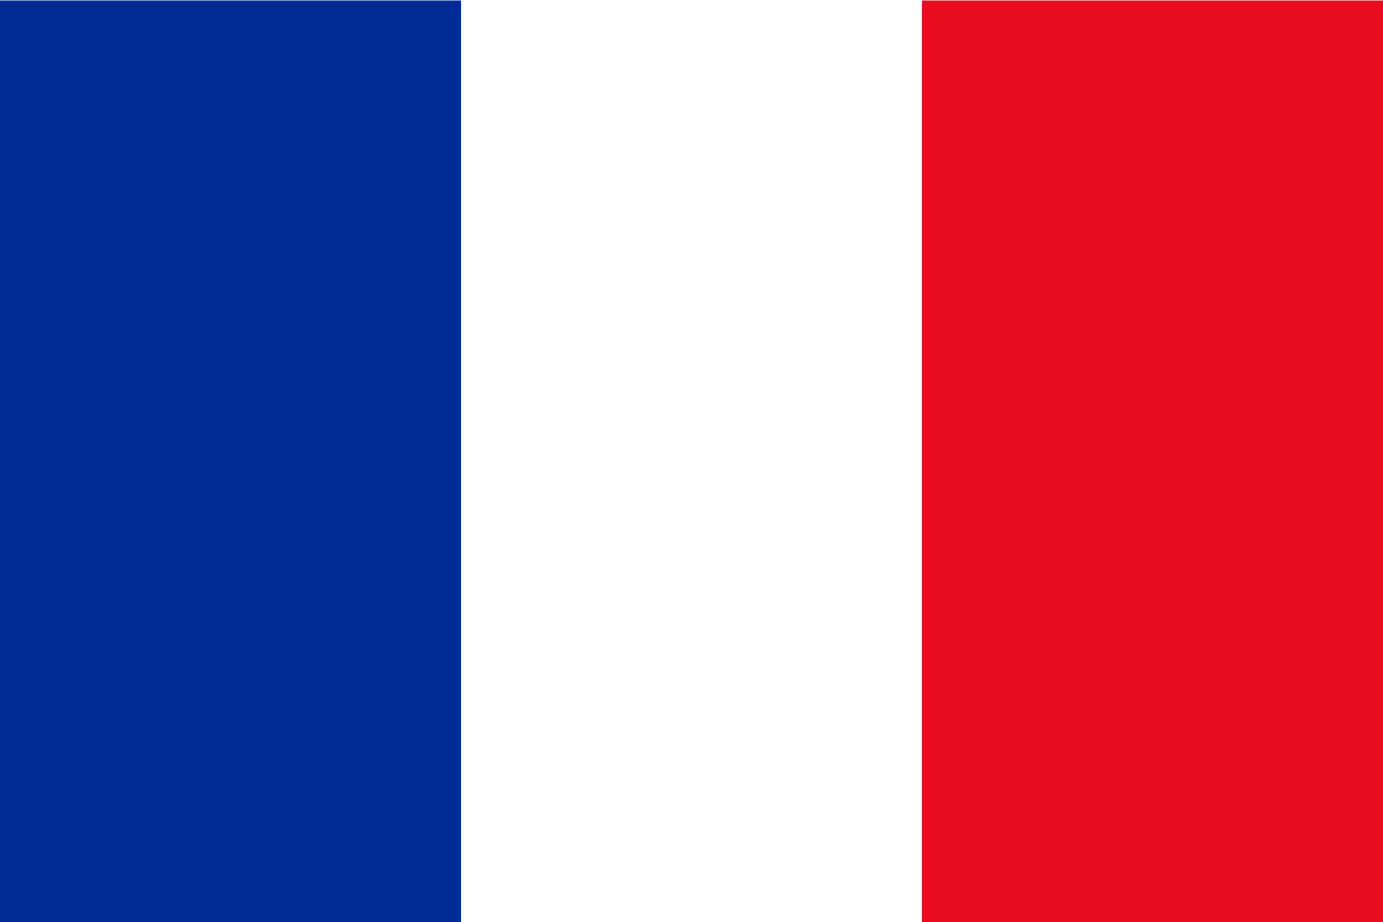

## Germany



## Great Britain

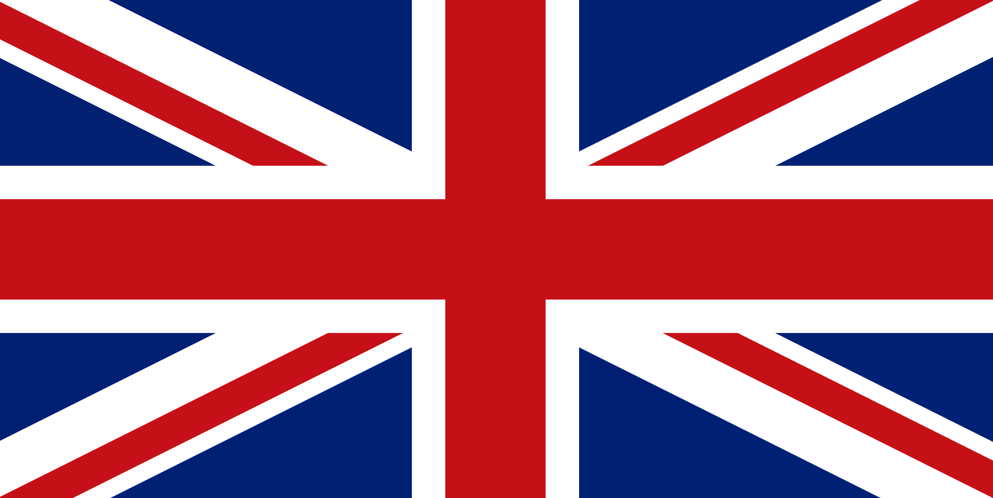

## Japan

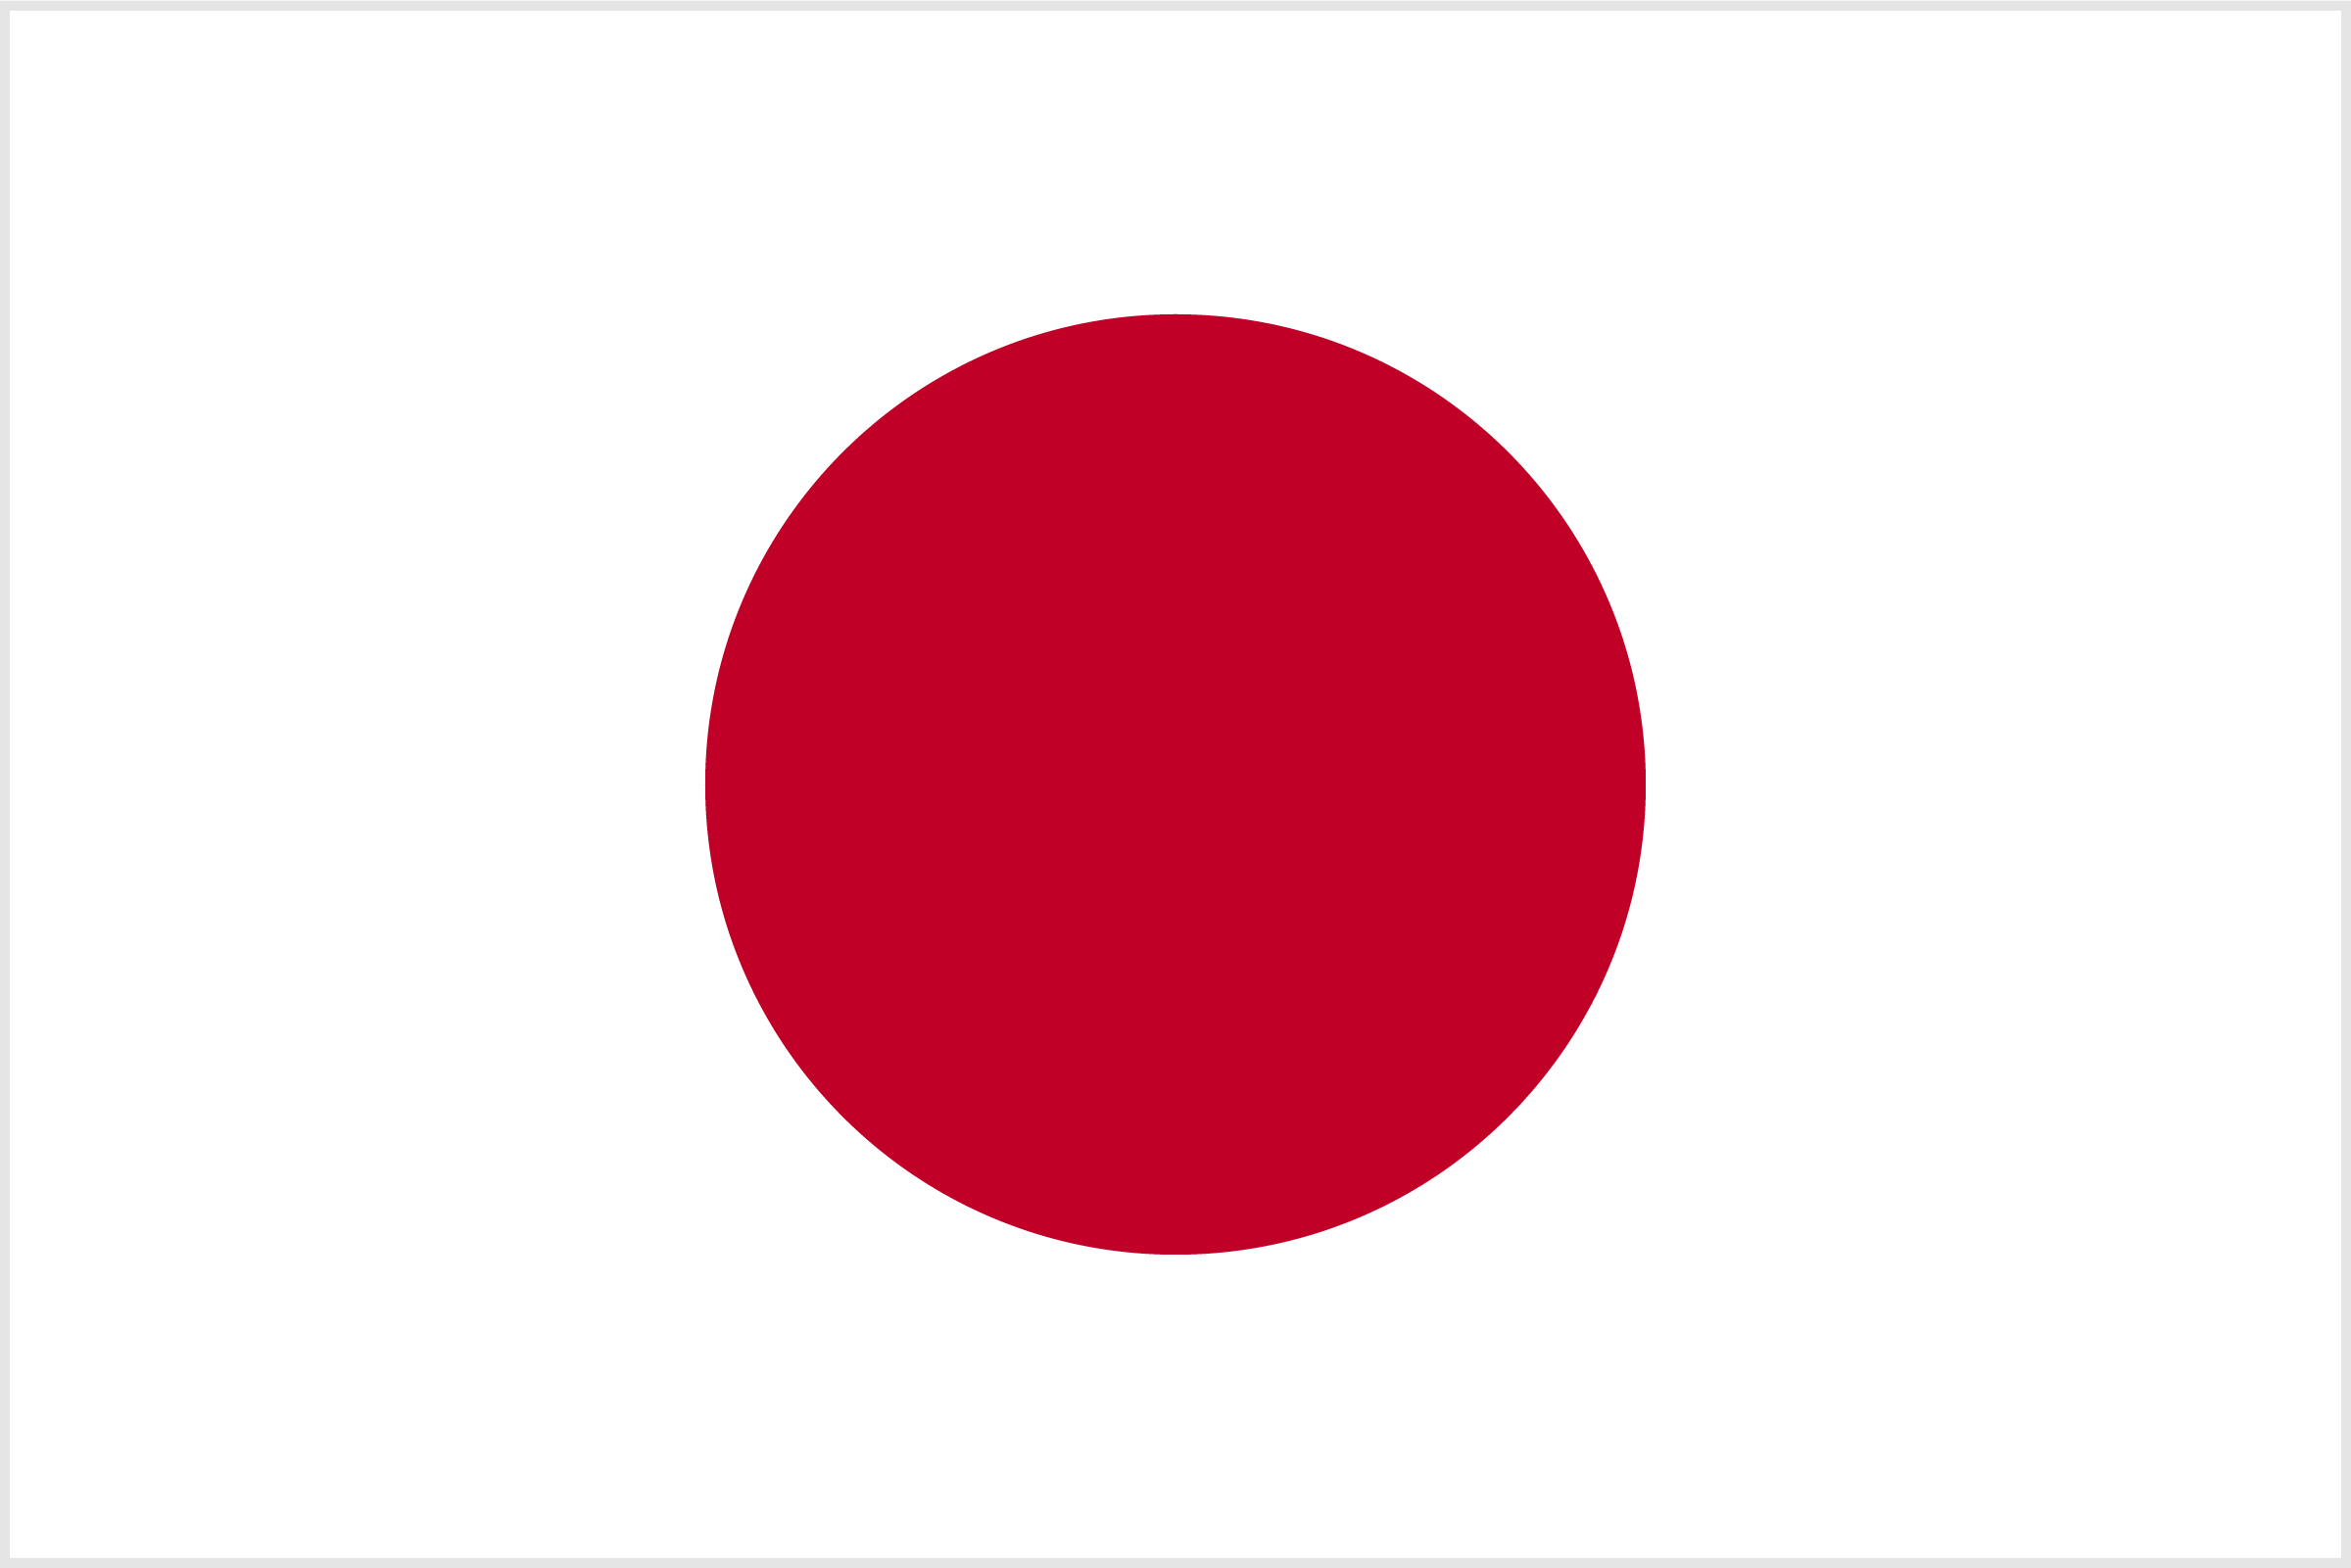

## South Africa

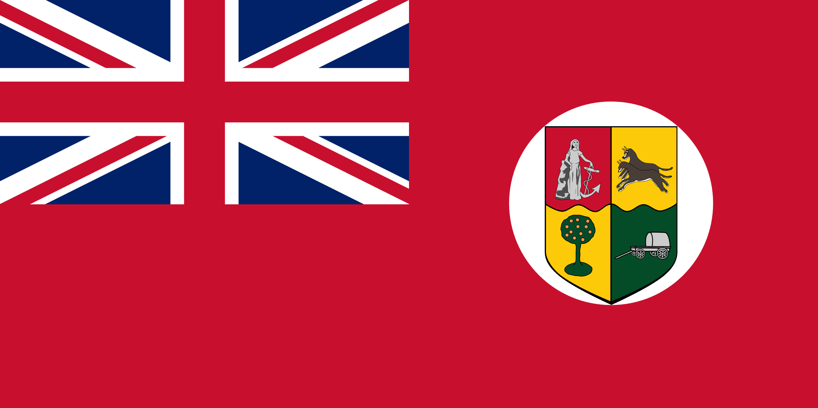

## United States

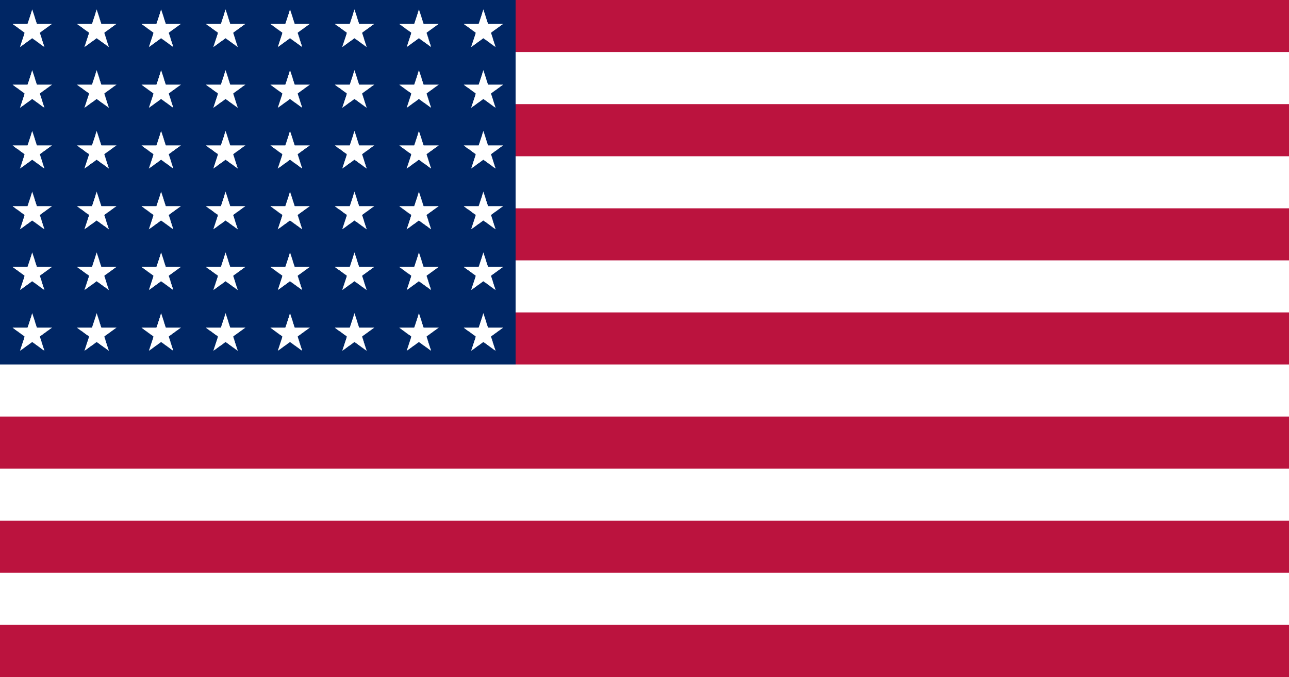

## World War I Terms

**Directions:** Use the following issues to deliberate and terms to choose from during the WWI Peace Talks simulation.

| Issues | Terms: A, B, or C? |
| --- | --- |
| **War Guilt**  Which country or countries should be blamed for causing World War I? | 1. All nations should accept blame for their role in the outbreak of World War I. 2. The Central Powers should accept more blame than the Allied Powers for the outbreak of World War I. 3. Germany should accept the primary blame for the outbreak of World War I. |
| **Reparations**  Which country or countries should pay for the damages of war? How much? | 1. Each nation should work to repair its own towns and countryside over time, at its own expense. 2. Germany should pay war reparations to the Allied countries for some but not all damages, in the amount of $ _______________. 3. Germany should pay war reparations to the Allied countries for all damages, in the amount of $ _______________ |
| **Military Power**  Should all countries be permitted to keep a powerful military in peacetime? | 1. All nations should be permitted to keep their military at prewar levels and continue their armament programs for self-defense. 2. All nations should reduce their armaments. They should decrease the size of armies and navies to the lowest reasonable levels. 3. Germany should reduce the size of its army and navy by half, and should be forbidden to develop any new aircraft, submarines, or tanks. |
| **Colonial Possessions**  Should countries be permitted to keep their colonial possessions in the wake of World War I? | 1. All territorial and colonial possessions should return to prewar status. 2. Some colonies will remain; others will become independent. This will be decided collectively by all European nations. 3. All German colonial claims should be split between the European Allied Powers and/or freed from colonial rule. |
| **League of Nations**  Should countries join an international peacekeeping & decision-making organization? | 1. An international peacekeeping organization should not exist. 2. All nations should have equal membership in an international peacekeeping organization that includes an International Court of Justice. 3. Most nations should belong to an international peacekeeping organization and the International Court of Justice. Germany should be excluded from this organization. |

## World War I Term Cards

### Issue #1—War Guilt

|  |  |  |  |  |  |  |  |  |
| --- | --- | --- | --- | --- | --- | --- | --- | --- |
| **War Guilt**  A  All nations should accept blame for their role in the outbreak of World War I. | | | **War Guilt**  B  The Central Powers should accept more blame than the Allied Powers for the outbreak of World War I. | | | **War Guilt**  C  Germany should accept the primary blame for the outbreak of World War I. | | |
| Country: |  |  | Country: |  |  | Country: |  |  |
|  | | |  | | |  | | |

### Issue #2—Reparations

|  |  |  |  |  |  |  |  |  |
| --- | --- | --- | --- | --- | --- | --- | --- | --- |
| **Reparations**  A  Each nation should work to repair its own towns and countryside over time, at its own expense. | | | **Reparations**  B  Germany should pay war reparations to the Allied countries for some but not all the damages, in the amount of $ ________________ | | | **Reparations**  C  Germany should pay war reparations to the Allied countries for all the damages, in the amount of $ ________________ | | |
| Country: |  |  | Country: |  |  | Country: |  |  |
|  | | |  | | |  | | |

### Issue #3—Military Power

|  |  |  |  |  |  |  |  |  |
| --- | --- | --- | --- | --- | --- | --- | --- | --- |
| **Military Power**  A  All nations should be permitted to keep their military at prewar levels and continue their armament programs for self-defense. | | | **Military Power**  B  All nations should reduce their armaments. They should decrease the size of armies and navies to the lowest reasonable levels. | | | **Military Power**  C  Germany should reduce the size of its army and navy by half, and should be forbidden to develop any new aircraft, submarines, or tanks. | | |
| Country: |  |  | Country: |  |  | Country: |  |  |
|  | | |  | | |  | | |

### Issue #4—Colonial Possessions

|  |  |  |  |  |  |  |  |  |
| --- | --- | --- | --- | --- | --- | --- | --- | --- |
| **Colonial Possessions**  A  All territorial and colonial possessions should return to prewar status. | | | **Colonial Possessions**  B  Some colonies will remain; others will become independent. This will be decided collectively by all European nations. | | | **Colonial Possessions**  C  All German colonial claims should be split between the European Allied Powers and/or freed from colonial rule. | | |
| Country: |  |  | Country: |  |  | Country: |  |  |
|  | | |  | | |  | | |

### Issue #5—League of Nations

|  |  |  |  |  |  |  |  |  |
| --- | --- | --- | --- | --- | --- | --- | --- | --- |
| **League of Nations**  A  An international peacekeeping organization should not exist. | | | **League of Nations**  B  All nations should have equal membership in an international peacekeeping organization that includes an International Court of Justice. | | | **League of Nations**  C  Most nations should belong to an international peacekeeping organization and the International Court of Justice. Germany should be excluded from this organization. | | |
| Country: |  |  | Country: |  |  | Country: |  |  |
|  | | |  | | |  | | |