|  |  |  |  |
| --- | --- | --- | --- |
| Name: |  | Date: |  |

## Preparation

* Download the [WHP Writing Rubric](https://www.oerproject.com/OER-Materials/OER-Media/PDFs/Teacher-Resources/WHP-Writing-Rubric)

## Purpose

This DBQ is the final writing assessment for the course. It is the exact same prompt you encountered early in the course in DBQ 0. This DBQ will show you how much you have grown in your ability to use a range of texts to construct an evidence-based, well-structured explanation or argument. Answering this DBQ now will give you a true sense of what you’ve learned and accomplished during the course.

## Process

Today, you are going to take the final DBQ assessment for the course. Do your best—you’ll very likely see a lot of growth since you first encountered this same DBQ at the beginning of the year.

Take out the DBQ and follow the directions. You may want to review the WHP Writing Rubric to remind yourself of the criteria you are aiming for in your writing.

## Unit 9 DBQ

**Directions:** Write a five- to six-paragraph essay in response to the following prompt. Make sure to use the documents provided to help support your argument. In addition to trying to meet the criteria of the WHP Writing Rubric, make sure to address the most relevant of these historical thinking skills in your response: comparison, causation, or CCOT. Finally, make sure you contextualize (describe the broader historical context) relevant to the prompt.

We suggest you spend 10-15 minutes reading these documents and 35-45 minutes writing. Sources are edited for brevity and clarity.

**Evaluate the extent to which globalization since the Second World War has benefited everyone.**

|  |
| --- |
|  |

## Document 1

Source: Max Roser, “The Short History of Global Living Conditions and Why it Matters That We Know It,” *Our World in Data*, University of Oxford. <https://ourworldindata.org/a-history-of-global-living-conditions-in-5-charts?linkId=62571595>.

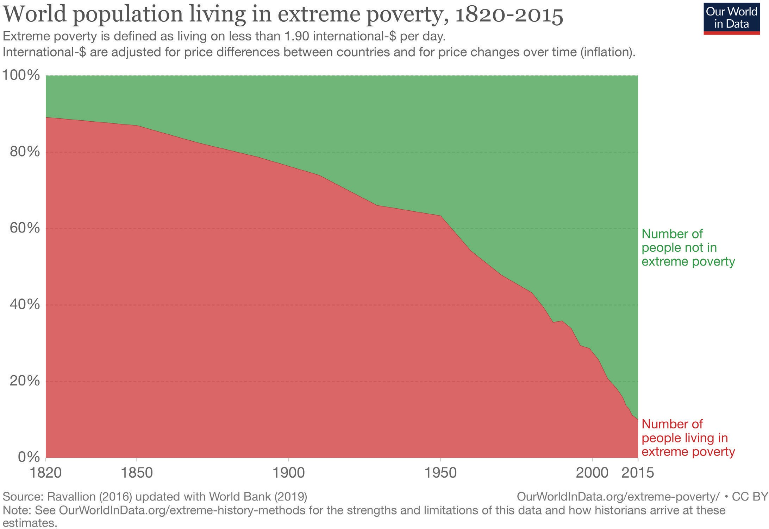

## Document 2

Source: Steven Pinker, *Enlightenment Now: The Case for Reason, Science, Humanism, and Progress* (New York: Viking, 2018). Excerpts are lightly edited and combined, taken from pages 249, 251, 257, 259, 261.

In 1870, Western Europeans worked an average of 66 hours a week, while Americans worked 62 hours. Over the past century and a half, workers have increasingly been emancipated from their wage slavery, more dramatically in social-democratic Western Europe (where they work 28 fewer hours a week) than in the go-getter United States (where, on average, they now work 22 fewer hours).

In 1919, and average American wage earner had to work 1,800 hours to pay for a refrigerator; in 2014 they had to work fewer than 24 hours. As utilities and appliances penetrated American households during the twentieth century, the amount of life that people lost to housework fell almost fourfold, from 58 hours a week in 1900 to 15.5 hours in 2011.

In 2015 American men reported 42 hours of leisure per week, around 10 more than their counterparts did 50 years earlier, and women reported 36 hours, more than 6 hours more.

In 1974, it cost $1,442 (in 2011 dollars) to fly from New York to Los Angeles; today it can be done for less than $300.

Grocers have broadened their offerings as well, from a few hundred items in the 1920s to 2,200 in the 1950s; 17,500 in the 1980s; and 39,500 in 2015.

We have, at our fingertips, virtually all the works of genius prior to our time. Better still, it is all available not just to the rich, but to anyone who is connected to the vast web of knowledge, which means most of humanity, and soon all of it.

## Document 3

Source: *Our World in Data*, University of Oxford, University of Oxford, calculations by Ola Rosling from Gapminder. <https://ourworldindata.org/uploads/2019/10/Global-inequality-in-1800-1975-and-2015.png>.

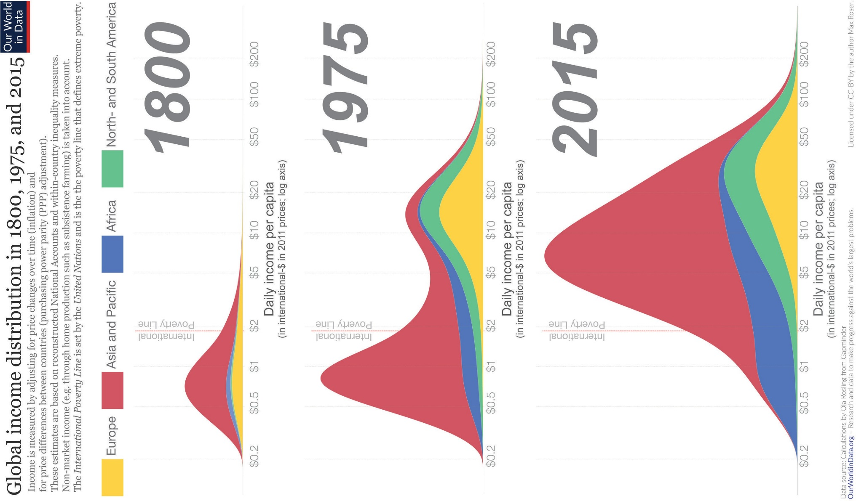

## Document 4

Source: Adapted from Simon Dalby, “Geographies of Global Environmental Security,” in Eleonore Kofman and Gillian Youngs, eds., *Globalization: Theory and Practice*, Third Edition (New York: Continuum, 2008), 31. This excerpt has been edited for clarity.

Economic security for some can mean worse economic conditions for others. The *United Nations Human Development Report* of 1994 suggested that the wealth ratio between the poorest 20% and the richest 20% of the world population grew from 30:1 to 60:1 between 1960 and 1991. This trend of increasing inequality has continued since. Some are getting richer and the number in absolute poverty goes down, but this is often at the expense of people who are displaced or marginalized. The poor end up with fewer protections. These are clearly matters of concern to anyone worried about international security and the possibility of poverty leading to violent conflict.

## Document 5

Source: Artist unknown, reproduced in New Zealand’s “The Daily Blog” in a February 2019 posting by Dr. Geoff Bertram, Senior Associate at the Institute for Governance and Policy Studies, Victoria University of Wellington, New Zealand. <https://thedailyblog.co.nz/2019/02/24/guest-blog-geoff-bertram-climate-change-free-trade/>.

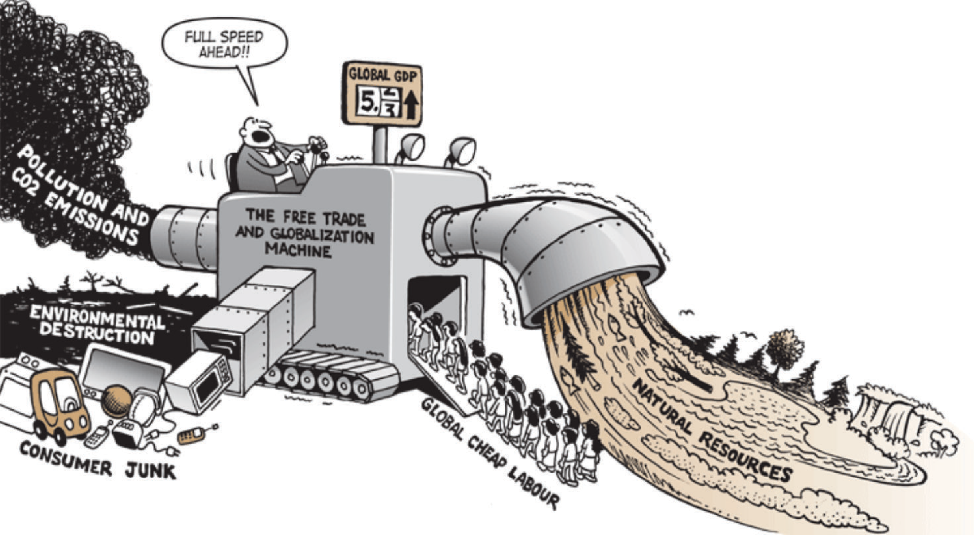

## Document 6

Source: *Our World in Data*, University of Oxford, United Nations, Population Division, <https://ourworldindata.org/life-expectancy>.

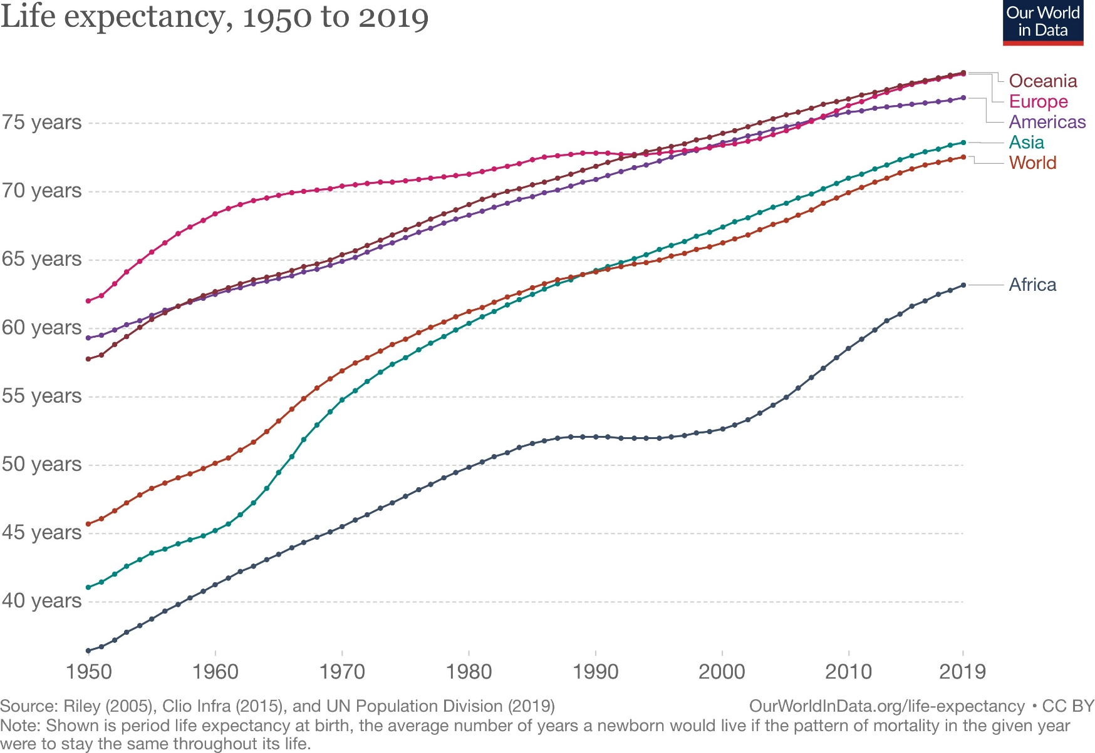

## Document 7

Source: Andalusia Knoll Soloff, “The Trouble with Globalization,” *The World History Project*, Unit 9, [https://www.oerproject.com/OER-Media/PDFs/1750/Unit9/The-Trouble-with-Globalization?PageId={F0BC6415-2213-40E7-B43D-4A1ED9A0DB8D}](https://www.oerproject.com/OER-Media/PDFs/1750/Unit9/The-Trouble-with-Globalization?PageId=%7bF0BC6415-2213-40E7-B43D-4A1ED9A0DB8D%7d).

Your clothes are evidence that globalization created jobs in the global south. Read the tags on your shoes, shirt, and pants. Were they made in China, Honduras, Bangladesh or some other distant part of the globe? But then think: If your shoes cost $100, how much do you think the person who glued their soles on got paid for each pair of shoes? How many hours do you think they would need to work to be able to purchase a pair? What kind of conditions do you think they work in?

Nike is the world’s largest athletic apparel maker in the world and arguably the most popular sneaker with a highly recognizable logo. In recent years Nike has hailed itself as a “social justice” company with a new campaign featuring social justice advocate Colin Kaepernick. They also ran a campaign encouraging women to break free of the limits society puts on them.

But wait for the other sneaker to drop. Nike’s factories around the world also have a long history of abuses. In 1997, an accounting firm documented how workers at a factory making Nike products in Vietnam were exposed to toxic chemicals, forced to work 65 hours a week, and earned only $10 dollars. Nike tried to dodge responsibility saying that the factory was really run by subcontractors. The company was eventually pressured by international watchdogs to set labor standards, but investigations have shown that they still do not comply with these standards. In 2011, workers at Nike’s Converse shoe factory in Indonesia protested that their “supervisors throw shoes at them, slap them in the face and call them dogs and pigs.”

Nike is just one example of a transnational corporation that benefits from increased global trade and low tariffs. While it has created hundreds of thousands of jobs across the world, that has not necessarily created prosperity. In fact, global inequality has risen exponentially over the past 30 years. In the United States alone, the top .001 percent earned 636% more in 2014 than what they earned in 1980 while there was no increase in income for the bottom half of earners.